J.N.T.U.H. COLLEGE OF ENGINEERING

**KUKATPALLY, HYDERABAD – 500 085**



**Certificate**

***This is to certify that M.Sri Sai Prashanthi, K.Nishitha,V.Swathi,R.Dharani,K.Esther B.Tech III year II Semester bearing the Hall-Ticket number 14011P0511,14011P0505,14011P0519,14011P0503,14011P0506 fulfilled their WEB TECHNOLOGIES LAB record for the academic year 2016-2017.***

***Signature of the Head of the Department Signature of the staff member***

***Date of Examination_________________________***

***Internal Examiner External Examiner***

|  |  |  |  |
| --- | --- | --- | --- |
| SNO | NAME OF EXPERIMENT | PAGENO | SIGN |
| 1. | Develop static pages (using Only HTML) of an online Book store.The pages should resemble: www.amazon.com The website should consist the following pages.  1. Home page 2. Registration and user Login 3. user Profile Page 4. Books catalogue 5. Shopping Cart 6. Payment By credit card 7. order Confirmation | 3 |  |
| 2 | Validate the Registration, user login and payment by credit card pages using JavaScript. | 16 |  |
| 3. | Create and save an XML document at the server, which contains 10 users information. Write a program, which takes user ID as an input and returns user details by taking user information from the XML document. | 19 |  |
| 4. | Create a JavaBean which gives the exchange value of INR (Indian rupees) into equivalent American/Canadian/Australian Dollar value. | 25 |  |
| 5. | Install TOMCAT web server. Convert the static web pages of assignments 2 into dynamic web pages using servlets and cookies. Hint: Users information (user id, password, credit card number) would be stored in web.xml. Each user should have a separate Shopping Cart. | 28 |  |
| 6. | Redo the previous task using JSP by converting the static webpages of assignments 2 into dynamic web pages. Create a database with user information and books information. The books catalogue should be dynamically loaded from the database. Follow the MVC architecture while doing the website. | 47 |  |
| 7. | Mini Project | 63 |  |

**1.Develop static pages(using only HTML) of an online book store.The website should consist of following pages:**

**a)home page**

**b)registration and user login**

**c)user profile**

**d)books catalog**

**e)payment by credit card**

**HOME PAGE**

<html>

<head>

<title>book catalog</title>

</head>

<body>

<h1>book catalogs</h1>

<table align="center"> <tr>

<td>flower book</br>

<a href="flowerbook.html">

<img src="chrysanthemum.jpg" alt="Mountain View" style="width:304px;height:228px;">

</a></td>

<td>

angels and demons</br>

<a href="angels and demons.html">

<img src="aad.jpg" alt="Mountain View" style="width:304px;height:228px;">

</a></td>

</tr>

<tr>

<td>da vinci code</br>

<a href="da vinci code.html">

<img src="dvc.jpg" alt="Mountain View" style="width:304px;height:228px;">

</a>

</td>

<td>lost symbol</br>>

<a href="flowerbook.html">

<img src="lostsymbol.jpg" alt="Mountain View" style="width:304px;height:228px;">

</a>

</td>

</tr>

<tr>

<td>inferno</br>

<a href="inferno.html">

<img src="inferno.jpg" alt="Mountain View" style="width:304px;height:228px;">

</a></td>

<td>stranger in the mirror</br>

<a href="stranger in the mirror.html">

<img src="sim.jpg" alt="Mountain View" style="width:304px;height:228px;">

</a></td>

</tr>

</table>

</body>

</html>

</body>

</html>

**Output:**

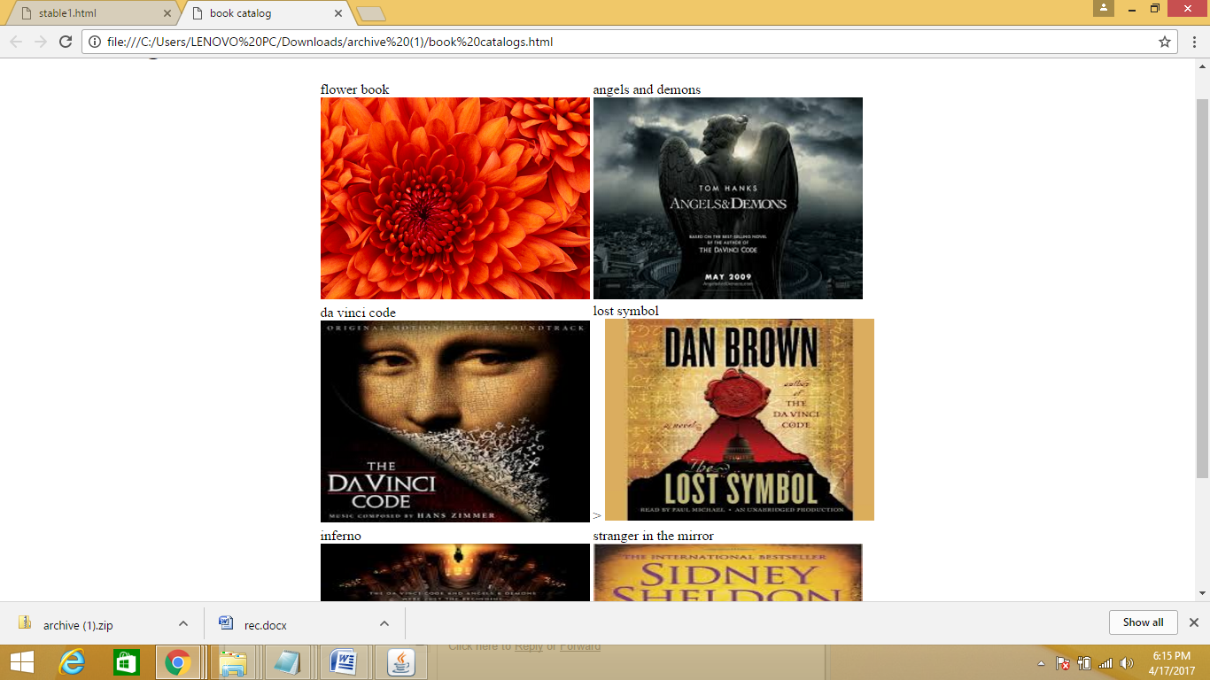

**REGISTRATION**

<html>

<fieldset>

<head>

<title>Registration page</title></head>

<body >

<h1><center><u>Registration</u></h1>

Enter username:<input type="text" name="ün" ></br>

Enter password:<input type="password" name="pwd" ></br>

Enter email:<input type="email" name="em" ></br>

Gender:

<input type="radio" name="gen">male

<input type="radio" name="gen">female</br>

Date of birth:

date:dd/mm/yyyy<input type="text" name="dob">

<option value="1"> 1</option>

Country:<select name="country">

<option value="ïndia" selected>India</option>

<option value="canada">Canada</option>

<option value="usa">USA</option>

<option value="australia">Australia</option></select><br>

</br>

</br>

adress: <input type="text" name="add">

</br>

phone no: <input t

</br><input type="submit" value="register"></br>

</body>

</fieldset>

</html>

**Output:**

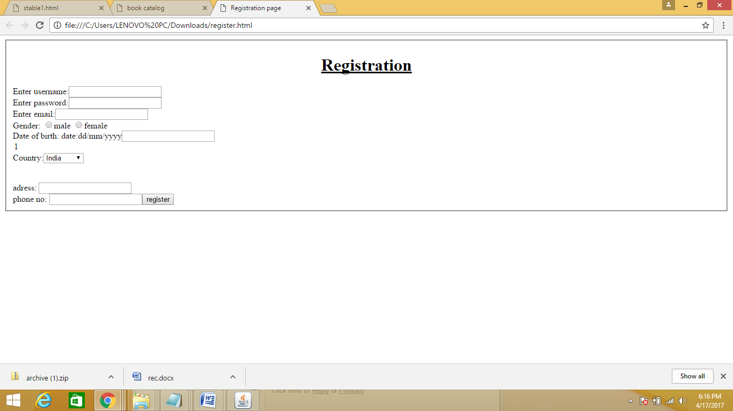

**LOGIN**

<html>

<head>

<title>login page</title></head>

<body >

<table align="center">

<h1><center><u>Registration</u></h1>

<tr><th>

Enter username:</th>

<td><input type="text" name="ün" ></td>

</tr>

<th>Enter password:</th>

<td><input type="password" name="pwd" ></td>

<tr>

<th></th>

<td>

<input type="submit" value="login"></td>

<tr>

<th> new user?</th>

<td>

<form action="register.html"> <input type="submit" value="register"></form>

</td></tr>

</table>

</body>

</html>

**Output:**

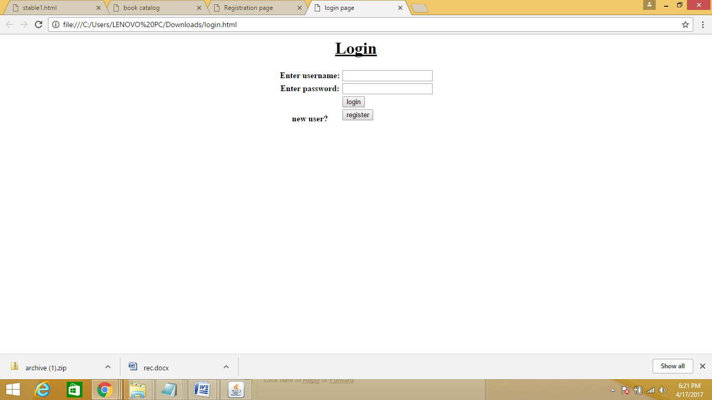

**books catalog**

<html>

<head>

<title>da vinci code</title>

</head>

<body>

<h1>book catalog</h1>

<table align="center">

<tr>

<th>name</th>

<td>da vinci code</td>

</tr>

<tr>

<th>number of pages</th>

<td>500</td>

</tr>

<tr>

<th>binding</th>

<td>hard bound</td>

</tr>

<tr>

<th>author</th>

<td>dan brown</td>

</tr>

<tr>

<th>

publication</th>

<td>penguin</td>

</tr>

<tr>

<th>genre</th>

<td>ficton</td>

<a href="book catalogs.html">home</a>

</body>

</html>

**Output:**

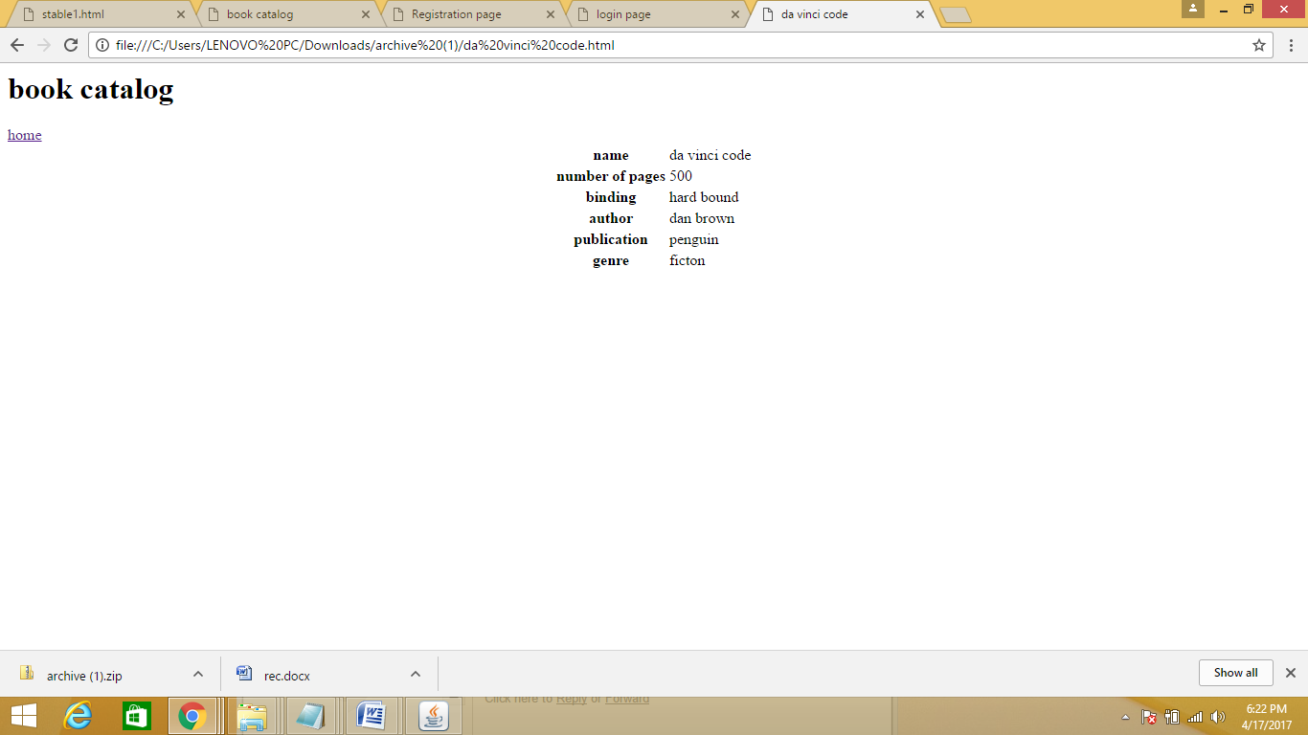

**USER PROFILE**

<html>

<head>

<title>user profile</title>

</head>

<body>

<h1><center>user profile</h1>

<center>

<img src="dvc.jpg" alter="no picture updated"></center>

<table align="center">

<tr>

<th>name</th>

<td>inferno</td>

</tr>

<tr>

<th>age</th>

<td>50</td>

</tr>

<tr>

<th>adress</th>

<td>hard bound</td>

</tr>

<tr>

<th>phone</th>

<td>dan brown</td>

</tr>

<tr>

<th>

profession</th>

<td>penguin</td>

</tr>

<tr>

<th>cart</th>

<td>ficton</td>

</body>

</html>

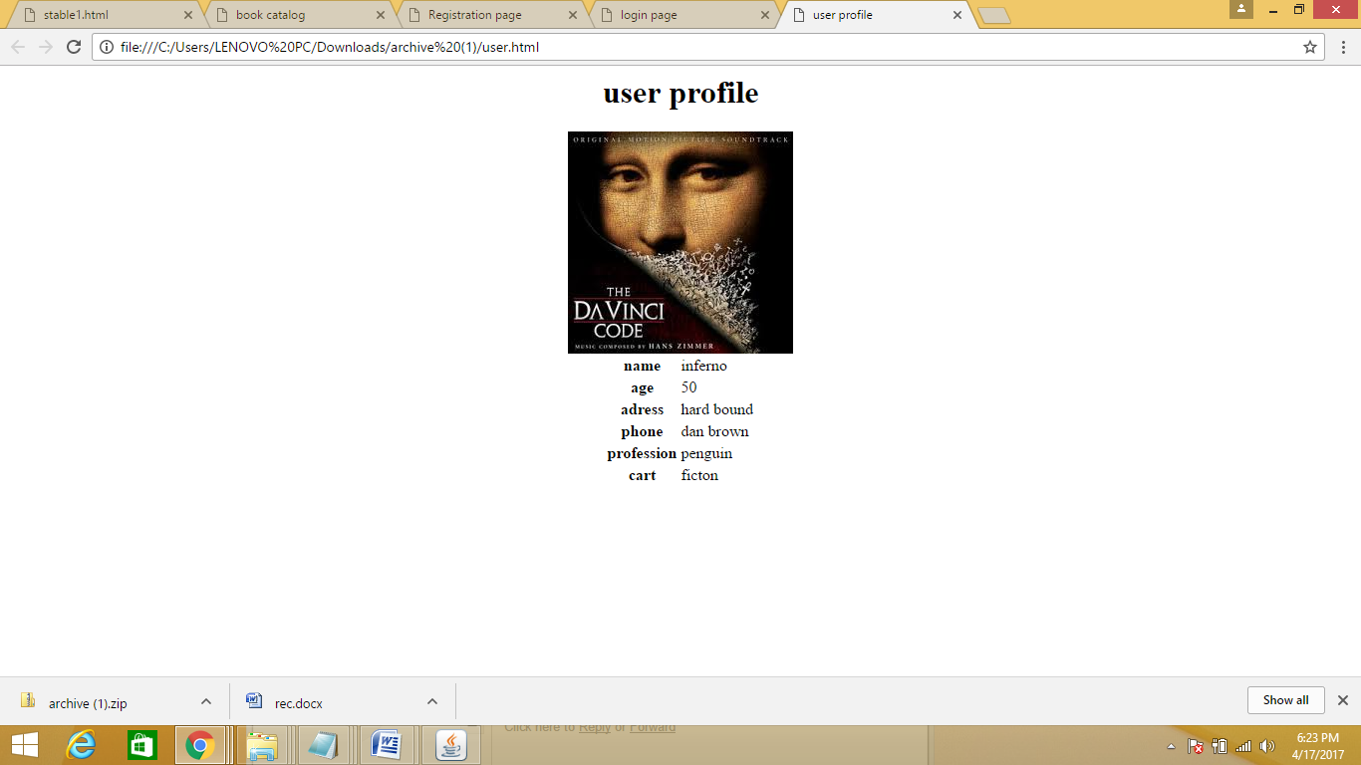

**PAYMENT BY CREDIT CARD**

<!doctype html>

<html>

<head>

<title> payment</title>

<style>

body{

text-align:center;

margin-top:10px;

text-align:center;

}

table{

border-style:solid;

text-align:center;

padding:20px;

height:200px;

}

input[type=button] {

padding: 12px 20px;

margin: 8px 0;

box-sizing: border-box;

border: none;

background-color: orange;

color: black;

border-radius:5px;

cursor:pointer;

}

input[type=text]{

border-radius:5px;

}

form {

display: inline-block;

text-align: center;

}

</style></head>

<body><a href="https://www.amazon.com/ref=ap_frn_logo" ></a>

<br>

<p id="error"> </p>

<form action="payment.jsp" method="post">

<p id="error"> </p>

<fieldset>

<p align=left>Your name:<br/>

<input type="text" name="uname" size="30" height="50"> <br/><br>

enter amount:<br/>

<input type="text" name="amt"n size="30"><br/><br>

card number<br/>

<input type="text" name="cn" size="30"><br/><br>

cvv<br/>

<input type="text" name="cvv" size="30"><br/><br>

pin<br/>

<input type="password" name="pin" size="30"><br/><br>

re-pin<br/>

<input type="password" name="rpin" size="30"><br/><br>

<input type="submit" value="submit card details" onClick="return val()"><br/></a>

<p align="left" style="font-family:Sans-Serif">By submitting, you agree to <br/>

<a href="terms and condition.html">Conditions of Use</a>

and<a href="privacynotice.html"> Privacy Notice</a>

</p>

</fieldset>

<script>

function val()

{

var name= document.getElementById("uname").value;

var cn= document.getElementById("cn").value;

var cvv= document.getElementById("cvv").value;

var pin= document.getElementById("pin").value;

var rpin= document.getElementById("rpin").value;

if(name=="")

{

document.getElementById("error").innerHTML="Enter ur name";

return false;

}

else if(cn==""||cvv=="")

{

document.getElementById("error").innerHTML="Enter ur card no.<br> card number and cvv are compulsory";

return false;

}

else if(pin=="")

{

document.getElementById("error").innerHTML="Enter ur pin";

return false;

}

}

}

</script>

</form>

</body>

</html>

**Output:**

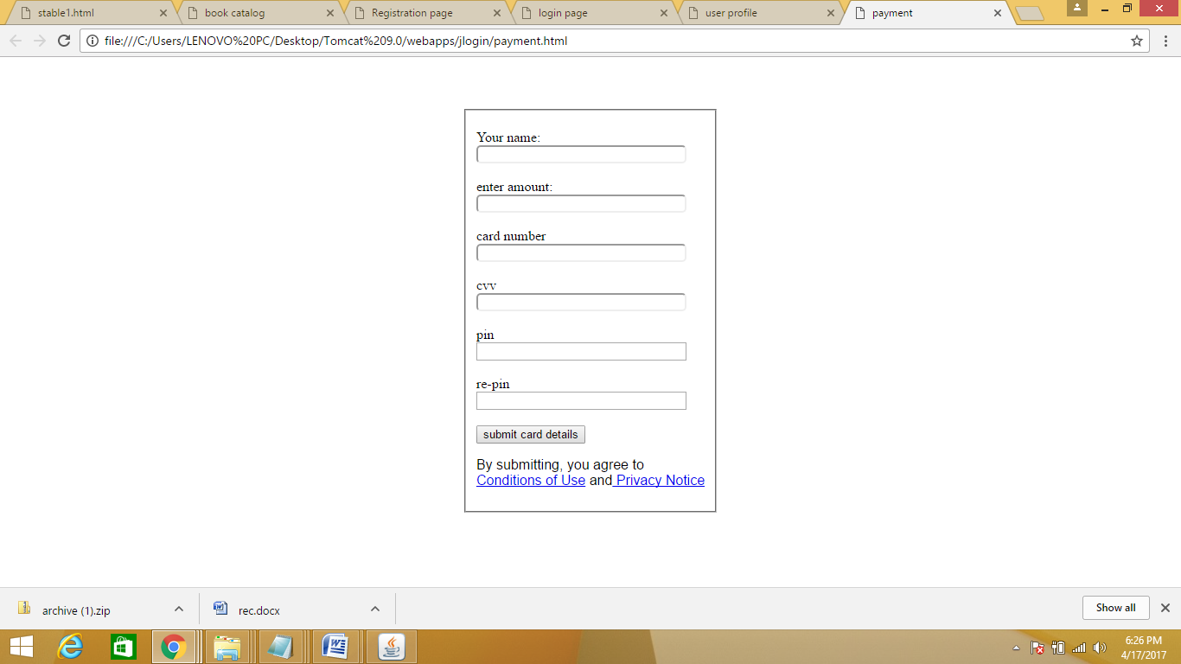

**2.Validate the registration ,user login, user profile and payment by credit card pages using JavaScript**

**REGISTRATION:**

<!DOCTYPE html>

<head>

<script>

var username=document.form1.uname.value;

var password=document.form1.pwd.value;

var email=document.form1.em.value;

function validate()

{

if(username==null||password==null||email==null)

{

alert(" shoudnt empty");

return false;

}

}

</script>

</head>

<body><table align="center">

<form name="form1">

<tr><th>user name</th>

<td><input type="text" name="uname"/></td>

</tr><tr>

<th>password</th>

<td><input type="password" name="pwd"/></td>

</tr>

<tr><th>gender</th><td><input type="radio" name="gender" value="male"/>male

<input type="radio" name="gender" value="female"/>female</tr>

</td>

</tr><tr><th>email</th><td><input type="text" name="em"/></td>

</tr><tr><th>country</th><td><select name="country">

<option value="india" selected>india</option>

<option value="usa" >usa</option>

<option value="russia">russia</option>

<input type="button" value="submit" onclick="validate()"/>

</form>

</body>

</html>

**Output:**

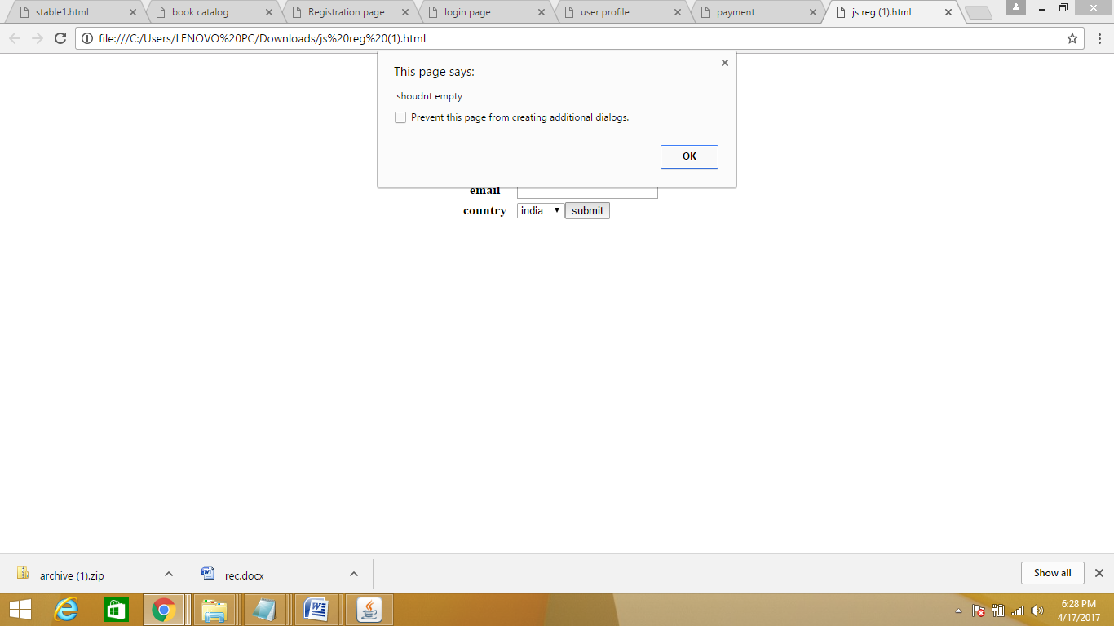

**LOGIN:**

<html>

<body>

<form>

<center>

<h1>LOGIN FORM</h1>

<table>

<tr><td>username</td></tr>

<td><input type=”text” name=”text”>

</td></tr>

<tr><td>Password:</tr></td>

<td>

<input type=”password” name=”pwd”>

</td></tr></br>

</table>

<input type=”button” value=”login” onclick=”check(this.form)”/>

<a>forgot password??</a><br>

<a href=”jreg.html”>register</br>

</form>

<script language=”javascript”>

function check(form)

{

if(form.text.value!=””&&form.pwd.value!=””)

{

Alert(“success”);

}

Else

{

Alert(“error in password or username”);

}

}

</script>

</body>

</html>

**Output:**

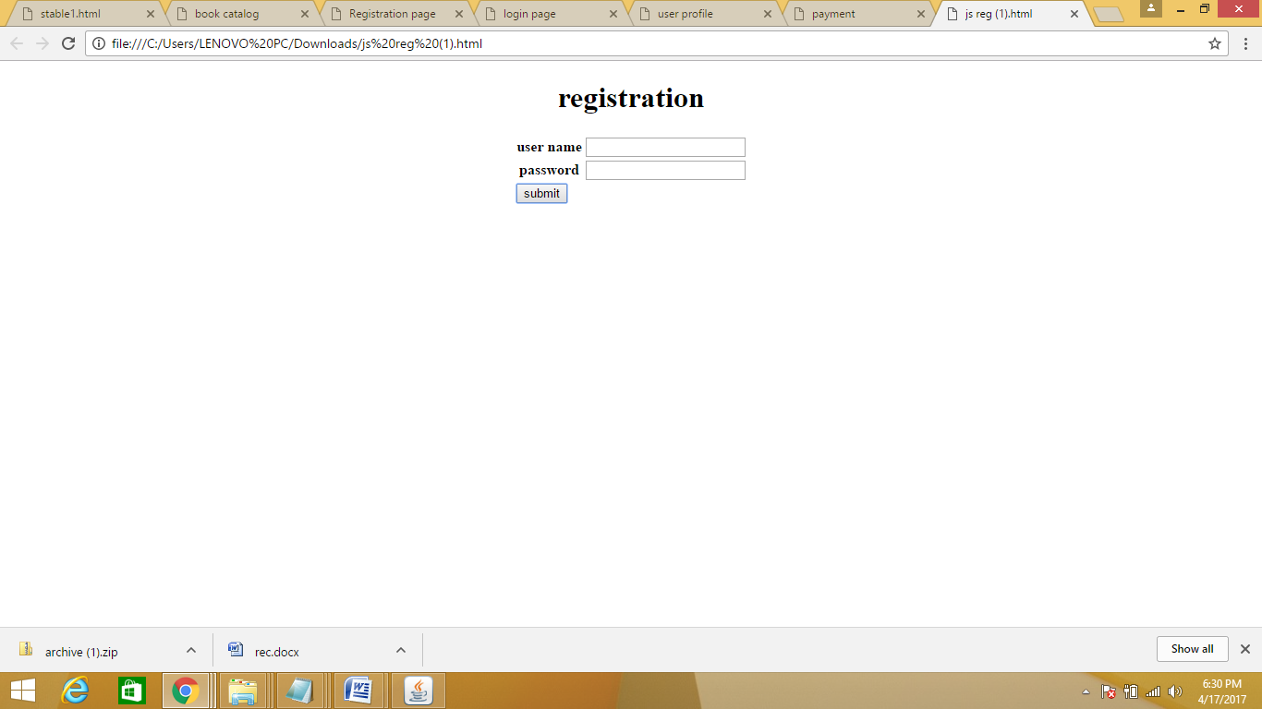

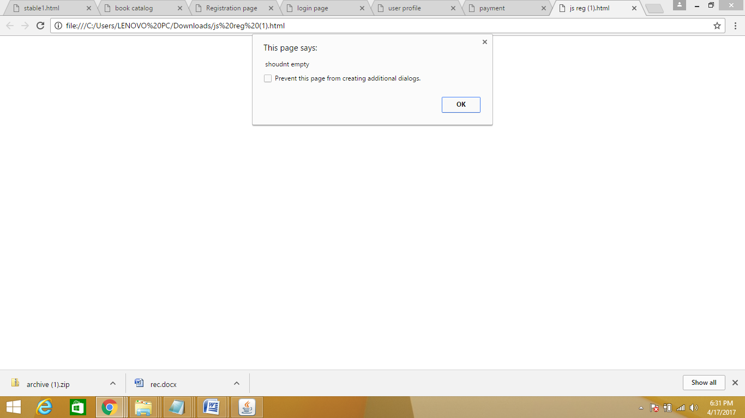

**3. Create and save an XML document at the server, which contains 10 users information. Write a program, which takes user ID as an input and returns user details by taking userinformation from the XML document.**

**Userpro.xml**

<?xml version="1.0"?>

<person>

<entry>

<Date>1/01/2001</Date>

<UserName>prashanthi</UserName>

<email>prash@gmail.com</email>

<age>20</age>

<Qualification>student</Qualification>

</entry>

<entry>

<Date>2/10/2007</Date>

<UserName>nishitha</UserName>

<email>nish@gmail.com</email>

<age>20</age>

<Qualification>student</Qualification>

</entry>

</person>

**Usp.html**

<!doctype html>

<html lang="en">

<head><meta charset="utf-8"></head>

<body>

User Name: <input type="text" name="UserName" id="input">

<br />

<input type="submit" value="Submit" onClick="searchXML()">

<br />

<br />

<div id="results"></div>

<script src="https://ajax.googleapis.com/ajax/libs/jquery/1.11.1/jquery.min.js"></script>

<script language="JavaScript" type="text/javascript">

function loadXMLDoc(dname)

{

if (window.XMLHttpRequest)

{

xhttp=new XMLHttpRequest();

}

else

{

xhttp=new ActiveXObject("Microsoft.XMLHTTP");

}

xhttp.open("GET",dname,false);

xhttp.send();

return xhttp.responseXML;

}

function searchXML()

{

var xmlDoc = loadXMLDoc("userpro.xml");

var x = xmlDoc.getElementsByTagName("UserName");

var input = document.getElementById("input").value;

var size = input.length;

if(input == null || input == "")

{

document.getElementById("results").innerHTML= "Please enter a user Name!";

return false;

} else

{

for (i = 0; i < x.length; i++)

{

if (x.length > 0)

{

var date = xmlDoc.getElementsByTagName("Date")[i].childNodes[0].nodeValue;

var product = xmlDoc.getElementsByTagName("UserName")[i].childNodes[0].nodeValue;

var email = xmlDoc.getElementsByTagName("email")[i].childNodes[0].nodeValue;

var age = xmlDoc.getElementsByTagName("age")[i].childNodes[0].nodeValue;

var Qualification = xmlDoc.getElementsByTagName("Qualification")[i].childNodes[0].nodeValue;

if(product==input){

var divText = "<h1>The userdetails are:</h1><br /><table border=1><tr><th>Date</th><th>User Name</th><th>email</th><th>age</th><th>Qualification</th></tr>" + "<tr><td>" + date + "</td><td>" + product + "</td><td>" + email+ "</td><td>" + age+ "</td><td>" + Qualification+ "</td></tr>" + "</table>";

break;

}

}

else

{

var divText = "<h2>The product does not exist.</h2>";

}

}

document.getElementById("results").innerHTML = divText;

}

}

</script>

</body></html>

**Output:**

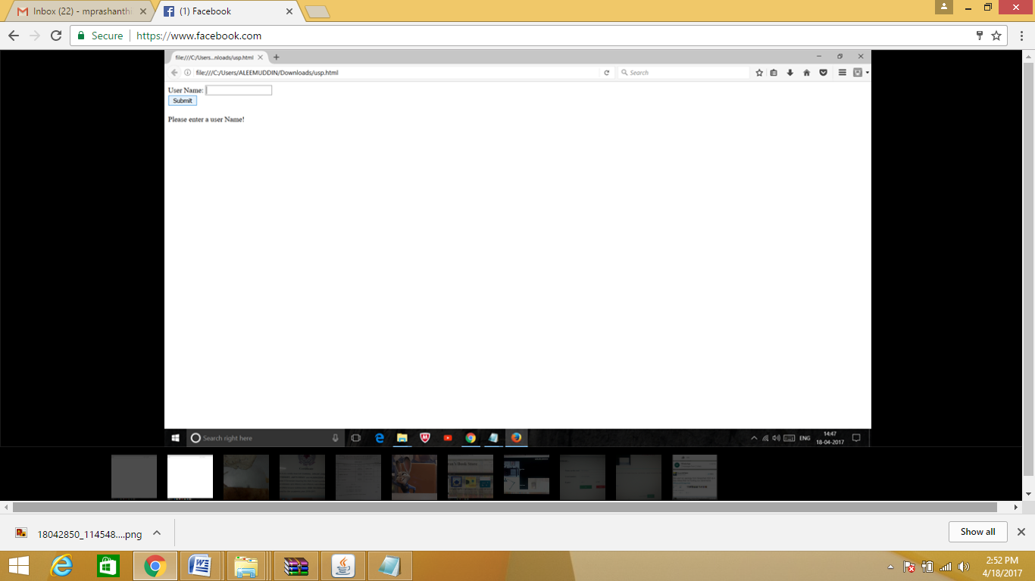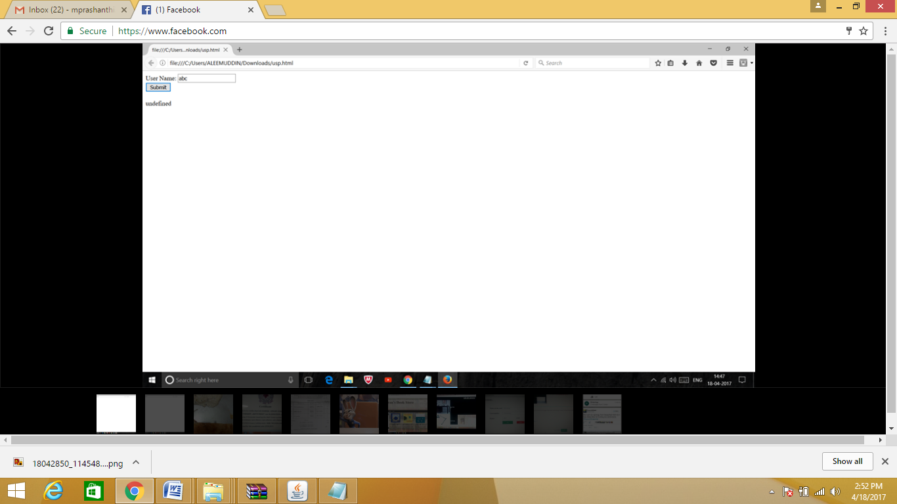



**4) Create a JavaBean which gives the exchange value of INR (Indian Rupees) into equivalent American/Canadian/Australian Dollar value.**

**Conversion.java**

import java.awt.*;

import java.awt.event.*;

public class conversion extends Canvas

{

private double rup,usd,ausd,cand;

public conversion()

{

setsize(100,200);

}

public double getrup()

{

return rup;

}

public void setrup(double rup)

{

this.rup=rup;

exchange();

}

public double getusd()

{

return usd;

}

public void setusd(double usd)

{

this.usd=usd;

exchange();

}

public double getausd()

{

return ausd;

}

public void setausd(double ausd)

{

this.ausd=ausd;

exchange();

}

public double getcand()

{

return cand;

}

public void setcand(double cand)

{

this.cand=cand;

exchange();

}

public void exchange()

{

rup=getrup();

usd=rup/68.8;

ausd=rup/59.1;

cand=rup/40.0;

setusd(usd);

setausd(ausd);

setcand(cand);

}

}

**Conversion.mft**

Name: conversion.class

Java-Bean: true

**Output:**

C:\users\14011p0511\Desktop\bdk1_1\beans>javac conversion.java

C:\users\14011p0511\Desktop\bdk1_1\beans>jar cfm conversion.jar conversion.mft conversion.class

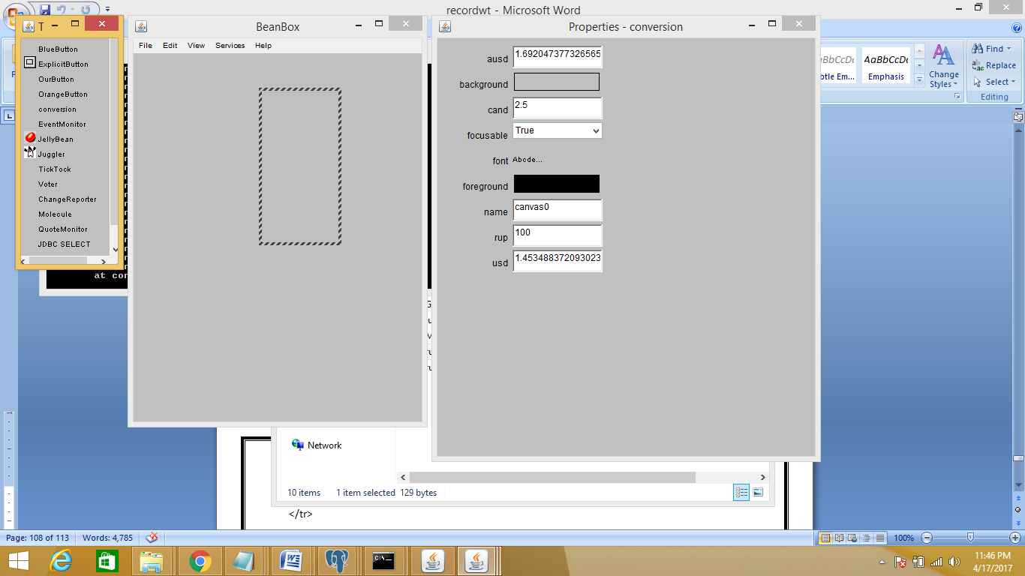

**5.Install TOMCAT web server. Convert the static web pages ofassignments 2 into dynamic web pages using servlets and cookies.Hint: Users information (user id, password, credit card number)would be stored in web.xml. Each user should have a separateShopping Cart.**

**Registration:**

**Index.html**

<!doctype html>

<html>

<head>

<title> amazon registration</title>

<style>

body{

text-align:center;

margin-top:10px;

text-align:center;

}

table{

border-style:solid;

text-align:center;

padding:20px;

height:200px;

}

input[type=button] {

padding: 12px 20px;

margin: 8px 0;

box-sizing: border-box;

border: none;

background-color: orange;

color: black;

border-radius:5px;

cursor:pointer;

}

input[type=text]{

border-radius:5px;

}

form {

display: inline-block;

text-align: center;

}

</style>

</head>

<body>

<br>

<p id="error"> </p>

<form action="./regg" method="post">

<p id="error"> </p>

<fieldset>

<p align=left>Your name:<br/>

<input type="text" name="uname" size="30" height="50"> <br/><br>

Email<br/>

<input type="text" name="em" size="30"><br/><br>

Email again<br/>

<input type="text" name="emagn" size="30"><br/><br>

Password<br/>

<input type="password" name="pwd" size="30"><br/><br>

Password again<br/>

<input type="password" name="pwdagn" size="30"><br/><br>

<input type="submit" value="Create your Amazon account" bgcolor="orange" onClick="return val()"><br/></a>

<p align="left" style="font-family:Sans-Serif">By creating an account, you agree to<br/>

<a href="terms and condition.html">Conditions of Use</a>

and<a href="privacynotice.html"> Privacy Notice</a>

</p>

</fieldset>

<script>

function val()

{

var name= document.getElementById("uname").value;

var em= document.getElementById("em").value;

var emagn= document.getElementById("emagn").value;

var pwd= document.getElementById("pwd").value;

var pwdagn= document.getElementById("pwdagn").value;

if(name=="")

{

document.getElementById("error").innerHTML="Enter ur name";

return false;

}

else if(em==""||emagn=="")

{

document.getElementById("error").innerHTML="Enter ur email<br> Email and Emailagain should be same";

return false;

}

else if(pwd=="")

{

document.getElementById("error").innerHTML="Enter ur password";

return false;

}

}

}

</script>

</form>

</body>

</html>

**Web.xml**

<web-app>

<servlet>

<servlet-name> sreg</servlet-name>

<servlet-class>Registration</servlet-class>

</servlet>

<servlet-mapping>

<servlet-name>sreg</servlet-name>

<url-pattern>/regg</url-pattern>

</servlet-mapping>

</web-app>

**Registration.java**

import java.io.*;

import java.sql.*;

import javax.servlet.ServletException;

import javax.servlet.http.*;

public class Registration extends HttpServlet {

public void doPost(HttpServletRequest request, HttpServletResponse response)

throws ServletException, IOException {

response.setContentType("text/html");

PrintWriter out = response.getWriter();

String n=request.getParameter("uname");

String e=request.getParameter("em");

String ea=request.getParameter("emagn");

String p=request.getParameter("pwd");

String pa=request.getParameter("pwdagn");

try{

Class.forName("org.postgresql.Driver");

Connection con=DriverManager.getConnection(

"jdbc:postgresql://localhost:5432/vijaya","postgres","prashanthi");

PreparedStatement ps=con.prepareStatement(

"insert into registration values(?,?,?,?,?)");

ps.setString(1,n);

ps.setString(2,e);

ps.setString(3,ea);

ps.setString(4,p);

ps.setString(5,pa);

int i=ps.executeUpdate();

PreparedStatement ps1=con.prepareStatement(

"insert into vijaya values(?,?)");

ps1.setString(1,n);

ps1.setString(2,p);

int k=ps1.executeUpdate();

if(i>0)

{

out.print("You are successfully registered...");

//response.sendRedirect("Login.html");

}

if(k>0)

{

out.println("vijaya updated");

}

}

catch(Exception er)

{

out.println(er);

er.printStackTrace();

}

out.close();

}

}

**Output:**

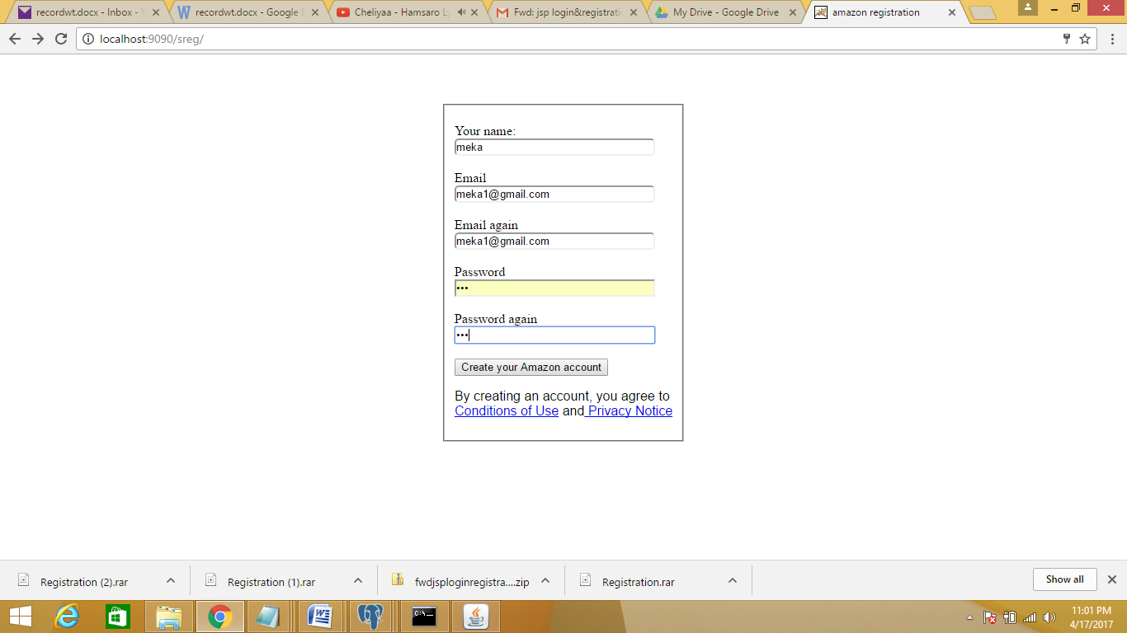

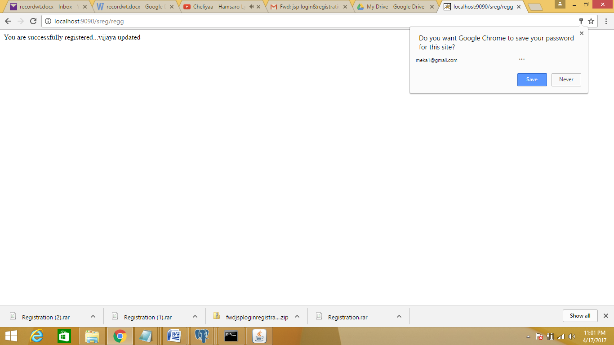

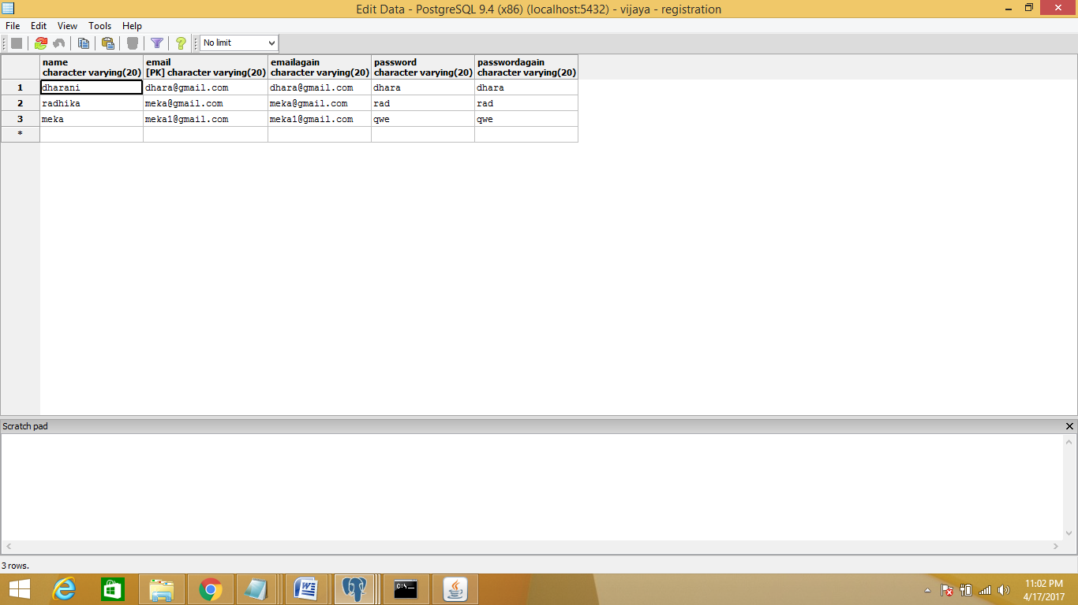

**b)Login: ( with single user)**

**Index.html**

<html>

<head>

<title>login page</title></head>

<body ><form action="./log" method="get">

<table align="center">

<h1><center><u>login</u></h1>

<tr><th>

Enter username:</th>

<td><input type="text" name="un" ></td>

</tr>

<th>Enter password:</th>

<td><input type="password" name="pwd" ></td>

<tr>

<th>

<input type="submit" value="login"></form>

</th>

<tr>

<th> new user???</th>

<td>

<form action="register.html"> <input type="submit" value="register"></form>

</td></tr>

</table>

</body>

</html>

**Web.xml**

<web-app>

<servlet>

<servlet-name> login</servlet-name>

<servlet-class>Log</servlet-class>

<init-param>

<param-name>user1_name</param-name>

<param-value>prashanthi</param-value>

</init-param>

<init-param>

<param-name>user1_pwd</param-name>

<param-value>prash</param-value>

</init-param>

</servlet>

<servlet-mapping>

<servlet-name> login</servlet-name>

<url-pattern>/log</url-pattern>

</servlet-mapping>

</web-app>

**Login.java**

import javax.servlet.http.*;

import javax.servlet.ServletException;

import javax.servlet.ServletConfig;

import java.io.*;

public class Log extends HttpServlet

{

public void init()

{

}

public void doGet(HttpServletRequest req,HttpServletResponse res)

throws ServletException,IOException

{

PrintWriter out=res.getWriter();

res.setContentType("text/html");

ServletConfig config=getServletConfig();

String a=config.getInitParameter("user1_name");

String b=config.getInitParameter("user1_pwd");

String name1=req.getParameter("un");

String pass1=req.getParameter("pwd");

out.println("<html><form>");

out.println("name:"+name1);

out.println("pass"+pass1);

if(a.equals(name1)&&b.equals(pass1))

{

out.println("login succssful</br> name:"+a+"</br>password:"+b+"</form></html>");

}

else

out.println("incorrect login details");

}

}

**Output:**

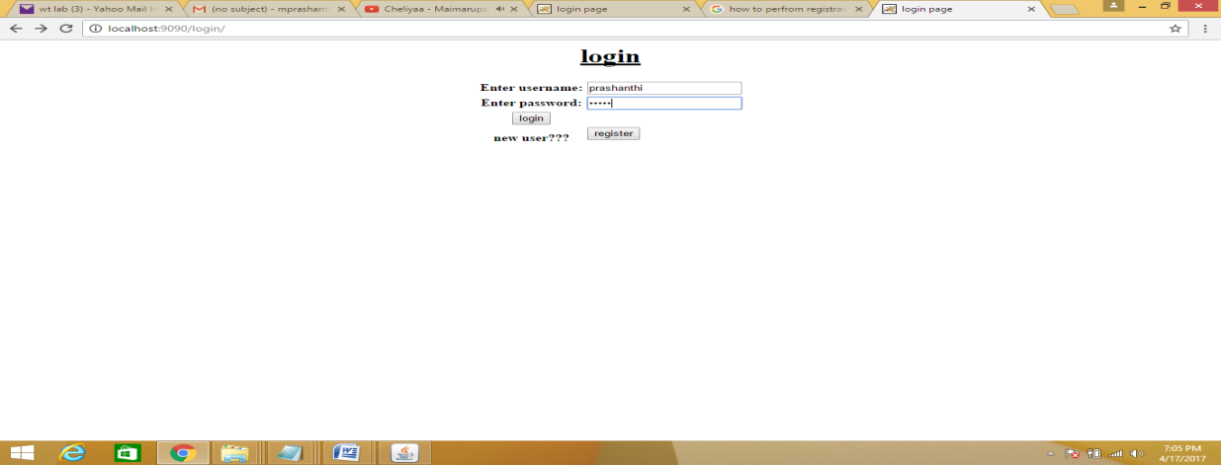 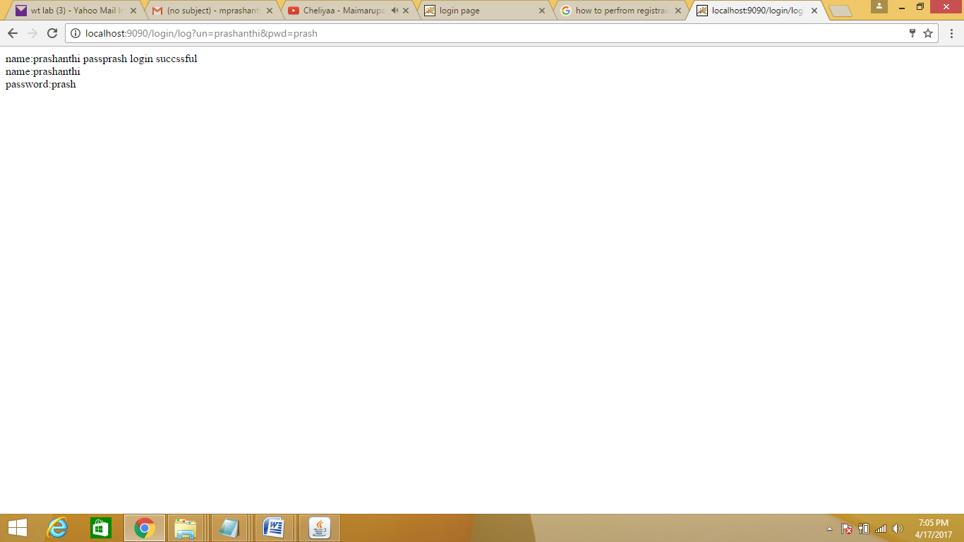

**Login: (with multiple users)**

**Index.html**

<html>

<head>

<title>login page</title></head>

<body ><form action="./logg" method="get">

<table align="center">

<h1><center><u>login</u></h1>

<tr><th>

Enter username:</th>

<td><input type="text" name="un" ></td>

</tr>

<th>Enter password:</th>

<td><input type="password" name="pwd" ></td>

<tr>

<th>

<input type="submit" value="login"></form>

</th>

<tr>

<th> new user???</th>

<td>

<form action="register.html"> <input type="submit" value="register"></form>

</td></tr>

</table>

</body>

</html>

**Web.xml**

<web-app>

<servlet>

<servlet-name> nlogin</servlet-name>

<servlet-class>Login_new</servlet-class>

<init-param>

<param-name>user1</param-name>

<param-value>prashanthi</param-value>

</init-param>

<init-param>

<param-name>user1_pwd</param-name>

<param-value>prash</param-value>

</init-param>

<init-param>

<param-name>user2</param-name>

<param-value>nishi</param-value>

</init-param>

<init-param>

<param-name>user2_pwd</param-name>

<param-value>prash</param-value>

</init-param>

<init-param>

<param-name>user3</param-name>

<param-value>meka</param-value>

</init-param>

<init-param>

<param-name>user3_pwd</param-name>

<param-value>prashanthi</param-value>

</init-param>

</servlet>

<servlet-mapping>

<servlet-name> nlogin</servlet-name>

<url-pattern>/logg</url-pattern>

</servlet-mapping>

</web-app>

**New_Login.java**

import javax.servlet.http.*;

import javax.servlet.ServletException;

import javax.servlet.ServletConfig;

import java.io.*;

public class Login_new extends HttpServlet

{

ServletConfig config;

public void init(ServletConfig config)

{

this.config=config;

}

public void doGet(HttpServletRequest req,HttpServletResponse res)

throws ServletException,IOException

{

PrintWriter out=res.getWriter();

res.setContentType("text/html");

java.util.Enumeration <String> e=config.getInitParameterNames();

String name1=req.getParameter("un");

String pass1=req.getParameter("pwd");

out.println("<html><form>");

int flag=0;

while(e.hasMoreElements())

{

String pn=e.nextElement();

String m=pn+"_pwd";

String pv=config.getInitParameter(pn);

String ne=config.getInitParameter(m);

if((pv.equals(name1))&&(ne.equals(pass1)))

{

out.println("name: "+pv);

out.println("pass: "+ne);

flag=1;

out.println("flag: "+flag);

}

}

if(flag==1)

{

out.println("login successful");

}

else

out.println("<br>incorrect login");

}

}

**Output:**

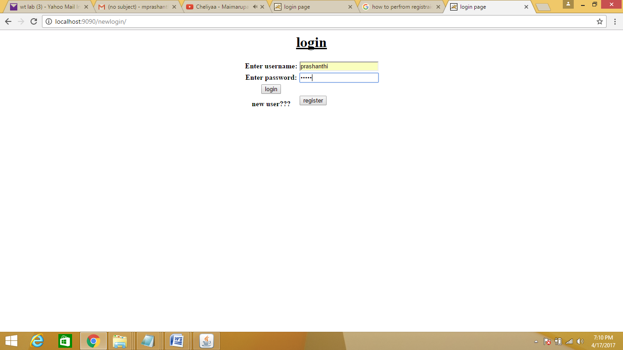 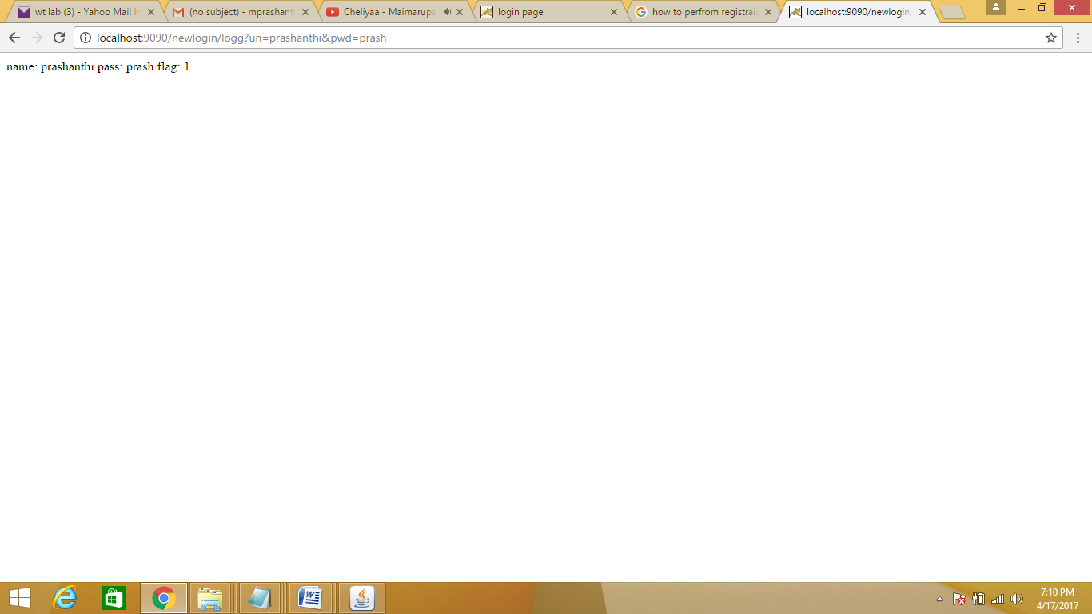 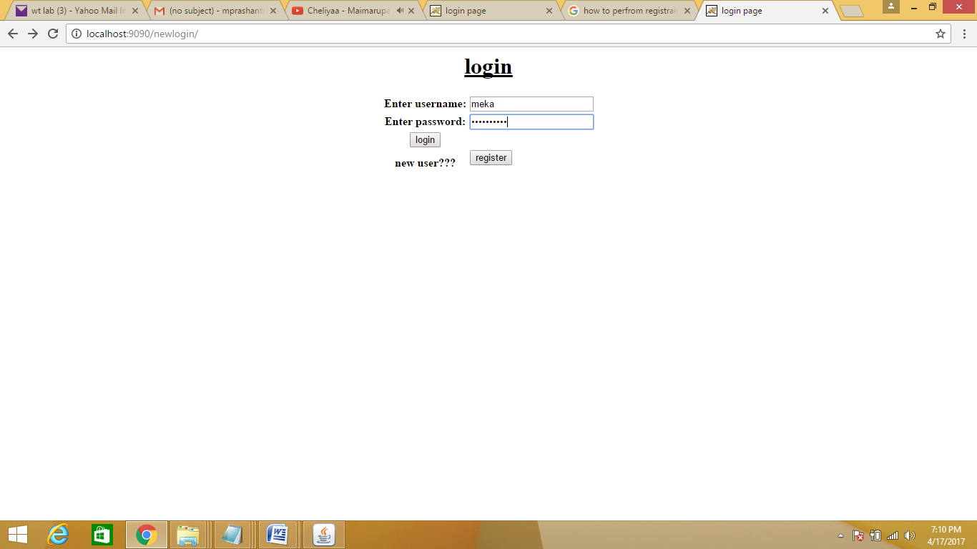 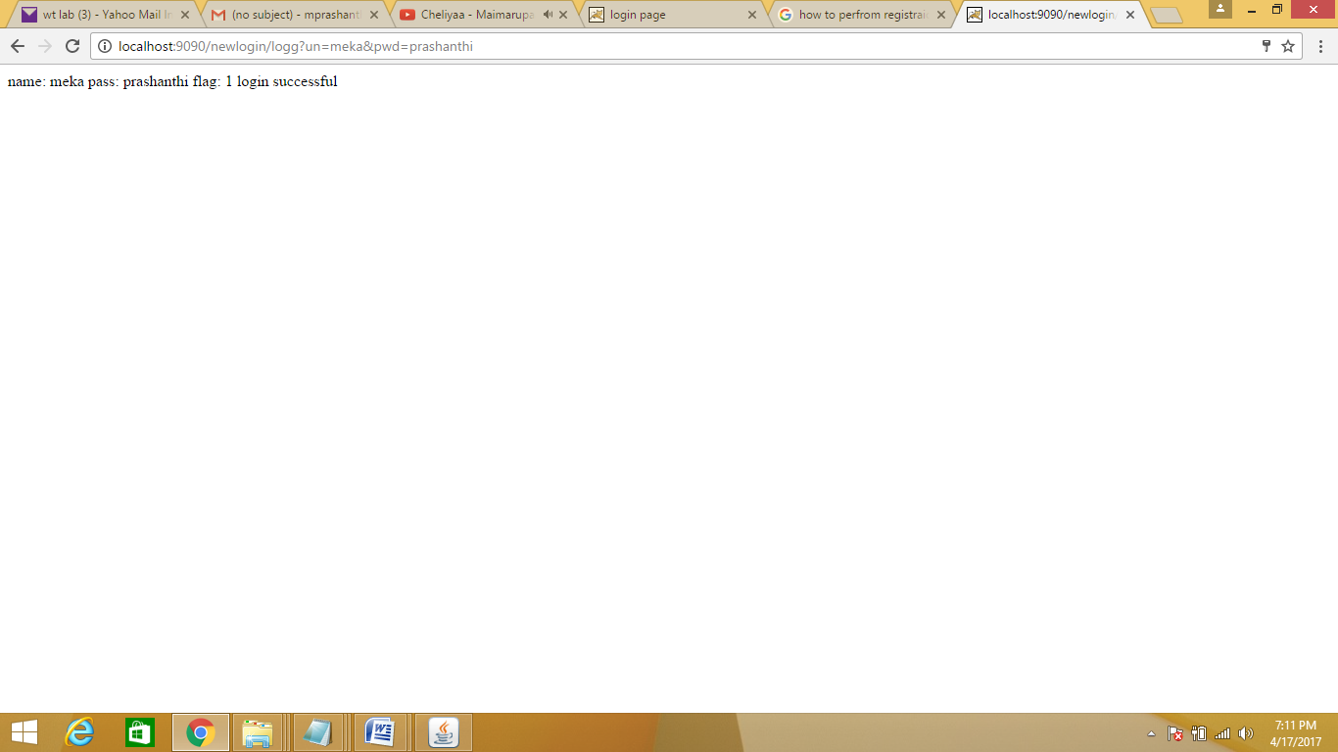

**Payment:**

**Index.html**

<!doctype html>

<html>

<head>

<title> payment</title>

<style>

text-align:center;

margin-top:10px;

text-align:center;

}

table{

border-style:solid;

text-align:center;

padding:20px;

height:200px;

}

input[type=button] {

padding: 12px 20px;

margin: 8px 0;

box-sizing: border-box;

border: none;

background-color: orange;

color: black;

border-radius:5px;

cursor:pointer;

}

input[type=text]{

border-radius:5px;

}

form {

display: inline-block;

text-align: center;

}

</style>

</head>

<body>

<br>

<p id="error"> </p>

<form action="./pay" method="get">

<p id="error"> </p>

<fieldset>

<p align=left>Your name:<br/>

<input type="text" name="uname" size="30" height="50"> <br/><br>

enter amount:<br/>

<input type="text" name="amt"n size="30"><br/><br>

card number<br/>

<input type="text" name="cn" size="30"><br/><br>

cvv<br/>

<input type="text" name="cvv" size="30"><br/><br>

pin<br/>

<input type="password" name="pin" size="30"><br/><br>

re-pin<br/>

<input type="password" name="rpin" size="30"><br/><br>

<input type="submit" value="submit card details" onClick="return val()"><br/></a>

<p align="left" style="font-family:Sans-Serif">By submitting, you agree to <br/>

<a href="terms and condition.html">Conditions of Use</a>

and<a href="privacynotice.html"> Privacy Notice</a>

</p>

</fieldset>

<script>

function val()

{

var name= document.getElementById("uname").value;

var cn= document.getElementById("cn").value;

var cvv= document.getElementById("cvv").value;

var pin= document.getElementById("pin").value;

var rpin= document.getElementById("rpin").value;

if(name=="")

{

document.getElementById("error").innerHTML="Enter ur name";

return false;

}

else if(cn==""||cvv=="")

{

document.getElementById("error").innerHTML="Enter ur card no.<br> card number and cvv are compulsory";

return false;

}

else if(pin=="")

{

document.getElementById("error").innerHTML="Enter ur pin";

return false;

}

}

}

</script>

</form>

</body>

</html>

**Web.xml**

<web-app>

<servlet>

<servlet-name>pay</servlet-name>

<servlet-class>Payment</servlet-class>

<init-param>

<param-name>user1</param-name>

<param-value>prashanthi</param-value>

</init-param>

<init-param>

<param-name>user1_cardno</param-name>

<param-value>1234567890123456</param-value>

</init-param>

<init-param>

<param-name>user1_cvv</param-name>

<param-value>345</param-value>

</init-param>

<init-param>

<param-name>user1_pin</param-name>

<param-value>1234</param-value>

</init-param>

<init-param>

<param-name>user1_rpin</param-name>

<param-value>1234</param-value>

</init-param>

<init-param>

<param-name>user2</param-name>

<param-value>nishi</param-value>

</init-param>

<init-param>

<param-name>user2_cardno</param-name>

<param-value>9876543210987654</param-value>

</init-param>

<init-param>

<param-name>user2_cvv</param-name>

<param-value>123</param-value>

</init-param>

<init-param>

<param-name>user2_pin</param-name>

<param-value>9876</param-value>

</init-param>

<init-param>

<param-name>user2_rpin</param-name>

<param-value>9876</param-value>

</init-param>

<init-param>

<param-name>user3</param-name>

<param-value>meka</param-value>

</init-param>

<init-param>

<param-name>user3_cardno</param-name>

<param-value>1212121212121212</param-value>

</init-param>

<init-param>

<param-name>user3_cvv</param-name>

<param-value>222</param-value>

</init-param>

<init-param>

<param-name>user3_pin</param-name>

<param-value>9999</param-value>

</init-param>

<init-param>

<param-name>user3_rpin</param-name>

<param-value>9999</param-value>

</init-param>

</servlet>

<servlet-mapping>

<servlet-name> pay</servlet-name>

<url-pattern>/pay</url-pattern>

</servlet-mapping>

</web-app>

**Payment.java**

import javax.servlet.http.*;

import javax.servlet.ServletException;

import javax.servlet.ServletConfig;

import java.io.*;

public class Payment extends HttpServlet

{

ServletConfig config;

public void init(ServletConfig config)

{

this.config=config;

}

public void doGet(HttpServletRequest req,HttpServletResponse res)

throws ServletException,IOException

{

PrintWriter out=res.getWriter();

res.setContentType("text/html");

java.util.Enumeration <String> e=config.getInitParameterNames();

String name1=req.getParameter("uname");

//String pass1=req.getParameter("pwd");

String card=req.getParameter("cn");

String vcc=req.getParameter("cvv");

String pi=req.getParameter("pin");

String rpi=req.getParameter("rpin");

out.println("<html><form>");

int flag=0;

while(e.hasMoreElements())

{

String pn=e.nextElement();

String m=pn+"_pwd";

String cn=pn+"_cardno";

String cvv=pn+"_cvv";

String pin=pn+"_pin";

String rpin=pn+"_rpin";

String pv=config.getInitParameter(pn);

String ne=config.getInitParameter(cn);

String s=config.getInitParameter(cvv);

String t=config.getInitParameter(pin);

String u=config.getInitParameter(rpin);

if((pv.equals(name1))&&(ne.equals(card))&&(s.equals(vcc))&&(t.equals(pi))&&(u.equals(rpi)))

{

out.println("name: "+pv);

//out.println("pass: "+ne);

flag=1;

out.println("flag: "+flag);

}

}

if(flag==1)

{

out.println("transaction complete");

}

else

out.println("<br>incorrect details");

}

}

**Output:**

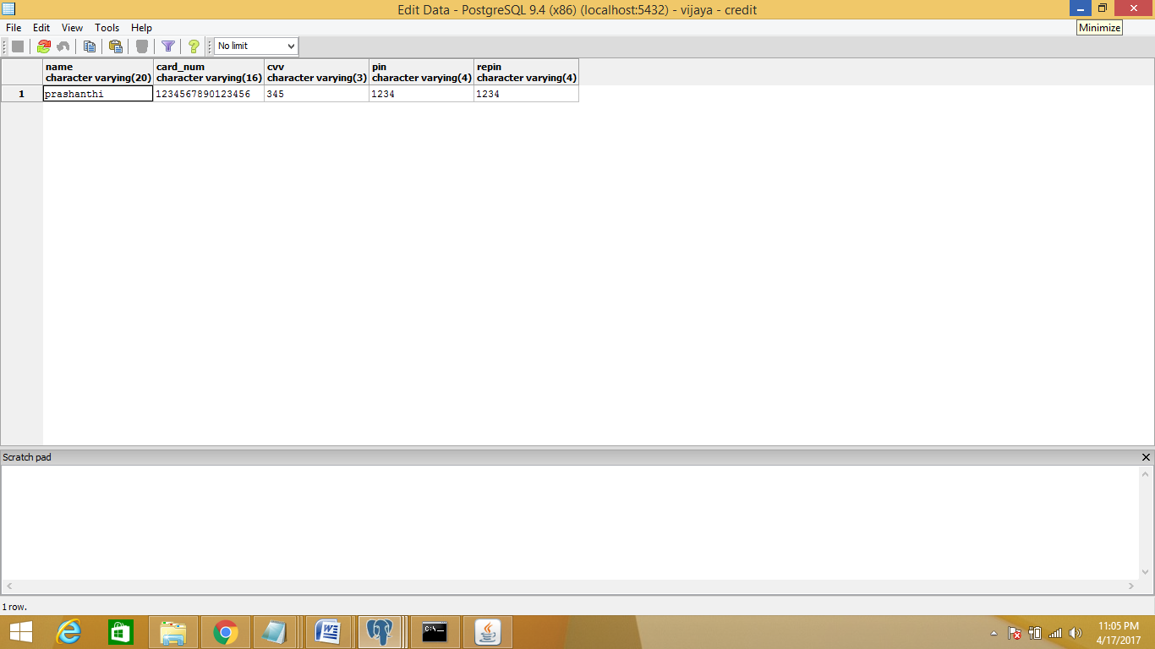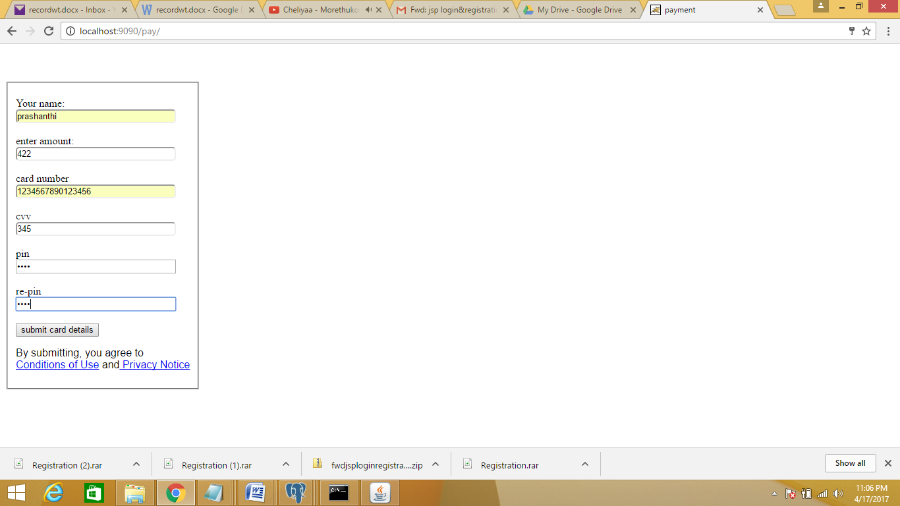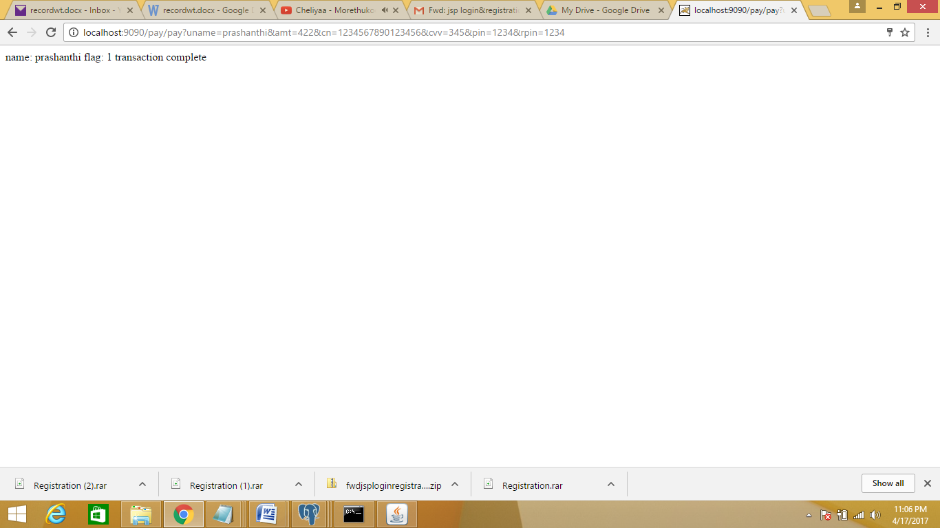

**6.Redo the previous task using JSP by converting the static webpages of assignments 2 into dynamic web pages. Create a databasewith user information and books information. The books catalogueshould be dynamically loaded from the database. Follow the MVC architecture while doing the website**.

**a)Registration**

**Register.html**

<!doctype html>

<html>

<head>

<title> amazon registration</title>

<style>

body{

text-align:center;

margin-top:10px;

text-align:center;

}

table{

border-style:solid;

text-align:center;

padding:20px;

height:200px;

}

input[type=button] {

padding: 12px 20px;

margin: 8px 0;

box-sizing: border-box;

border: none;

background-color: orange;

color: black;

border-radius:5px;

cursor:pointer;

}

input[type=text]{

border-radius:5px;

}

form {

display: inline-block;

text-align: center;

}

</style>

</head>

<body>

<a href="https://www.amazon.com/ref=ap_frn_logo" ><img src="C:\Users\Dell\Desktop\HTML\amazon logo.png" alt="amazon"></a>

<br>

<p id="error"> </p>

<form action="registration.jsp" method="post">

<p id="error"> </p>

<fieldset>

<p align=left>Your name:<br/>

<input type="text" name="uname" size="30" height="50"> <br/><br>

Email<br/>

<input type="text" name="em" size="30"><br/><br>

Email again<br/>

<input type="text" name="emagn" size="30"><br/><br>

Password<br/>

<input type="password" name="pwd" size="30"><br/><br>

Password again<br/>

<input type="password" name="pwdagn" size="30"><br/><br>

<input type="submit" value="Create your Amazon account" bgcolor="orange" onClick="return val()"><br/></a>

<p align="left" style="font-family:Sans-Serif">By creating an account, you agree to Amazon.com's<br/>

<a href="terms and condition.html">Conditions of Use</a>

and<a href="privacynotice.html"> Privacy Notice</a>

</p>

</fieldset>

<script>

function val()

{

var name= document.getElementById("uname").value;

var em= document.getElementById("em").value;

var emagn= document.getElementById("emagn").value;

var pwd= document.getElementById("pwd").value;

var pwdagn= document.getElementById("pwdagn").value;

if(name=="")

{

document.getElementById("error").innerHTML="Enter ur name";

return false;

}

else if(em==""||emagn=="")

{

document.getElementById("error").innerHTML="Enter ur email<br> Email and Emailagain should be same";

return false;

}

else if(pwd=="")

{

document.getElementById("error").innerHTML="Enter ur password";

return false;

}

}

}

</script>

</form>

</body>

</html>

**Registration.jsp**

<%@ page import="java.sql.*" %>

<%@ page import="java.io.*" %>

<html>

<head>

<title> jsp page </title>

</head>

<h1>jsp page</h1>

<%

String n=request.getParameter("uname");

String e=request.getParameter("em");

String ea=request.getParameter("emagn");

String p=request.getParameter("pwd");

String pa=request.getParameter("pwdagn");

try

{

Class.forName("org.postgresql.Driver");

Connection con=DriverManager.getConnection(

"jdbc:postgresql://localhost:5432/vijaya","postgres","prashanthi");

PreparedStatement ps=con.prepareStatement(

"insert into registration values(?,?,?,?,?)");

ps.setString(1,n);

ps.setString(2,e);

ps.setString(3,ea);

ps.setString(4,p);

ps.setString(5,pa);

int i=ps.executeUpdate();

PreparedStatement ps1=con.prepareStatement(

"insert into vijaya values(?,?)");

ps1.setString(1,n);

ps1.setString(2,p);

int k=ps1.executeUpdate();

if(i>0)

{

out.print("You are successfully registered...");

//response.sendRedirect("Login.html");

}

if(k>0)

{

out.println("vijaya updated");

}

}

catch(Exception er)

{

out.println(er);

er.printStackTrace();

}

out.close();

%>

</html>

**Output:** 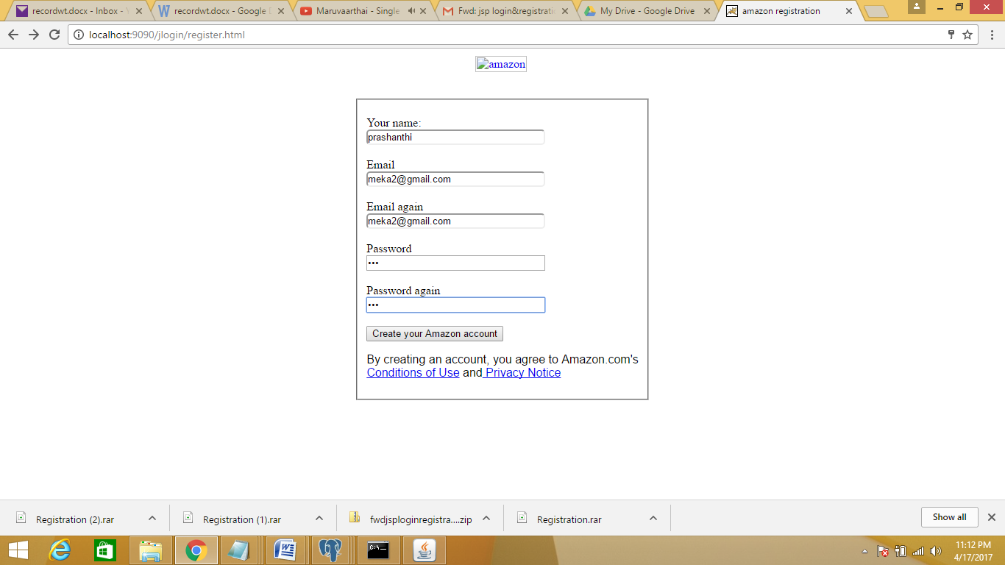

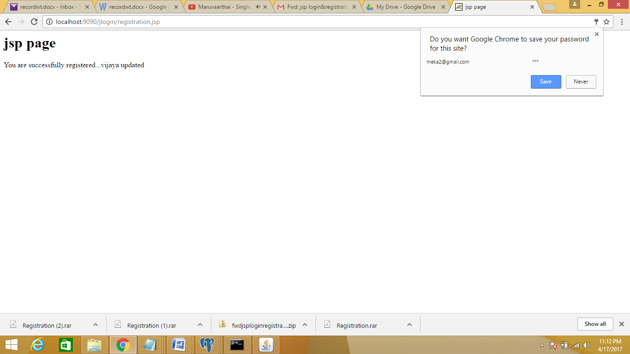

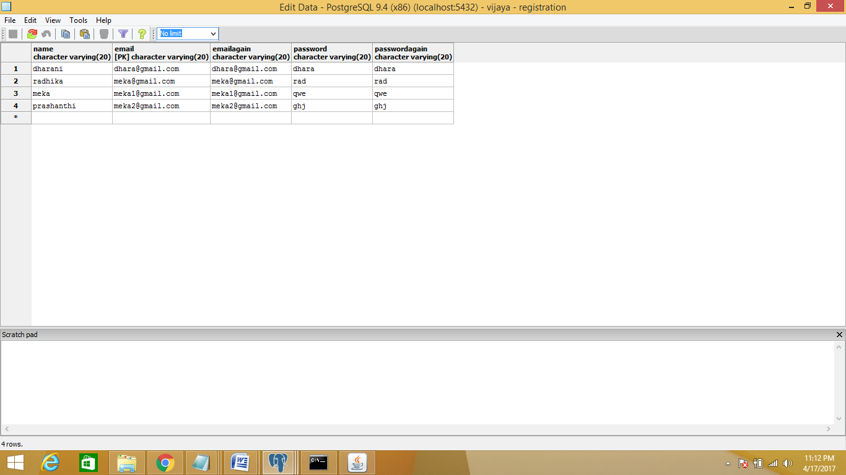

**b)login**

**login.html**

<html>

<head>

<style type="text/css">

body{background-image:;}</style>

<center><h1>LOGIN PAGE</h1></center>

</head>

<body bgcolor="lightblue" textcolor="darkblue">

<br><br><br><br><br><br>

<center>

<form name="log" action="login.jsp" method="post">

<table rows="3" cols="3" border="1">

<tr>

<td>

<h2>Login name</h2></td>

<td>

<input type="text" name="login"/>

</td>

</tr>

<tr>

<td>

<h2>Password</h2></td>

<td>

<input type="password" name="password"/>

</td></tr>

</table>

<br><br>

<input type="submit" value="Enter"> &#160 &#160

<input type="button" value="cancel">

<br><br><br>

<a href="register.html><h3>register now!</h3></a>

</form>

</center>

<body>

</html>

**login.jsp**

<%@ page import="java.sql.*" %>

<%@ page import="java.io.*" %>

<html>

<head>

<title> jsp page </title>

</head>

<h1>jsp page</h1>

<%

int flag=0;

String username=request.getParameter("login");

String password=request.getParameter("password");

try

{

Class.forName("org.postgresql.Driver");

Connection con=DriverManager.getConnection(

"jdbc:postgresql://localhost:5432/vijaya","postgres","prashanthi");

Statement ps=con.createStatement();

ResultSet rs=ps.executeQuery("select username,password from vijaya");

out.println("Resulye set executed");

while(rs.next())

{

if((rs.getString(1).equals(username)) && (rs.getString(2).equals(password)))

{

flag=1;

}

}

if(flag==1)

{

out.println("valid user");

}

else

{ out.println("Invalid User");

}

}

catch(Exception e)

{

out.println(e);

e.printStackTrace();

}

out.close();

%>

</html>

**Output:**

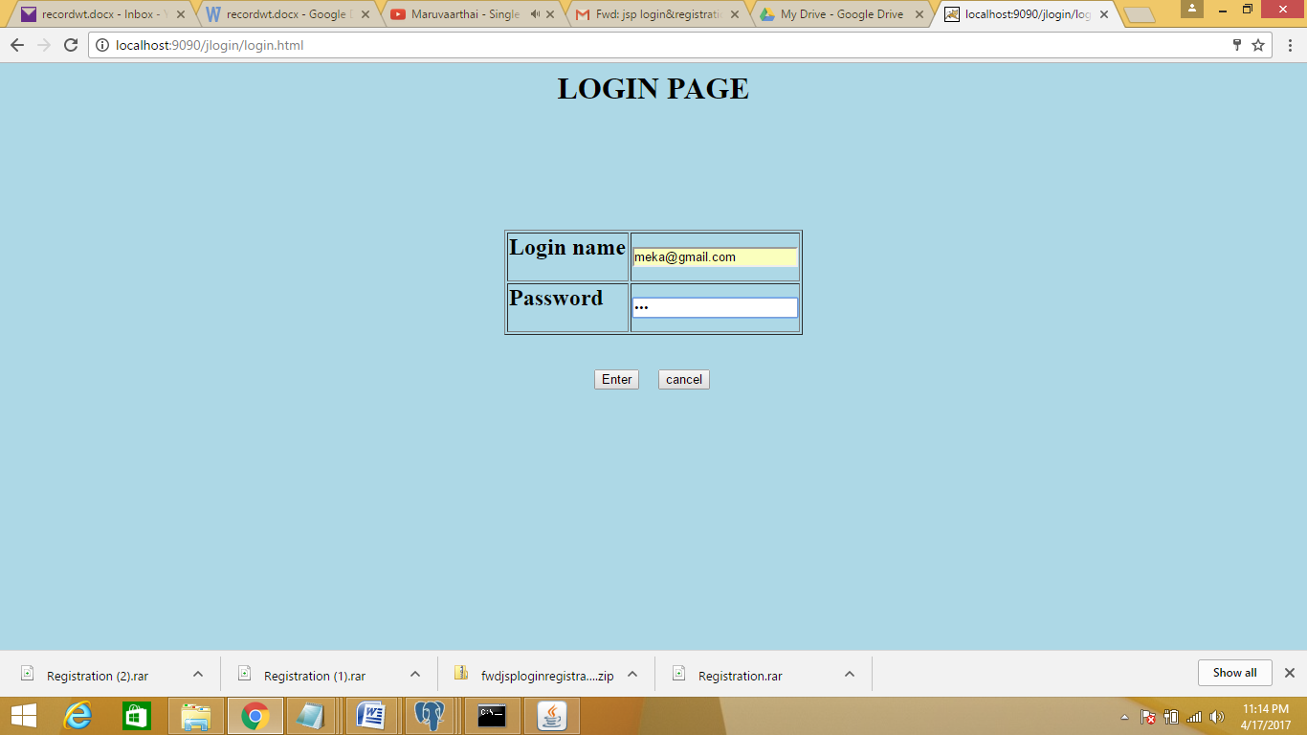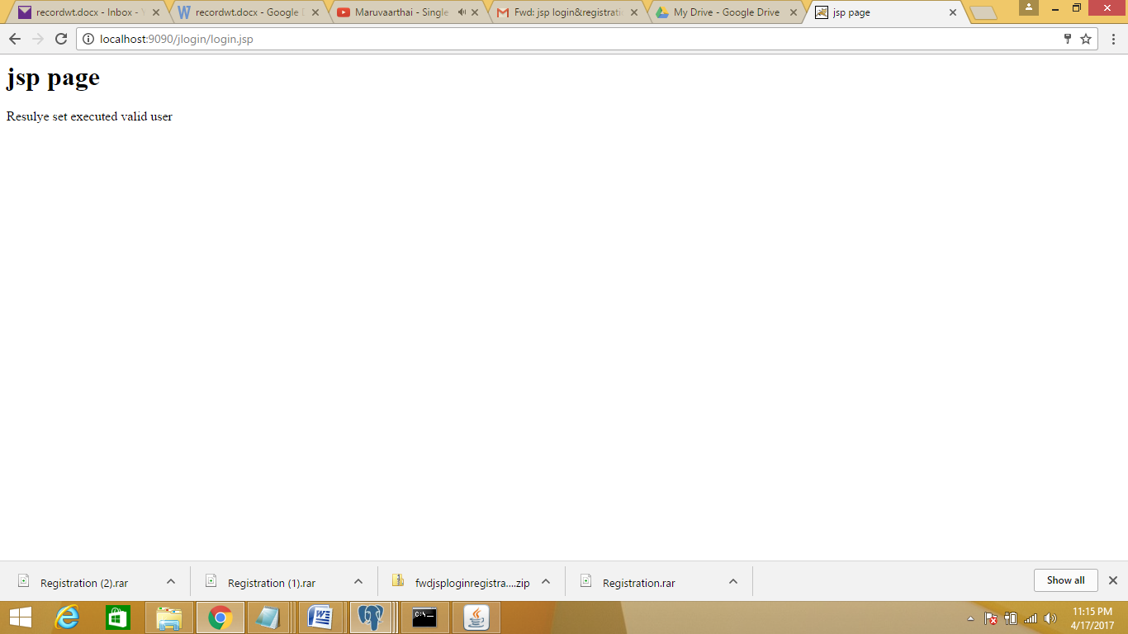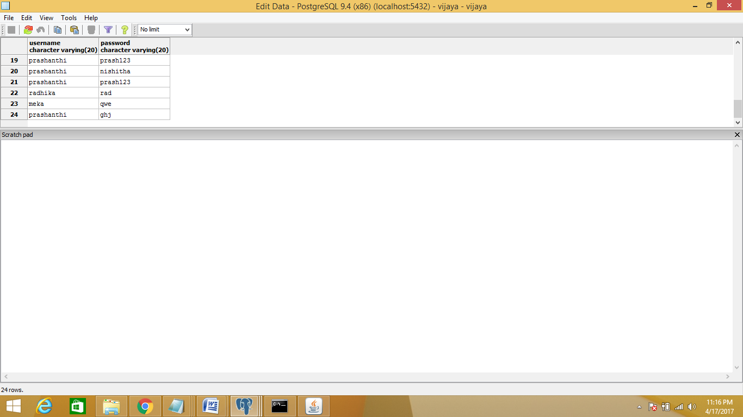

**c)payment**

**payment.html**

<!doctype html>

<html>

<head>

<title> payment</title>

<style>

body{

text-align:center;

margin-top:10px;

text-align:center;

}

table{

border-style:solid;

text-align:center;

padding:20px;

height:200px;

}

input[type=button] {

padding: 12px 20px;

margin: 8px 0;

box-sizing: border-box;

border: none;

background-color: orange;

color: black;

border-radius:5px;

cursor:pointer;

}

input[type=text]{

border-radius:5px;

}

form {

display: inline-block;

text-align: center;

}

</style>

</head>

<body>

<a href="https://www.amazon.com/ref=ap_frn_logo" ></a>

<br>

<p id="error"> </p>

<form action="payment.jsp" method="post">

<p id="error"> </p>

<fieldset>

<p align=left>Your name:<br/>

<input type="text" name="uname" size="30" height="50"> <br/><br>

enter amount:<br/>

<input type="text" name="amt"n size="30"><br/><br>

card number<br/>

<input type="text" name="cn" size="30"><br/><br>

cvv<br/>

<input type="text" name="cvv" size="30"><br/><br>

pin<br/>

<input type="password" name="pin" size="30"><br/><br>

re-pin<br/>

<input type="password" name="rpin" size="30"><br/><br>

<input type="submit" value="submit card details" onClick="return val()"><br/></a>

<p align="left" style="font-family:Sans-Serif">By submitting, you agree to <br/>

<a href="terms and condition.html">Conditions of Use</a>

and<a href="privacynotice.html"> Privacy Notice</a>

</p>

</fieldset>

<script>

function val()

{

var name= document.getElementById("uname").value;

var cn= document.getElementById("cn").value;

var cvv= document.getElementById("cvv").value;

var pin= document.getElementById("pin").value;

var rpin= document.getElementById("rpin").value;

if(name=="")

{

document.getElementById("error").innerHTML="Enter ur name";

return false;

}

else if(cn==""||cvv=="")

{

document.getElementById("error").innerHTML="Enter ur card no.<br> card number and cvv are compulsory";

return false;

}

else if(pin=="")

{

document.getElementById("error").innerHTML="Enter ur pin";

return false;

}

}

}

</script>

</form>

</body>

</html>

**Payment.jsp**

<%@ page import="java.sql.*" %>

<%@ page import="java.io.*" %>

<html>

<head>

<title> jsp page </title>

</head>

<h1>jsp page</h1>

<%

int flag=0;

String username=request.getParameter("uname");

String cardno=request.getParameter("cn");

String cvv=request.getParameter("cvv");

String pin=request.getParameter("pin");

String rpin=request.getParameter("rpin");

try

{

Class.forName("org.postgresql.Driver");

Connection con=DriverManager.getConnection(

"jdbc:postgresql://localhost:5432/vijaya","postgres","prashanthi");

Statement ps=con.createStatement();

ResultSet rs=ps.executeQuery("select * from credit");

out.println("Resulye set executed");

while(rs.next())

{

if((rs.getString(1).equals(username)) && (rs.getString(2).equals(cardno))&& (rs.getString(3).equals(cvv))&& (rs.getString(4).equals(pin))&& (rs.getString(5).equals(rpin)))

{

flag=1;

}

}

if(flag==1)

{

out.println("transaction succesful");

}

else

{ out.println("Invalid User");

}

}

catch(Exception e)

{

out.println(e);

e.printStackTrace();

}

out.close();

%>

</html>

**Output:**

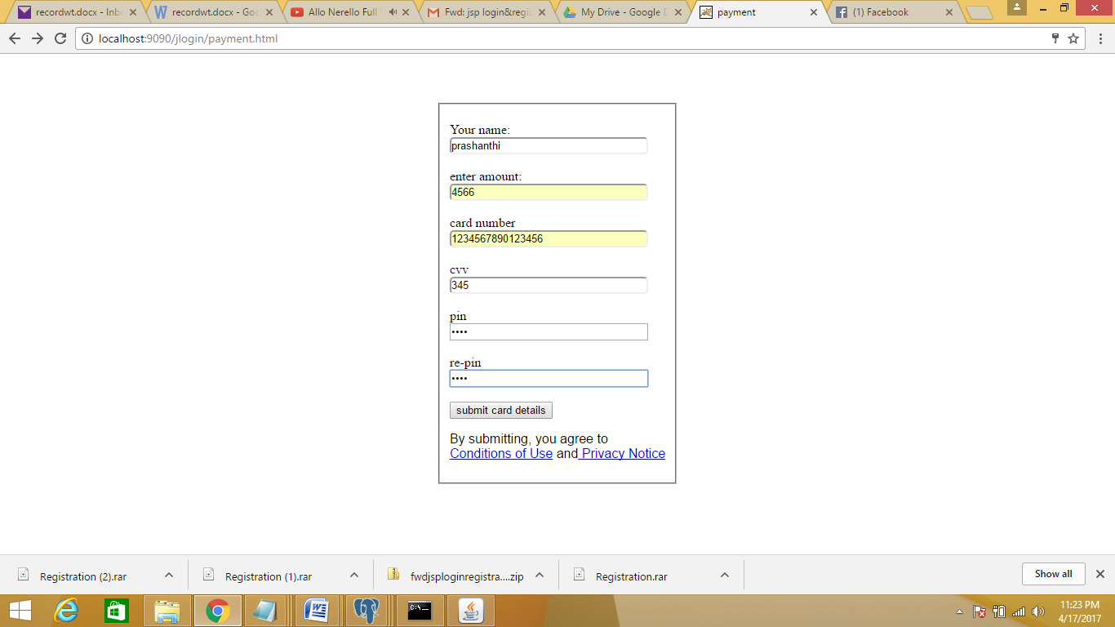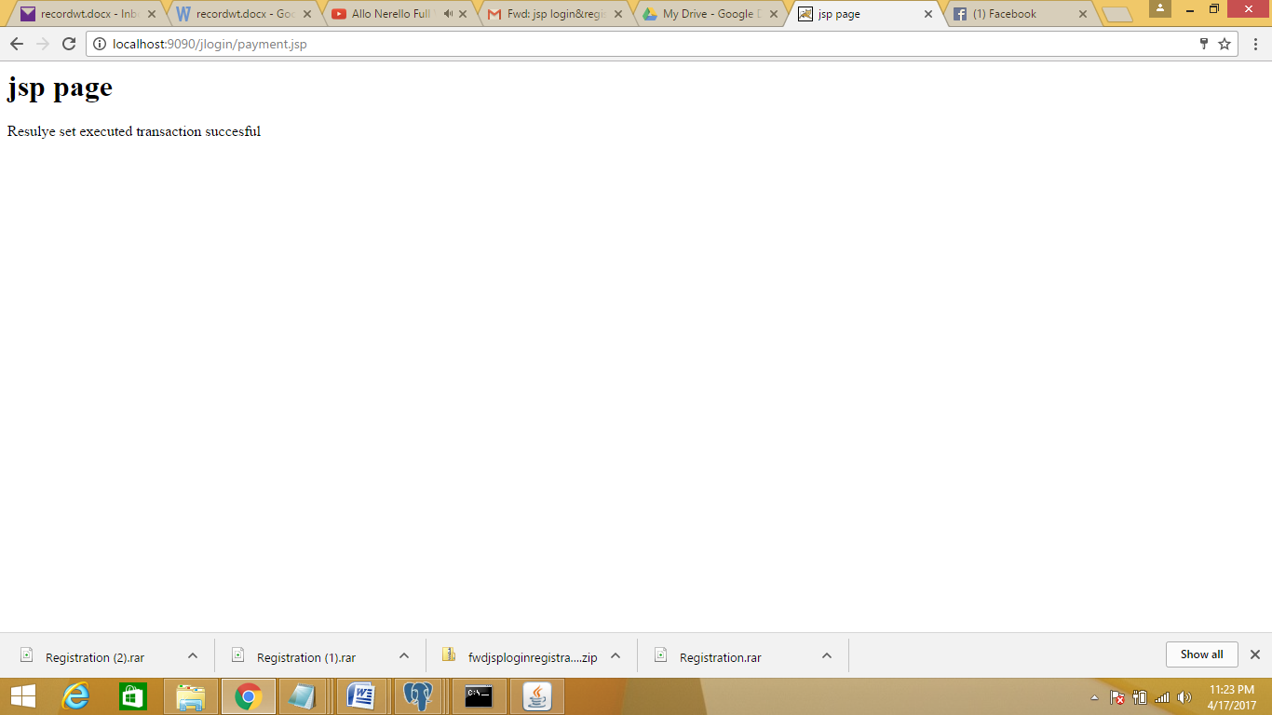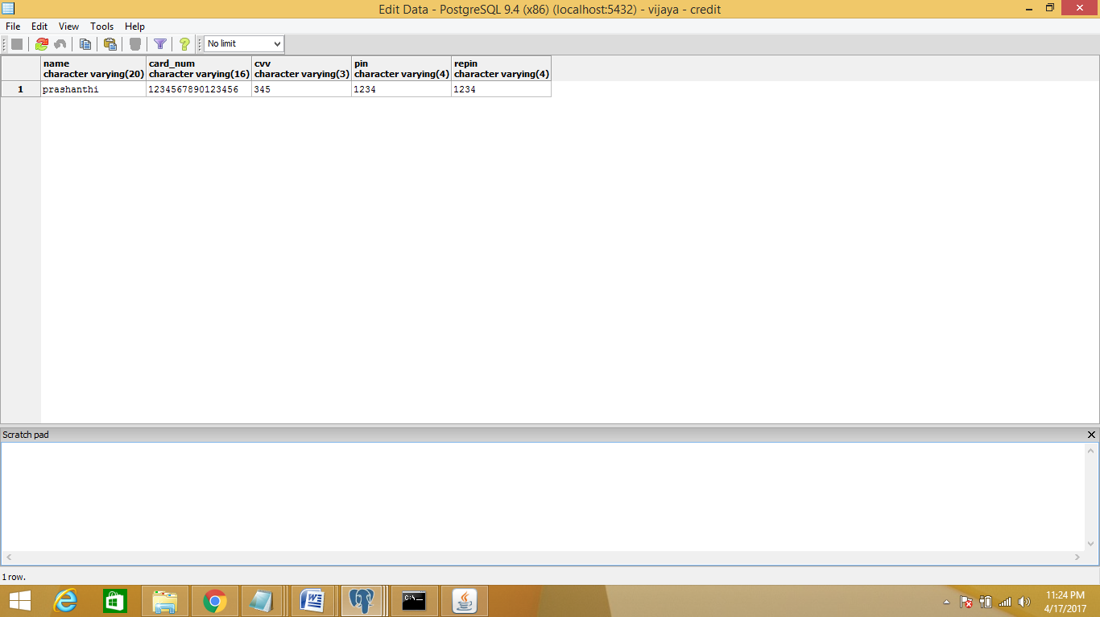

WT MINI PROJECT

**Furniture.html**

<!doctype html>

<html>

<style>

body{

background:url("bg2.png");

background-size:cover;

}

a:link

color:cyan;

background-color:transparent;

text-decoration:none;

}

a:visited

{

color:red;

background-color:transparent;

text-decoration:none;

}

a:hover

{

color:cyan;

background-color:transparent;

text-decoration:none;

}

a:active

{

color:red;

background-color:transparent;

text-decoration:none;

}

</style>

<body>

<h1 align="center" style="color:green"><i>WELCOME</i></h1><hr>

<marquee><h2 style="color=black">Welcome to FURNITURE FOR YOU</h2></marquee>

<h3 style="background-color:black;color:white;" align="center">

<a href="register.html">Register </a>&nbsp &nbsp &nbsp &nbsp <a href="logg.html">Login</a>&nbsp &nbsp &nbsp &nbsp

<a href="aboutus.html">About us</a>&nbsp &nbsp &nbsp &nbsp

<a href="contactus.html">Contact us</a>&nbsp &nbsp &nbsp &nbsp

<a href="feedback.html">Feedback</a>&nbsp &nbsp &nbsp &nbsp

<a href="cart.jsp">cart</a>&nbsp &nbsp &nbsp &nbsp

<a href="logout.jsp">logout</a>

</h3>

<br><br>

<table align="center"><tr><th><font size="5">Select Category: </font></th></tr>

<tr><td></td><td><a href="living.html" ><font size="5"><img src="livingroom.jpg" alt="unsupported version" style="width:304px;height=300px;"></br>Living room</font></a></td>

<td></td><td><a href="dining.html" ><font size="5"><img src="dining.jpg" alt="unsupported version" style="width:304px;height=300px;"></br>Dining</font></a></td></tr>

<tr><td></td><td><a href="bedroom.html" ><font size="5"><img src="bdroom.jpg" alt="unsupported version" style="width:304px;height=350px;"></br>Bedroom</font></a></td>

<td></td><td><a href="Studyroom1.html" ><font size="5"><img src="studyroom.jpg" alt="unsupported version" style="width:304px;height=300px;"></br>Study room</font></a></td></tr>

<tr><td></td><td><a href="romantic.html" ><font size="5"><img src="kidsroom.jpg" alt="unsupported version" style="width:304px;height=300px;"></br>Kids room</font></a></td>

<td></td><td><a href="others.html" ><font size="5"><img src="others.jpg" alt="unsupported version" style="width:304px;height=300px;"></br>Others</font></a></td></tr></tr></table>

<br><br><br>

</body>

</html>

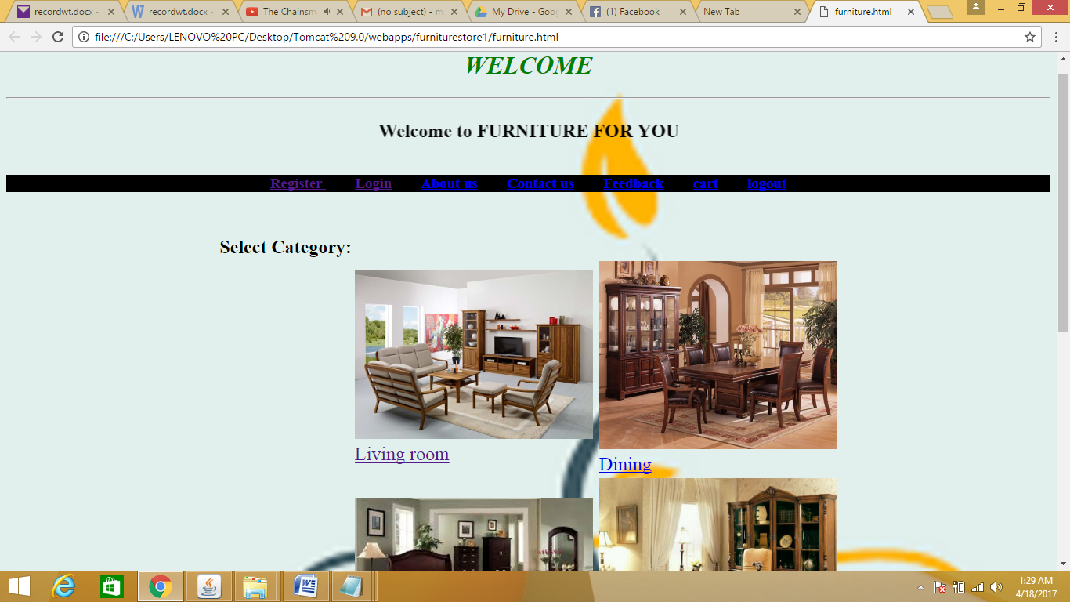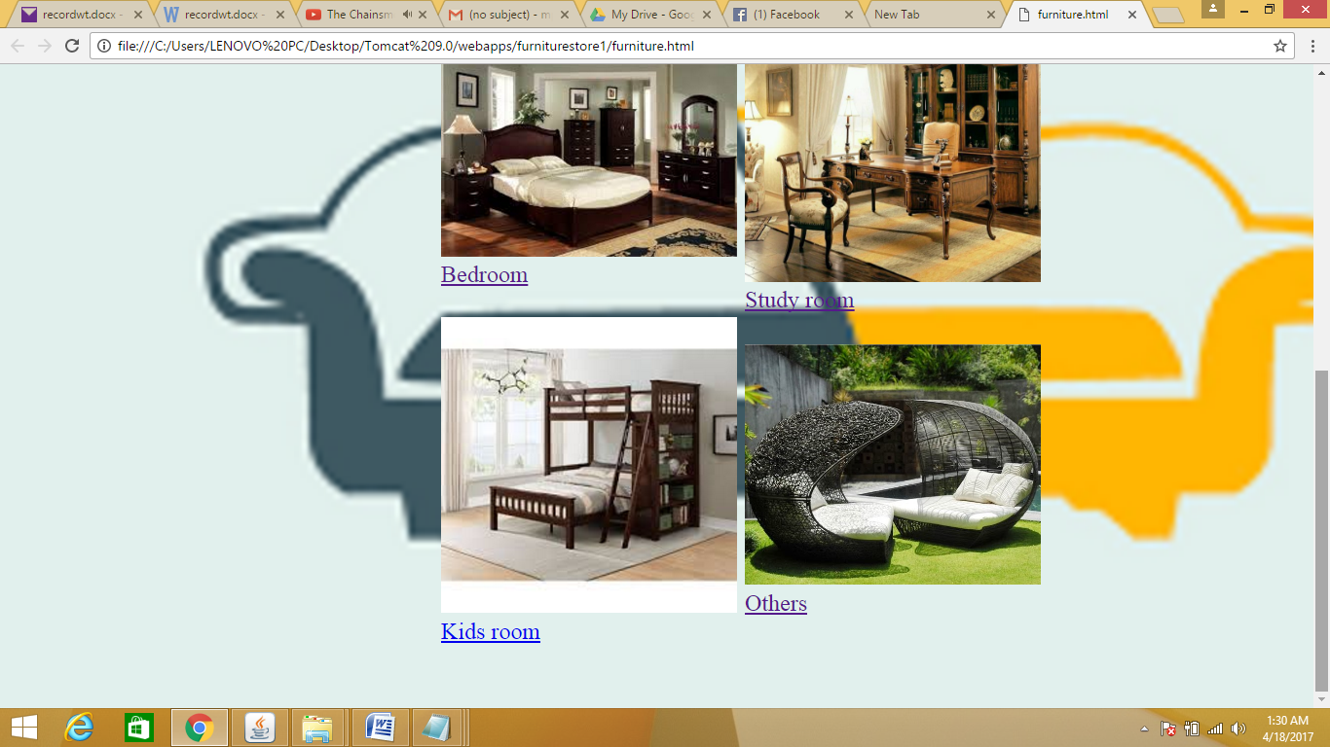

**Aboutus.html**

<html>

<body style="background-color:bisque">

<h1 align="center" style="color:crimson">More Information <i>Aboutus</i></h1>

<h2 style="color:blueviolet">#1:What is "FURNITURE FOR YOU"?</h2>

<img src="about-us-icon.png" align ="right" style="width:500px;height:200px;">

=>Book_your_book.com is an online furnituretore that helps you to view and buy furniture of different categories.<br>

=>This website is available for users all over India.<br>

=>It is originated from the idea that readers would buy their required furniture online.<br>

=>FFU is fulfilling the needs of its users by easy access and direct contact with the website.<br>

<h2 style="color:blueviolet">#2:Easy Buy</h2>

=>FFU gives complete details and reviews about the book .<br>

=>FFU is an easy way to get your required book with amazing discounts and offers .<br>

=>FFU asks for no extra charges(shipping,taxes) .<br>

<h2 style="color:blueviolet">#3:Team</h2>

=>Founders and Developers:<br>

K.Nishitha<br>

M.Prashanthi<br>

V.Swathi<br>

R.Dharani<br>

Esther

<h2 style="color:blueviolet">#4:Privacy Policy</h2>

=>The website www.FURNITUREFORU.com is owned and maintained by a private third party company.<br>

=>All the information available in our website is subjected to creators and google furniture.<br>

=>The visitors details provided to us is kept completely confidential.<br>

=>FFU doesnot ask for any personal information on or off the website.Please donot respond to such kind of illegal acts.

<h2 style="color:blueviolet">#5:Terms of use</h2>

=>By registering with us you have read and agree with the terms and conditions given by the founders.<br>

=>Website doesnot support for any third party advertisements.<br>

=>We are not responsible for such irrelevant information.<br>

</body>

</html>

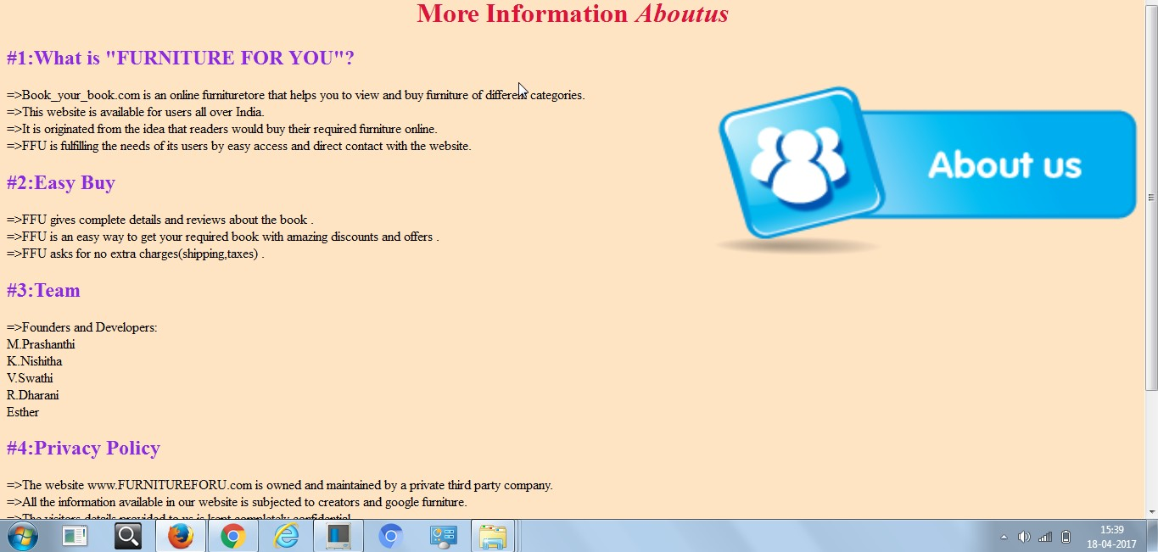

**Contactus.html**

<html>

<body>

<style>

body{

background:url("contact1.jpg");

background-size:cover;

}

a:link

{

text-decoration:none;}

</style>

<h1 align="center" style="color:indigo"><i>CONNECT</i></h1>

<h2 style="color:red">Mail us :</h2>

<img src="gmail.png" style="width:40px;height:40px">&nbsp &nbsp <a href="https://accounts.google.com/ServiceLogin?service=mail&passive=true&rm=false&continue=https://mail.google.com/mail/&ss=1&scc=1&ltmpl=default&ltmplcache=2&emr=1&osid=1#identifier"> www.onlinebooks@bookyourbook.in</a><br>

<h2 style="color:blue">Contact us :</h2>

<img src="call.jpg" style="width:40px;height:40px">&nbsp &nbsp

<b>040-23456789</b>

<h2 style="color:limegreen">Whatsapp at :</h2>

<img src="wa.jpg" style="width:40px;height:40px">&nbsp &nbsp

<b>+91 9876543210</b>

<h2 style="color:darkslateblue">Like our page :</h2>

<img src="fb1.jpg" style="width:40px;height:40px">&nbsp &nbsp <a href="https://www.facebook.com/Book_your_book?fref=ts">Book your book</a><br>

<h2>Follow on :</h2>

<img src="twitter.png" style="width:40px;height:40px">&nbsp &nbsp <a href="https://twitter.com/">Book your book</a><br>

<h2 style="color:royalblue">Find us at :</h2>

<img src="loc.jpg" style="width:40px;height:40px">

<p><pre>

6-3-354/1,

Shop No. A/B,

Nagarjuna Circle Road,

Road No.1,

Punjagutta,

Hyderabad,

Telangana

Zipcode-500034

</pre></p>

</body>

</html>

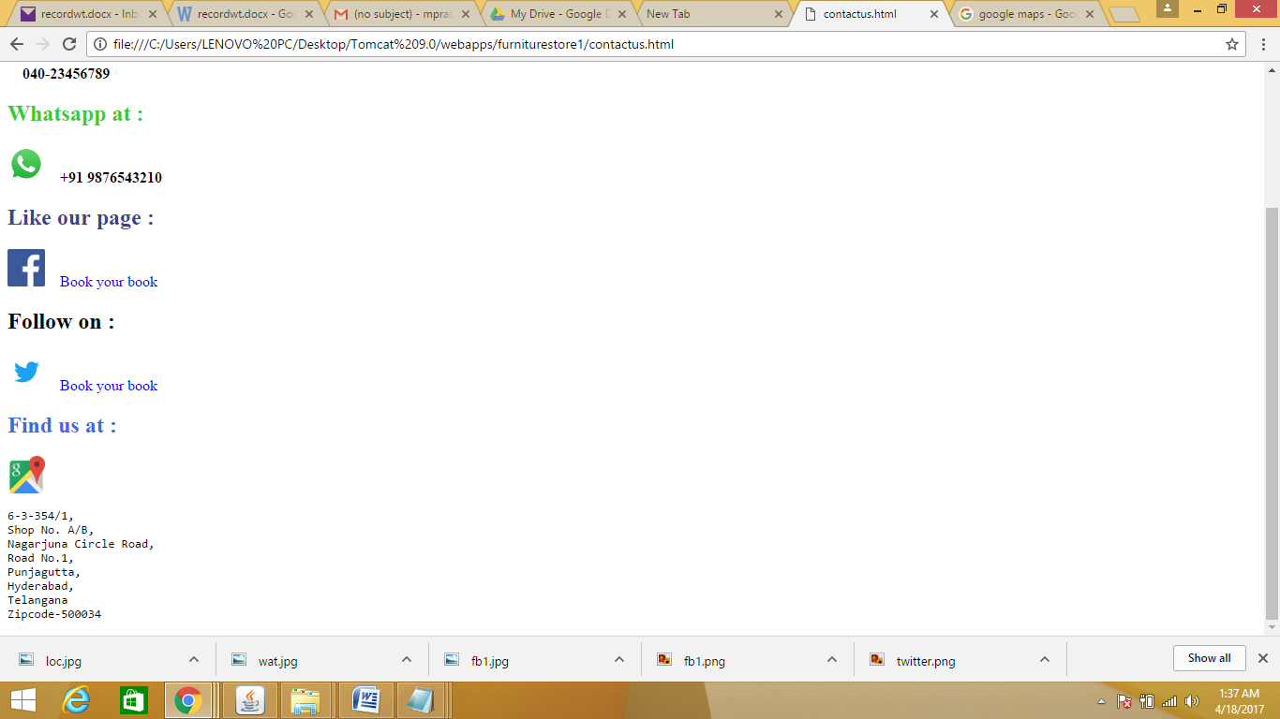

**Feedback.html**

<html>

<br><br><body style="background-color:azure">

<h1 align="center" style="color:blue">We value your feedback!!</h1>

<table align="center">

<tr><td>

If you find any faults or bugs in our website ,then you are always welcome to give us your suggestions....

</td></tr>

<tr><td align="center"><textarea rows=10 cols=50></textarea></td></tr>

<tr><td align="center"><input type="submit" value="submit"><input type="reset" value="clear"></td></tr>

</table><br><br>

<table align="center">

<tr><td><a href="feedres.html"><img src="e1.jpg" style="width:100px;height:100px"></a></td>

<td></td><td></td><td></td><td></td><td></td><td></td><td></td>

<td><a href="feedres.html"><img src="e2.jpg" style="width:100px;height:100px"></a></td>

<td></td><td></td><td></td><td></td><td></td><td></td>

<td><a href="feedres.html"><img src="e3.jpg" style="width:100px;height:100px"></a><td></tr>

<tr><td align="center"><b>BAD</b></td>

<td></td><td></td><td></td><td></td><td></td><td></td><td></td>

<td align="center"><b>AVERAGE</b></td>

<td></td><td></td><td></td><td></td><td></td><td></td>

<td align="center"><b>GOOD</b></td></tr>

</table>

</body>

</html>

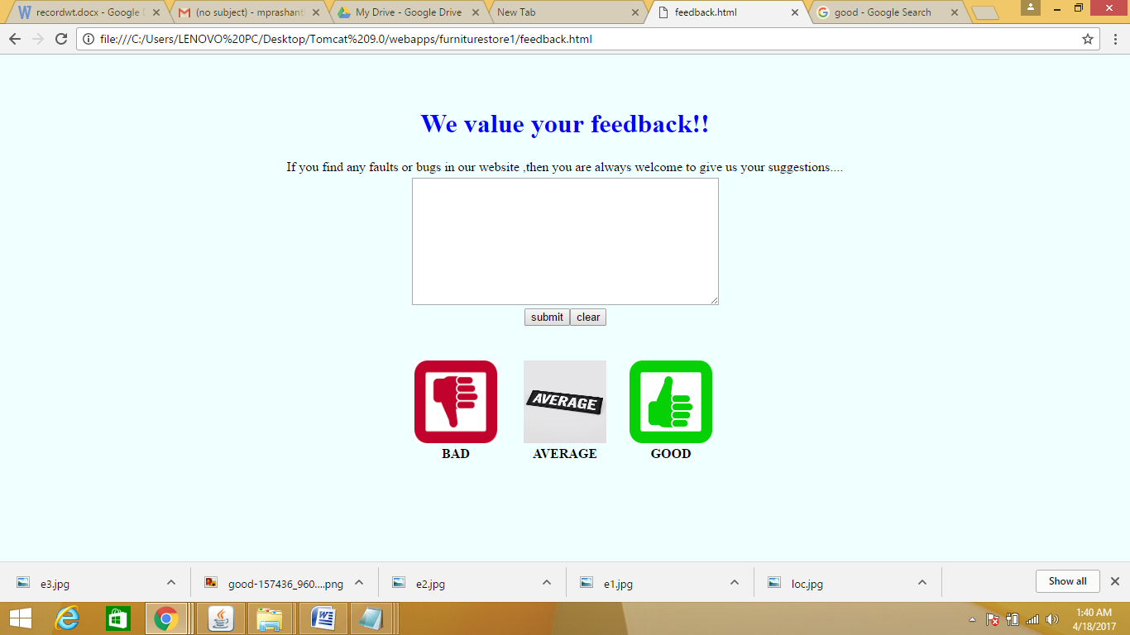

**Register.html**

<!DOCTYPE html>

<html>

<head>

<style>

body{

background:url("regbg.gif");

background-size:cover;

}

form {

border: 3px solid #f1f1f1;

}

input[type=text], input[type=password] , input[type=email] {

width: 150%;

padding: 12px 20px;

margin: 15px 0;

display: inline-block;

border: 1px solid #ccc;

border-radius: 10px;

box-sizing: border-box;

}

button {

background-color: #4CAF50;

color: white;

padding: 14px 20px;

border: 2%;

cursor: pointer;

width: 75%;

}

.cancelbtn {

width: 150%;

padding: 10px 18px;

color:white;

cursor: pointer;

background-color: #f44336;

}

button:hover{

background-color:lightskyblue;

}

div {

margin: 0 300px ;

border-radius: 5px;

background-color: cornsilk;

padding: 20px;

}

span.psw {

float: right;

padding-top: 16px;

}

/* Change styles for span and cancel button on extra small screens */

@media screen and (max-width: 300px) {

span.psw {

display: block;

float: none;

}

.cancelbtn {

width: 100%;

}

}

</style>

<script type="text/javascript">

function uProfile()

{

var un=new String(document.getElementById("uname").value);

var pd=new String(document.getElementById("psw").value);

var npd=new String(document.getElementById("npsw").value);

var mob=new String(document.getElementById("num").value);

var mail=new String(document.getElementById("email").value);

var mobpattern=/[0-9]{10}/;

var mailpattern=/(?=.*[@][a-z A-Z])/;

if(!(pd.match(npd)))

{

alert("Passwords dont match");

return false;

}

if(un=="")

{

alert("Enter Username");

return false;

}

if(pd=="")

{

alert("Enter Password");

return false;

}

if(npd=="")

{

alert("Re-Enter Password");

return false;

}

if(pd.length<8)

{

alert("Password length should be greater than 7!!");

return false;

}

if(un.length<6)

{

alert("Username length should be greater than 6!!");

return false;

}

if(!(mail.match(mailpattern)))

{

alert("Enter valid mail-id");

return false;

}

if(!(mob.match(mobpattern)))

{

alert("Enter valid mobile number");

return false;

}

else

{

alert("Successfully Registered!!");<!--document.write("<html><h3>Successfully Registered!!!</h3><table align=center><tr><td><a href=bookstore.html>Go To Homepage</a></td></tr><tr><td><a href=log.html>Login</a></td></tr></table></html>");-->

}

}

</script>

<body>

<form action="registration.jsp" method="post" onsubmit="furniture.html">

<--<form action="bookstore2.html" method="post">-->

<div><table align="center">

<tr><td></td></tr>

</table>

<h2 align=center><font face="algerian" size=7 color="black">Registration Form</font></h2>

<!--<table><tr>

<td></td><td></td><td></td><td></td><td></td><td></td><td></td>

<td><font face="arial" size="7" color="forestgreen">It's free and always will be!!</font></td></tr>

</table>-->

<table align="center">

<!--<tr><td><font face="arial" size="7">It's free and always will be!!</font></td></tr>-->

<tr><td><label><b><font size=5 color="firebrick"> Firstname </font></b></label></td>

<td><input type="text" placeholder="Enter Firstname" id="fname" name="fname" required></td></tr>

<tr><td><label><b><font size=5 color="firebrick"> Lastname </font></b></label></td>

<td><input type="text" placeholder="Enter Lastname" id="lname" name="lname"></td></tr>

<tr><td><label><b><font size=5 color="firebrick" > Email </font></b></label></td>

<td><input type="email" placeholder="Enter email" id="email" name="email"></td></tr>

<tr><td><label><b><font size=5 color="firebrick" > Mobile </font></b></label></td>

<td><input type="text" placeholder="Enter mobile" id="num" name="num" required></td></tr>

<tr><td><label><b><font size=5 color="firebrick" > Gender </font></b></label></td>

<td><input type="radio" name="gender" value="male" size="10"><font size=5 color="firebrick" >Male</font>

</td><td><input type="radio" name="gender" value="Female" size="10"><font size=5 color="firebrick">Female</font></td></tr>

<tr><td><label><b><font size=5 color="firebrick" > Address </font></b></label></td>

<td><textarea rows=4 placeholder="Enter Address" name="address"></textarea></td></tr>

<tr><td><label><b><font size=5 color="firebrick"> City </font></b></label></td>

<td><input type="text" placeholder="Enter city" id="city" name="city" required></td></tr>

<tr><td><label><b><font size=5 color="firebrick"> Username </font></b></label></td>

<td><input type="text" placeholder="Enter Username" id="uname" name="uname" required></td></tr>

<tr><td><label><b><font size=5 color="firebrick"> Password </font></b></label>

<td><input type="password" placeholder="Enter Password" id="psw" name="psw" required></td></tr>

<tr><td><label><b><font size=5 color="firebrick" > Re-enter Password </font></b></label></td>

<td><input type="password" placeholder="Enter Password" id="npsw" required></td></tr>

<tr><td></td><td><button type="submit" onclick="return uProfile()">Register</button></td></form>

<!--<tr><td><input type="checkbox" checked="checked"> Remember me

</td></tr>--><td><form action="furniture.html" method="post">

<button class="cancelbtn">Cancel</button>

<!--<span class="psw">Forgot <a href="#">password?</a></span>-->

</form></td></tr>

</table>

<!--<span class="psw">Forgot <a href="#">password?</a></span>-->

</div>

</form>

</body>

</head>

</html>

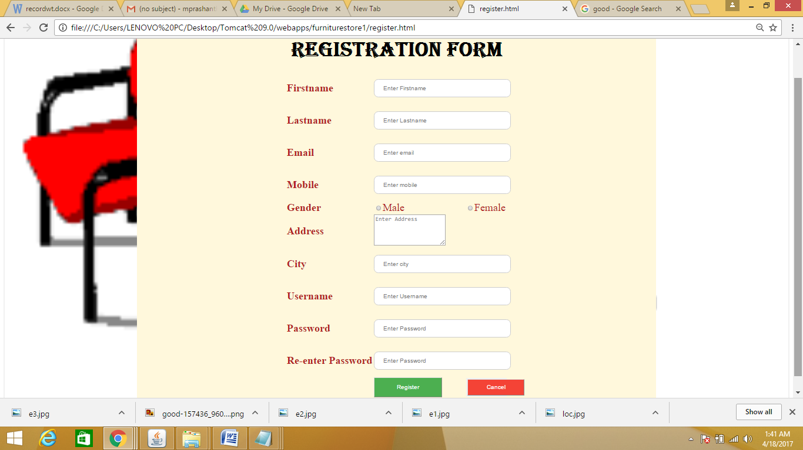

**Registration.jsp**

<%@ page import="java.sql.*" %>

<%@ page import="java.io.*" %>

<html>

<head>

<title> jsp page </title>

</head>

<body>

<h1>REGISTRATION SUCCESSFUL</h1>

<%

String n=request.getParameter("fname");

String e=request.getParameter("lname");

String ea=request.getParameter("email");

String d=request.getParameter("num");

String g=request.getParameter("gender");

String a=request.getParameter("address");

String b=request.getParameter("uname");

String p=request.getParameter("psw");

String pa=request.getParameter("npsw");

try

{

Class.forName("org.postgresql.Driver");

Connection con=DriverManager.getConnection(

"jdbc:postgresql://localhost:5432/vijaya","postgres","prashanthi");

PreparedStatement ps=con.prepareStatement(

"insert into reg values(?,?,?,?,?,?,?,?,?)");

ps.setString(1,n);

ps.setString(2,e);

ps.setString(3,ea);

ps.setString(4,d);

ps.setString(5,g);

ps.setString(6,a);

ps.setString(7,b);

ps.setString(8,p);

ps.setString(9,pa);

int i=ps.executeUpdate();

PreparedStatement ps1=con.prepareStatement(

"insert into vijaya values(?,?)");

ps1.setString(1,b);

ps1.setString(2,p);

int k=ps1.executeUpdate();

if(i>0)

{

out.print("You are successfully registered...");

//response.sendRedirect("Login.html");

}

if(k>0)

{

out.println("back to home page??");

//response.sendRedirect("furniture.html");

out.print("Registration Successfull!"+"<a href='furniture.html'>home</a>");

} }

catch(Exception er)

{

out.println(er);

er.printStackTrace();

}

out.close();

%>

<%="hello"%>

</html>

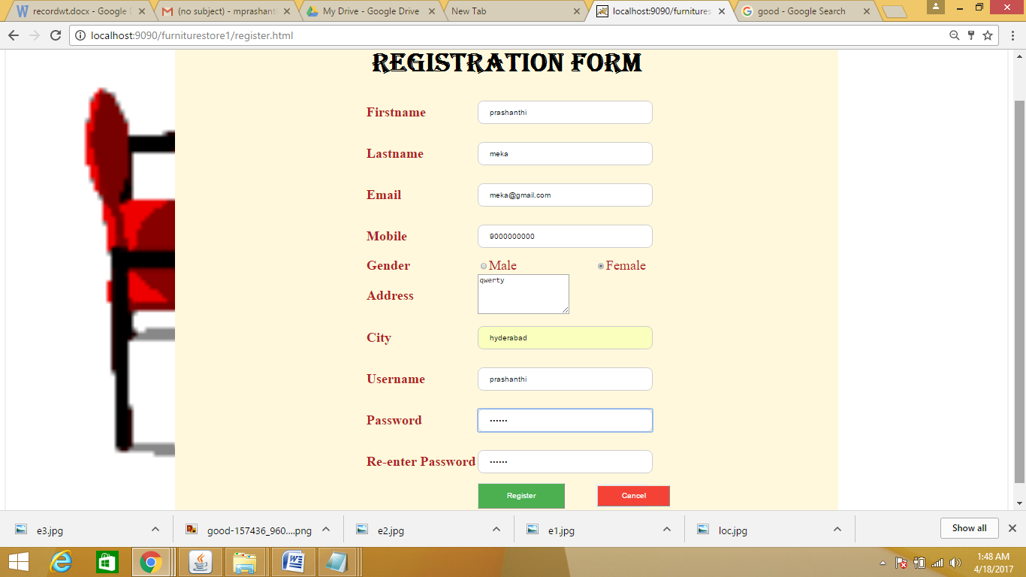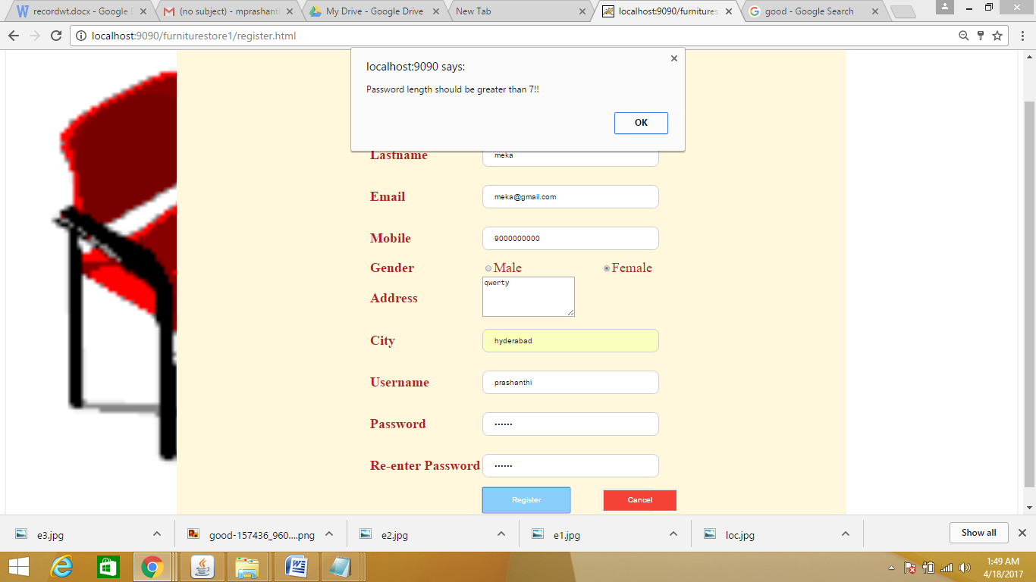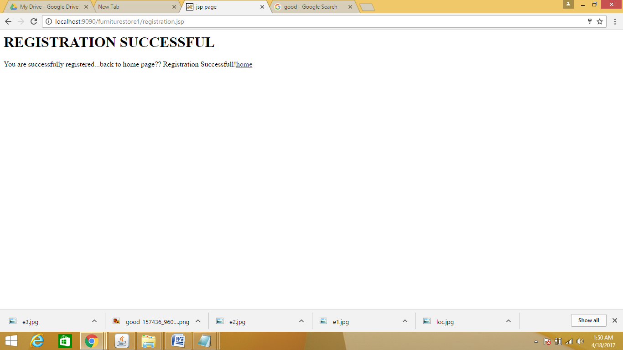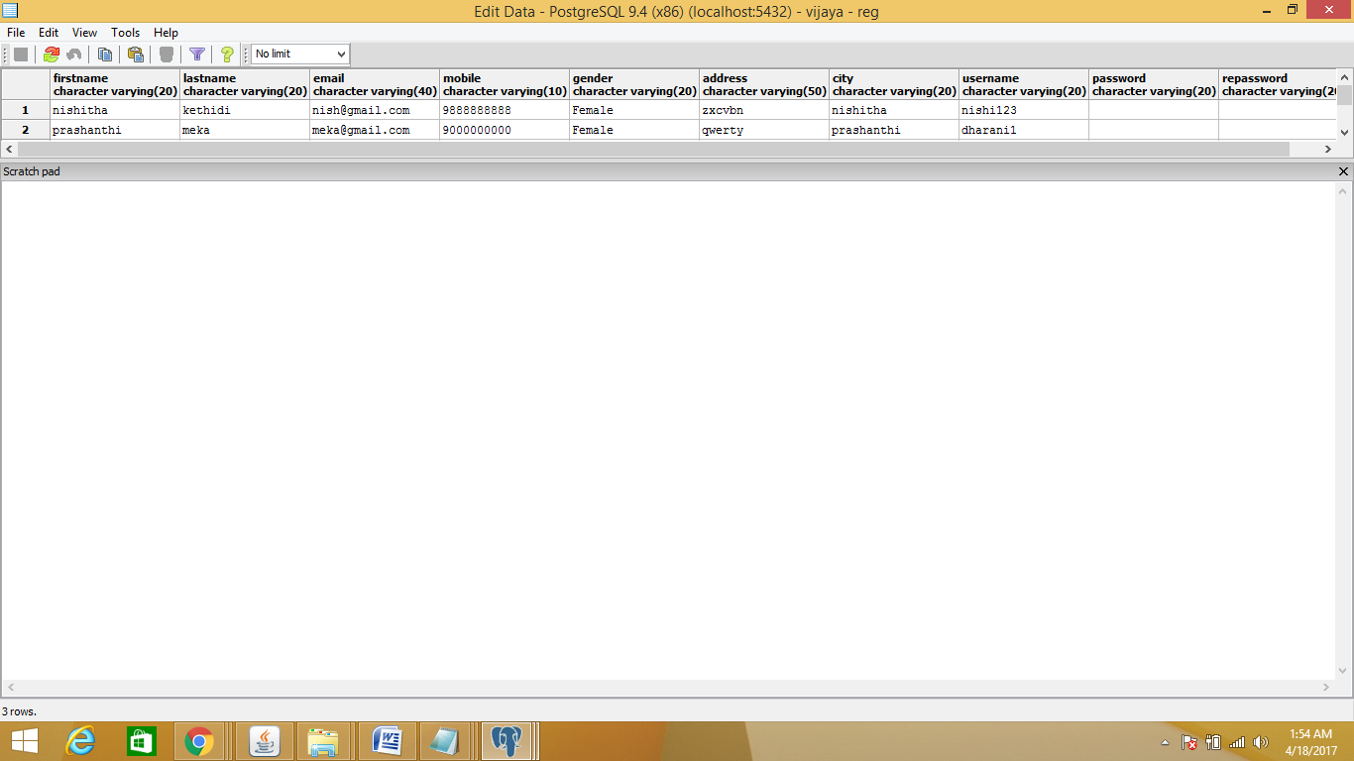

**Login.html**

<!DOCTYPE html>

<html>

<head>

<style>

form {

border: 3px solid #f1f1f1;

}

input[type=text], input[type=password] {

width: 100%;

padding: 12px 20px;

margin: 15px 0;

display: inline-block;

border: 1px solid #ccc;

border-radius: 10px;

box-sizing: border-box;

}

button {

background-color: #4CAF50;

color: white;

padding: 14px 20px;

border: 2%;

cursor: pointer;

width: 50%;

}

.cancelbtn {

width: 50%;

padding: 10px 18px;

color:white;

cursor: pointer;

background-color: #f44336;

}

button:hover{

background-color:lightskyblue;

}

.imgcontainer {

text-align: center;

margin: 24px 0 12px 0;

}

img.avatar {

width: 40%;

}

.container {

padding: 16px;

}

span.psw {

float: right;

padding-top: 16px;

}

/* Change styles for span and cancel button on extra small screens */

@media screen and (max-width: 300px) {

span.psw {

display: block;

float: none;

}

.cancelbtn {

width: 100%;

}

}

</style>

<script type="text/javascript">

function uProfile()

{

var un=new String(document.getElementById("uname").value);

var pd=new String(document.getElementById("psw").value);

if(un=="")

{

alert("Enter Username");

return false;

}

else if(pd=="")

{

alert("Enter Password");

return false;

}

else

{

alert("please wait");

}

}

</script>

<body>

<form action="login.jsp" method="post">

<!--<h2 align=center><font size=7 color="cornsilk"> Login Form </font></h2>-->

<table align="center">

<tr><div class="imgcontainer">

<td></td><td><img src="log.png" style="width:600px;height:300px" alt="Avatar" class="avatar"></td>

</div></tr>

<tr><div class="container">

<td><label><b>Username &nbsp &nbsp </b></label></td>

<td><input type="text" placeholder="Enter Username" id="uname" name="uname" required></td></tr>

<tr><td><label><b>Password &nbsp &nbsp </b></label></td>

<td><input type="password" placeholder="Enter Password" id="psw" name="psw" required></td></tr>

<tr><td></td><td align="center"><button type="submit" onclick="return uProfile()">Login</button></td></tr>

<tr><td><input type="checkbox" checked="checked"> Remember me<td></tr>

<tr><td></td><td align="center">

<!--<div class="container" style="background-color:#f1f1f1">-->

<button class="cancelbtn">Cancel</button>

</tr>

<tr><td>

<b>new user???</b><a href="register.html">register</a></td></tr>&nbsp&nbsp&nbsp&nbsp

<tr><td><b>forgot password??</b><a href="pass.html">change password</a><td></tr>

</form></td></tr>

</table>

</div>

</body>

</head>

</html>

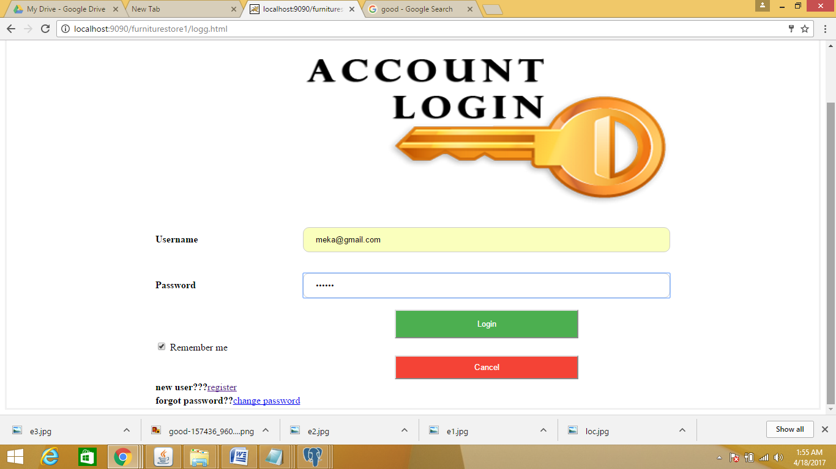

**Login.jsp**

<%@ page import="java.sql.*" %>

<%@ page import="java.io.*" %>

<html>

<head>

<title> login </title>

</head>

<body bgcolor="black" link="white" text="white" >

<h1><center>WELCOME<center></h1>

<%

int flag=0;

String username=request.getParameter("uname");

String password=request.getParameter("psw");

session.setAttribute( "sna", username );

try

{

Class.forName("org.postgresql.Driver");

Connection con=DriverManager.getConnection(

"jdbc:postgresql://localhost:5432/vijaya","postgres","prashanthi");

Statement ps=con.createStatement();

ResultSet rs=ps.executeQuery("select * from vijaya");

//out.println("Resulye set executed");

while(rs.next())

{

if((rs.getString(1).equals(username)) && (rs.getString(2).equals(password)))

{

flag=1;

}

}

if(flag==1)

{

out.println("<center>valid user");

out.print("<br><center>LOGIN Successfull!"+"<a href='furniture.html'>home</a></p>");

}

else

{ out.println("<center>Invalid User");

out.print("<br><center>LOGIN UnSuccessfull!"+"<a href='logg.html'>Go to Login</a>");

}

}

catch(Exception e)

{

out.println(e);

e.printStackTrace();

}

out.close();

%>

</html>

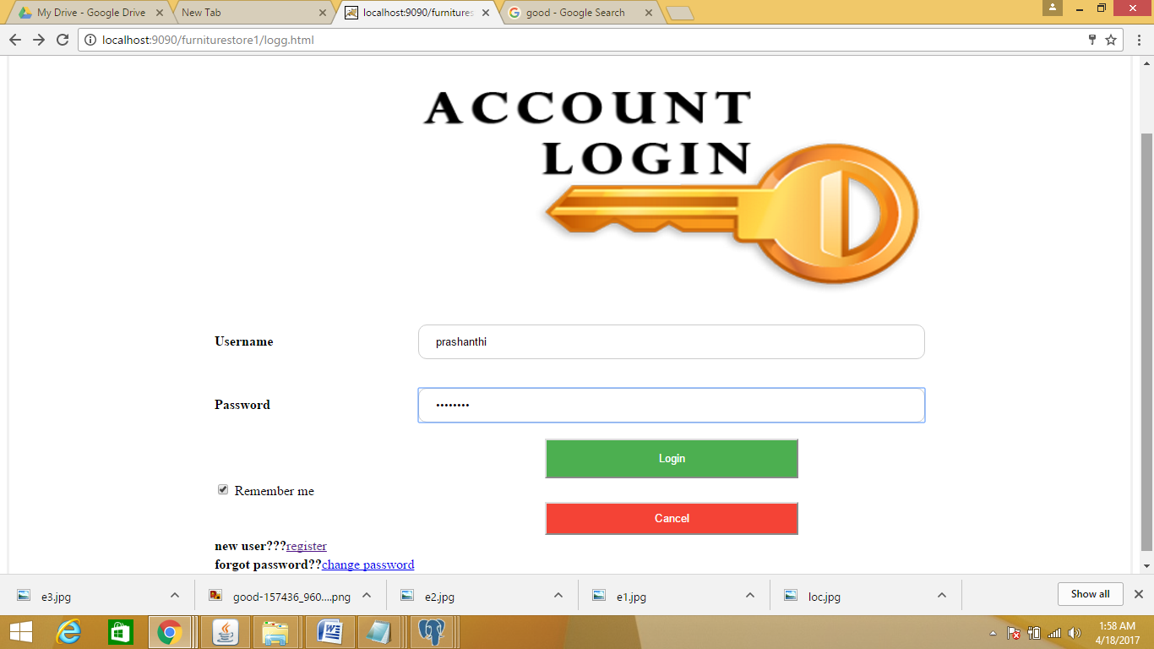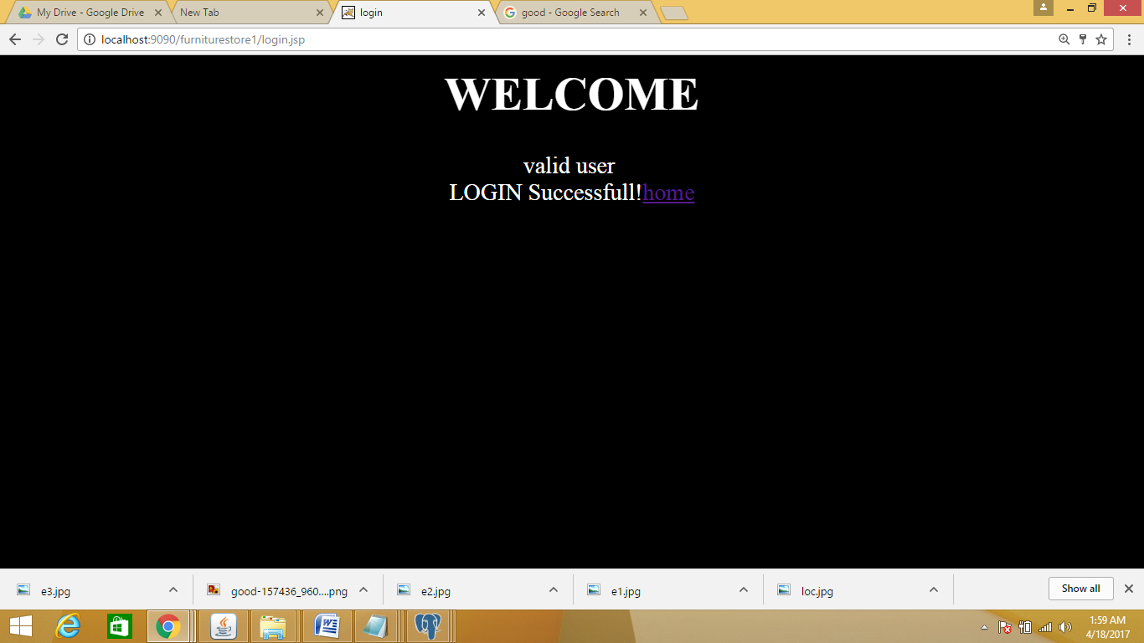

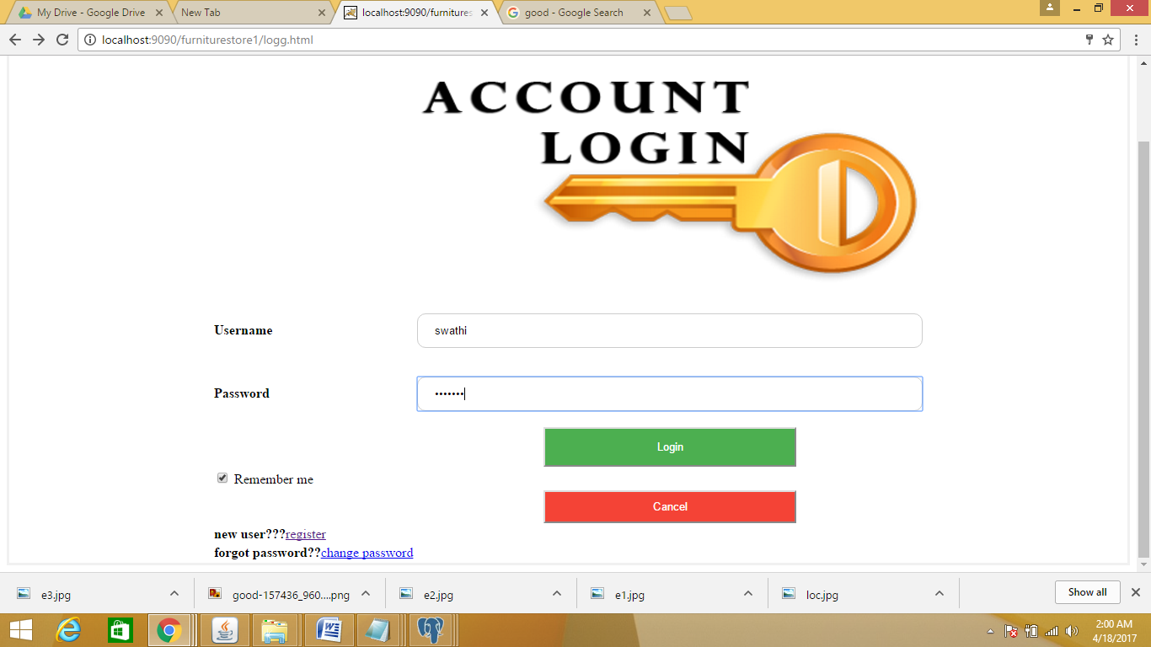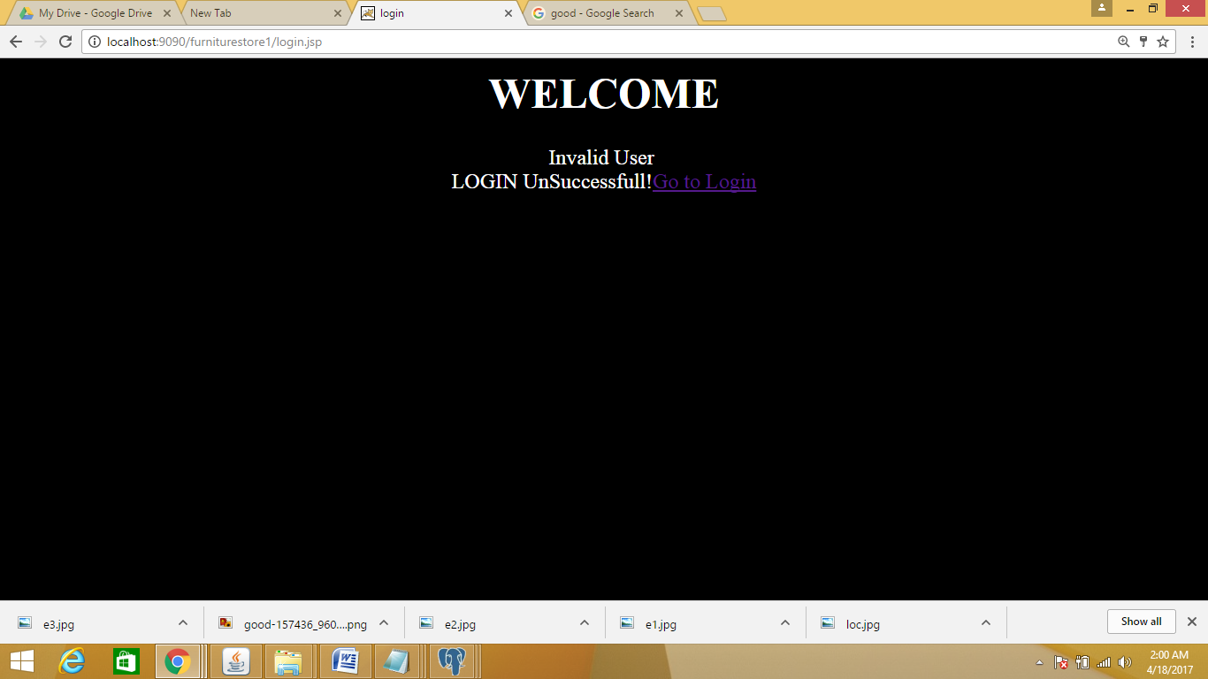

**Livingroom.html**

<html>

<body>

<h1 align="center"><b>LIVING ROOM</b></h1>

<table align="center">

<tr><td><h2>SOFA SETS</h2><a href="sofas.html"><img src="sofas.jpg" style=" height:320px; width:320px;"></a></td>

<td><h3>TABLES</h3><a href="tables.html"><img src="tables.jpg" style="height:320px; width:320px;" ></a></td></tr>

<tr><td><h4>CHAIRS</h4><a href="chairs.html"><img src="chairs.jpg" style="height:320px; width:320px;"></a></td>

<td><h5>FLOWERPOTS</h5><a href="flowers.html"><img src="flowers.jpg" style="height:320px; width:320px;"></a></td></tr>

</table>

</body>

</html>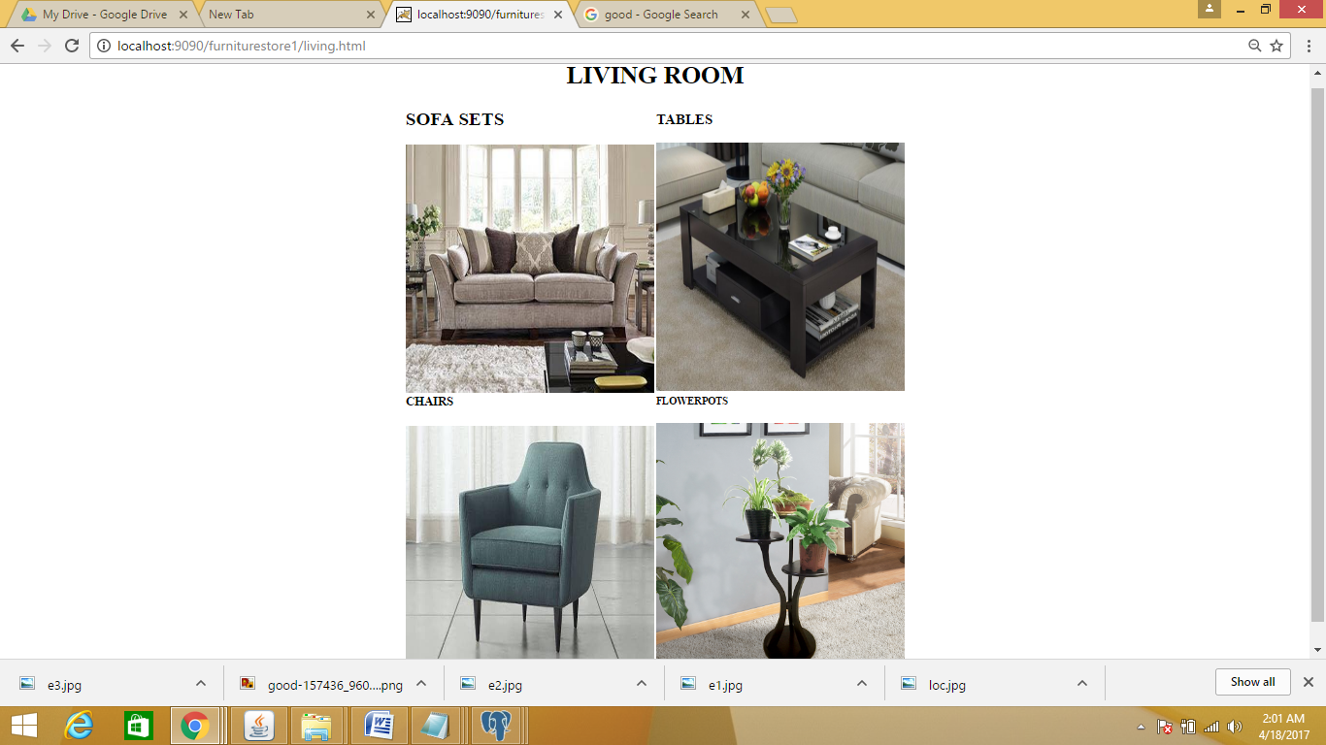

**Sofas.html**

<html>

<body>

<h1 align="center"><b>SOFA SETS</b></h1>

<table align="center">

<tr><td><a href="s1details.html"><img src="s1.jpg" style=" height:320px; width:320px;"></a></td>

<td><a href="s2details.html"><img src="s2.jpg" style="height:320px; width:320px;" ></a></td></tr>

<tr><td><a href="s3details.html"><img src="s3.jpg" style="height:320px; width:320px;"></a></td>

<td><a href="s4details.html"><img src="s4.jpg" style="height:320px; width:320px;"></a></td></tr>

</table>

</body>

</html>

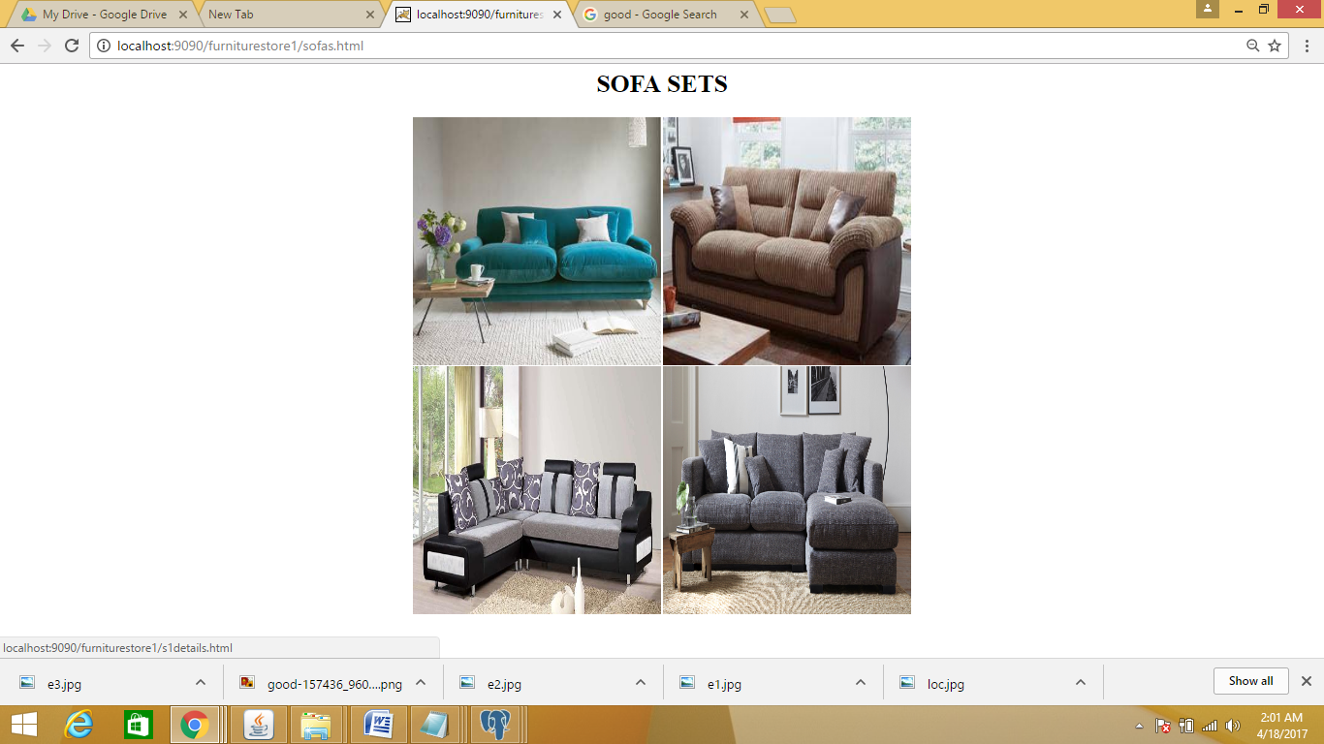

**S1details.html**

|  |  |
| --- | --- |
|  |  |
|  | <!DOCTYPE html> |
|  | <html> |
|  | <style> |
|  | button { |
|  | background-color: #4CAF50; |
|  | color: white; |
|  | padding: 14px 20px; |
|  |  |
|  |  |
|  | border: 2%; |
|  | cursor: pointer; |
|  | width: 100%; |
|  | } |
|  |  |
|  | </style> |
|  |  |
|  | <body> |
|  | <br><br> |
|  | <table align="center"> |
|  | <tr><td><img src="s1.jpg" style="width:300px;height:400px;"></td> |
|  | <td><table> |
|  | <tr> |
|  | <td></td> |
|  | <td></td> |
|  | <td><font face="broadway" color="black" size="6">COMFORTER SOFA</font></td> |
|  | </tr> |
|  | <tr><td><font face="aharoni" color="grey" size="6">Seller</font></td> |
|  | <td><font face="aharoni" color="grey" size="6">:</font></td> |
|  | <td><font face="aharoni" color="grey" size="6">HOMEDECORS</font></td> |
|  | </tr>  <tr><td><form action="cart.jsp">  <input type="hidden" name="s1" value="living"><input type="submit" name="add to cart" value="add to cart">  </td></tr></form></table> |
|  | </td> |
|  | </tr> |
|  | </table> |
|  | <hr color="cyan"> |
|  | <br><br> |
|  | <table> |
|  | <tr><td><font face="vijaya" size="4" color="brown"><b><i>Type:livingroom Furniture |
|  | Model Number:18011 <br> |
|  | Specific Use:sofa Set <br> |
|  | General Use:Home Furniture <br> |
|  | Appearance:Antique <br> |
|  | Place of Origin:USA <br> |
|  |  |
|  |  |
|  |  |
|  |  |
|  |  |
|  | </i></b></font></td></tr> |
|  | <tr><td></td> |
|  | <td><font face="calibri light" size="5" color="blue"></font></td> |
|  | </tr> |
|  | <tr><td><font face="vijaya" size="7" color="brown"><b><i>Reviews:</i></b></font></td></tr> |
|  | <tr> |
|  | <td><font face="calibri light" size="5" color="black">1."very comfortable and long lifed "</font><br><font size="5" color="coral">– rashika</font></td> |
|  | </tr> |
|  | <tr> |
|  | <td><font face="calibri light" size="5" color="black">2."very comfortable but expensive"</font><br><font size="5" color="coral">– suresh</font></td> |
|  | </tr> |
|  | <tr> |
|  | <td><font face="calibri light" size="5" color="black">3."looks very antique " </font><br><font size="5" color="coral">– nishitha</font></td> |
|  | </tr> |
|  | </table> |
|  | <br> |
|  | <table align="center"> |
|  | <tr><td>price:rs 25,000.00</td><td> |
|  | <form action="payment.html" method="post"> |
|  | <button type="submit">Buy Now</button> |
|  | </form> |
|  | </td> |
|  | </tr> |
|  | </table> |
|  |  |
|  | </body> |
|  | </html> |

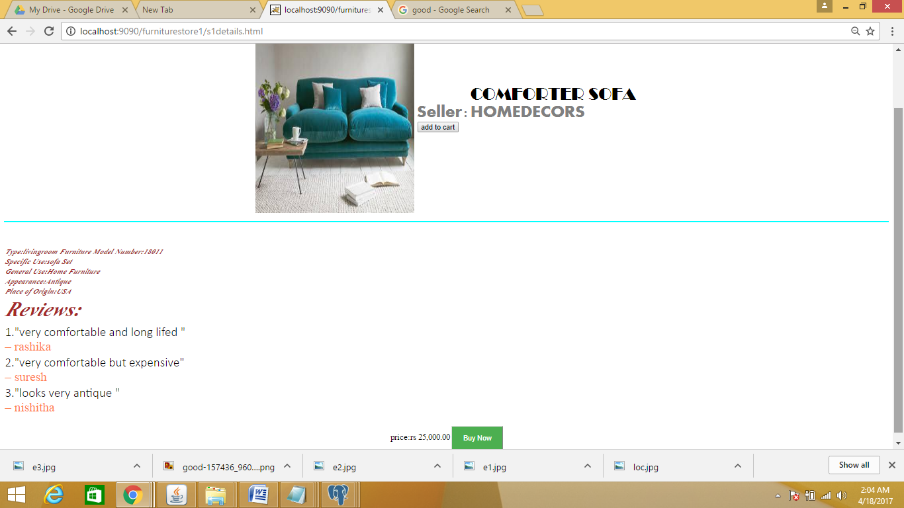

**Studyroom**

**Studyroom1.html**

<html>

<body bgcolor="black" text="white" link="white" >

<center><u><i><b><h1 style="color:white" >STUDY ROOM</H1></i><b></u>

<table align="left" ><h3>

<tr><td></td>

<td><a href="studytable.html" ><font size="10" style="color:white" ><img src="st1.jpg" alt="unsupported version" style="width:304px;height=300px;">

</td>

<td><a href=studytable.html">Study Table</a></td>

<td rowspan="15">&nbsp&nbsp&nbsp&nbsp&nbsp&nbsp&nbsp&nbsp&nbsp&nbsp</td>

<td rowspan="15"><img src="studyroom.jpg"></td>

</tr>

<tr><td></td>

<td><a href="studylamp.html" ><font size="10" style="font-sizw:20px" ><img src="st2.jpg" alt="unsupported version" style="width:304px;height=300px;">

</td>

<td>

<a href="studylamp.html"> Study Lamps</a></td>

</tr>

<tr><td></td>

<td><a href="studybook.html" ><font size="10"><img src="st3.jpg" alt="unsupported version" style="width:304px;height=300px;">

</td>

<td><a href="studybook.html">Book Shelves</a></td>

</tr>

<tr><td></td>

<td><a href="studychair.html" ><font size="10"><img src="st4.jpg" alt="unsupported version" style="width:304px;height=300px;">

</td>

<td><a href="studychair.html">Chairs</a></td>

</tr>

</h3>

</table>

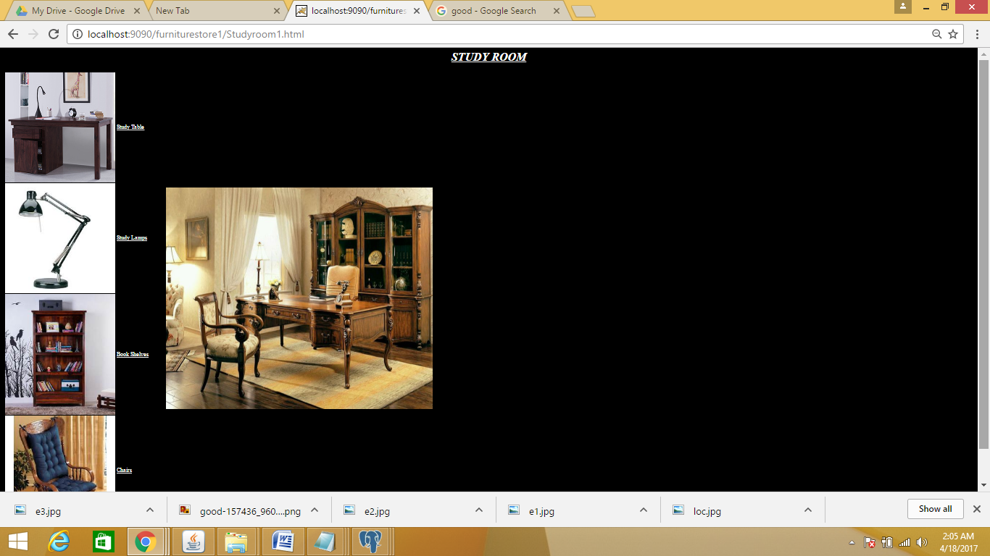

**Studytable.html**

<html>

<body bgcolor="navy blue" text="white" link="white" >

<center><u><i><b><h1 style="color:white" >STUDY TABLES</H1></i><b></u>

<table align="left" ><h3>

<tr><td rowspan="3" colspan="2"><img src="studyroom.jpg" height="600px" width="500px"></td>

<td><a href="stable1.html" ><font size="10" style="font-size:20px"><img src="s11.jpg" alt="unsupported version" style="width:345px;height=400px;">

<br>

<a href="stable1.html"><h5>modern study and<br> laptop tables<h5></a></td>

<td rowspan="3" colspan="2"><img src="sroom.jpg" height="600px" width="500px"></td>

</tr>

<tr>

<td><a href="stable2.html" ><font size="10" style="font-size:20px" ><img src="s12.jpg" alt="unsupported version" style="width:345px;height=400px;">

<br>

<a href="stable2.html"><h5>Study table- wenge finish<h5></a></td>

</tr>

<tr>

<td><a href="stable3.html" ><font size="10" style="font-size:20px"><img src="st1.jpg" alt="unsupported version" style="width:345px;height=400px;">

<br>

<a href="stable3.html"><h5>Study Table <br> dark oak finish<h5></a></td>

</tr>

</h3>

</table>

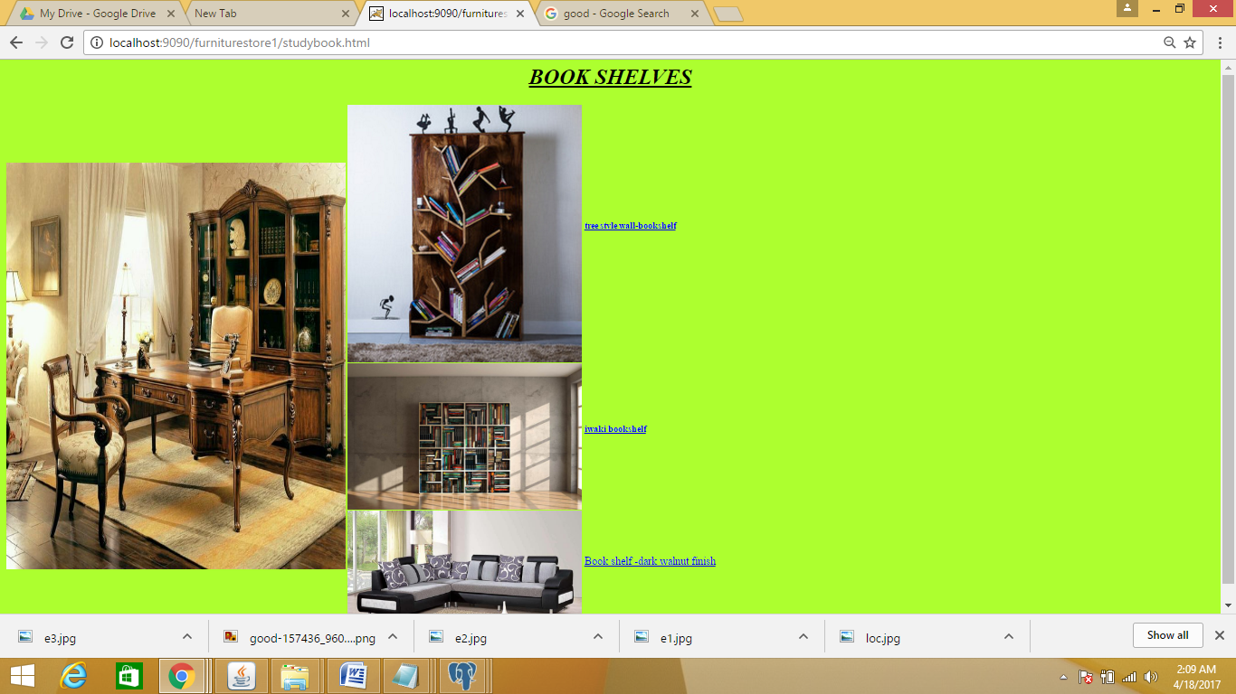

**Stable1.html**

<!DOCTYPE html>

<html>

<style>

button {

background-color: #4CAF50;

color: white;

padding: 14px 20px;

border: 2%;

cursor: pointer;

width: 100%;

}

</style>

<body>

<br><br>

<table align="center">

<tr><td><img src="s11.jpg" style="width:300px;height:400px;"></td>

<td><table>

<tr>

<td></td>

<td></td>

<td><font face="broadway" color="hotpink" size="6">Modern study and laptop table</font></td>

</tr>

<tr><td><font face="aharoni" color="green" size="6">Seller</font></td>

<td><font face="aharoni" color="green" size="6">:</font></td>

<td><font face="broadway" color="hotpink" size="6">Pepper Fry</font></td>

</tr>

<tr><td><form action="cart.jsp">

<input type="hidden" name="stable1" value="study"><input type="submit" name="add to cart" value="add to cart">

</td></tr></form></table>

</td>

</tr>

</table>

<hr color="cyan">

<br><br>

<table>

<tr><td><font face="vijaya" size="4" color="brown"><b><i>Description:Brand: Bohemiana

Dimensions: H 30 X W 67 X D 35

Weight: 38 KG

Colour: white

Warranty: 12 Months' Warranty

Primary Material: Malaysian Wood

Height: 30.0 inches

Width: 67.0 inches

Depth: 35.0 inches

Seating Capacity: 6 Seater

</i></b></font></td></tr>

<tr><td></td>

<td><font face="calibri light" size="5" color="blue"></font></td>

</tr>

<tr><td><font face="vijaya" size="7" color="brown"><b><i>Reviews:</i></b></font></td></tr>

<tr>

<td><font face="calibri light" size="5" color="blue">1."Excellent product. "</font><br><font size="5" color="coral">– Joe Moore</font></td>

</tr>

<tr>

<td><font face="calibri light" size="5" color="blue">2."Pictures are very deceptive. "</font><br><font size="5" color="coral">– DP Lyle</font></td>

</tr>

<tr>

<td><font face="calibri light" size="5" color="blue">3."Din't like the product " </font><br><font size="5" color="coral">– Robert Dugoni</font></td>

</tr>

</table>

<br>

<table align="center">

<tr><td>price:$2000.00</td><td>

<form action="payment.html" method="post">

<button type="submit">Buy Now</button>

</form>

</td>

</tr>

</table>

</body>

</html>

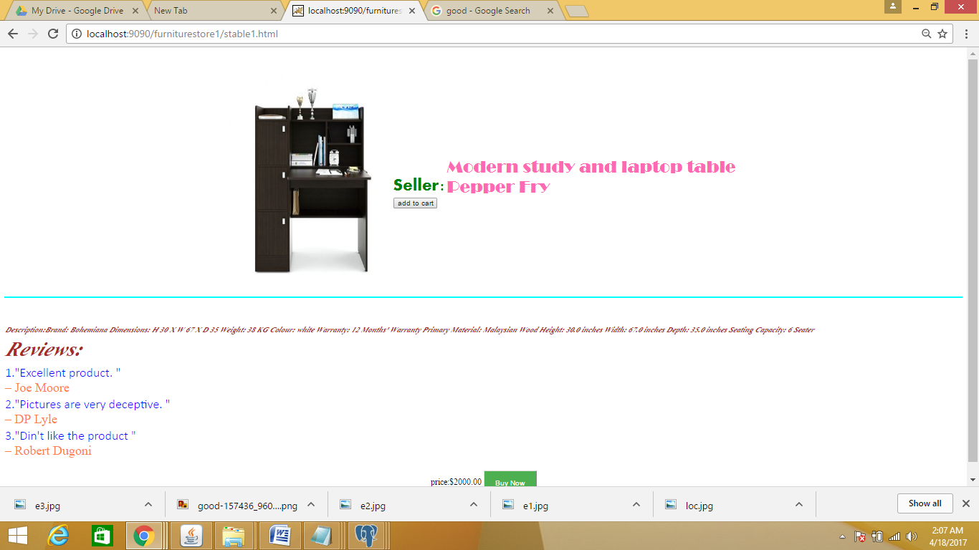

**Bedroom**

**Bedroom.html**

<html>

<body>

<h1 align="center"><b>BEDROOM ROOM</b></h1>

<table align="center">

<tr><td><a href="b1details.html"><img src="bedroom1.jpg" style=" height:320px; width:320px;"></a></td>

<td><a href="b2details.html"><img src="bedroom2.jpg" style="height:320px; width:320px;" ></a></td></tr>

<tr><td><a href="b3details.html"><img src="bedroom3.jpg" style="height:320px; width:320px;"></a></td>

<td><a href="b4details.html"><img src="bedroom4.jpg" style="height:320px; width:320px;"></a></td></tr>

</table>

</body>

</html>

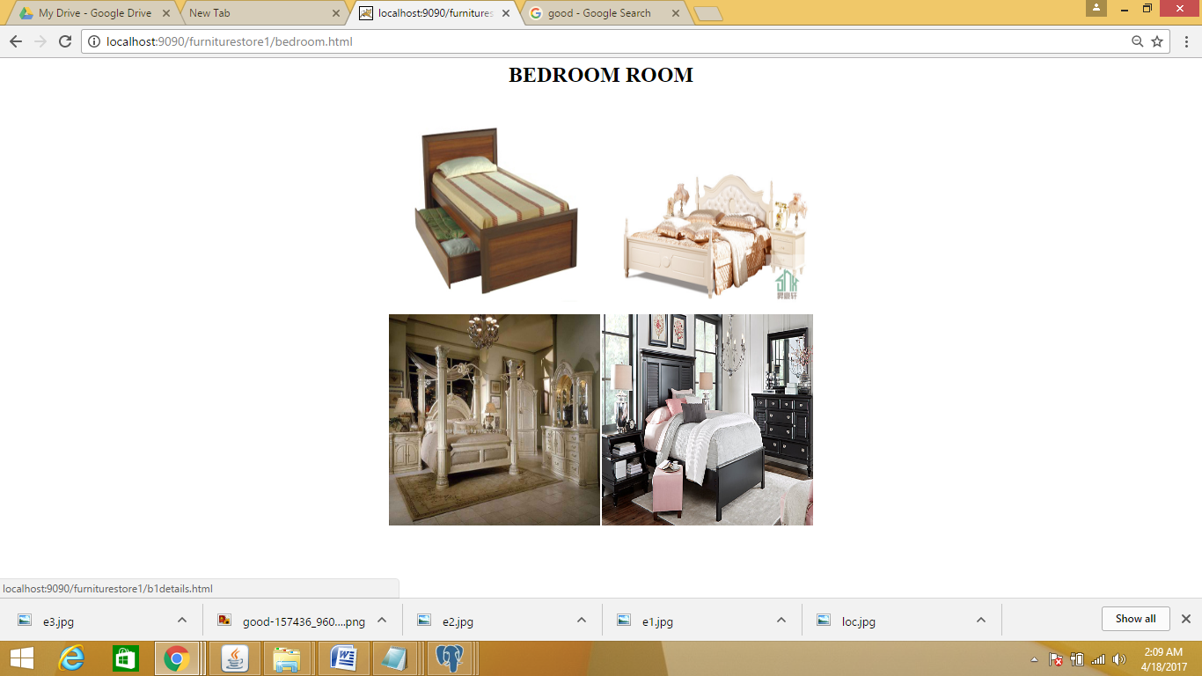

**B1details.html**

<!DOCTYPE html>

<html>

<style>

button {

background-color: #4CAF50;

color: white;

padding: 14px 20px;

border: 2%;

cursor: pointer;

width: 100%;

}

</style>

<body>

<br><br>

<table align="center">

<tr><td><img src="bedroom1.jpg" style="width:300px;height:400px;"></td>

<td><table>

<tr>

<td></td>

<td></td>

<td><font face="broadway" color="hotpink" size="6">Victor Exoctica</font></td>

</tr>

<tr><td><font face="aharoni" color="green" size="6">Seller</font></td>

<td><font face="aharoni" color="green" size="6">:</font></td>

<td><font face="broadway" color="hotpink" size="6">Verito</font></td>

</tr>

<tr><td><form action="cart.jsp">

<input type="hidden" name="bd" value="bedroom"><input type="submit" name="add to cart" value="add to cart">

</td></tr></form></table>

</td>

</tr>

</table>

<hr color="cyan">

<br><br>

<table>

<tr><td><font face="vijaya" size="4" color="brown"><b><i>Type:Bedroom Furniture

Specific Use:Bedroom Set

General Use:Home Furniture

Material:P2 America standard MDF+envimental paint

Appearance:Antique

Place of Origin:Zhejiang, China (Mainland)

Brand Name:NO(OEM)

Model Number:Bedroom sets

Product name:Bedroom sets

</i></b></font></td></tr>

<tr><td></td>

<td><font face="calibri light" size="5" color="blue"></font></td>

</tr>

<tr><td><font face="vijaya" size="7" color="brown"><b><i>Reviews:</i></b></font></td></tr>

<tr>

<td><font face="calibri light" size="5" color="blue">1."product is very ugly and got damaged very soon "</font><br><font size="5" color="coral">– rashika</font></td>

</tr>

<tr>

<td><font face="calibri light" size="5" color="blue">2."it is very nice and is same as shown in the picture "</font><br><font size="5" color="coral">– suresh</font></td>

</tr>

<tr>

<td><font face="calibri light" size="5" color="blue">3."good one. " </font><br><font size="5" color="coral">– nishitha</font></td>

</tr>

</table>

<br>

<table align="center">

<tr><td>price:$1500.00</td><td>

<form action="payment.html" method="post">

<button type="submit">Buy Now</button>

</form>

</td>

</tr>

</table>

</body>

</html>

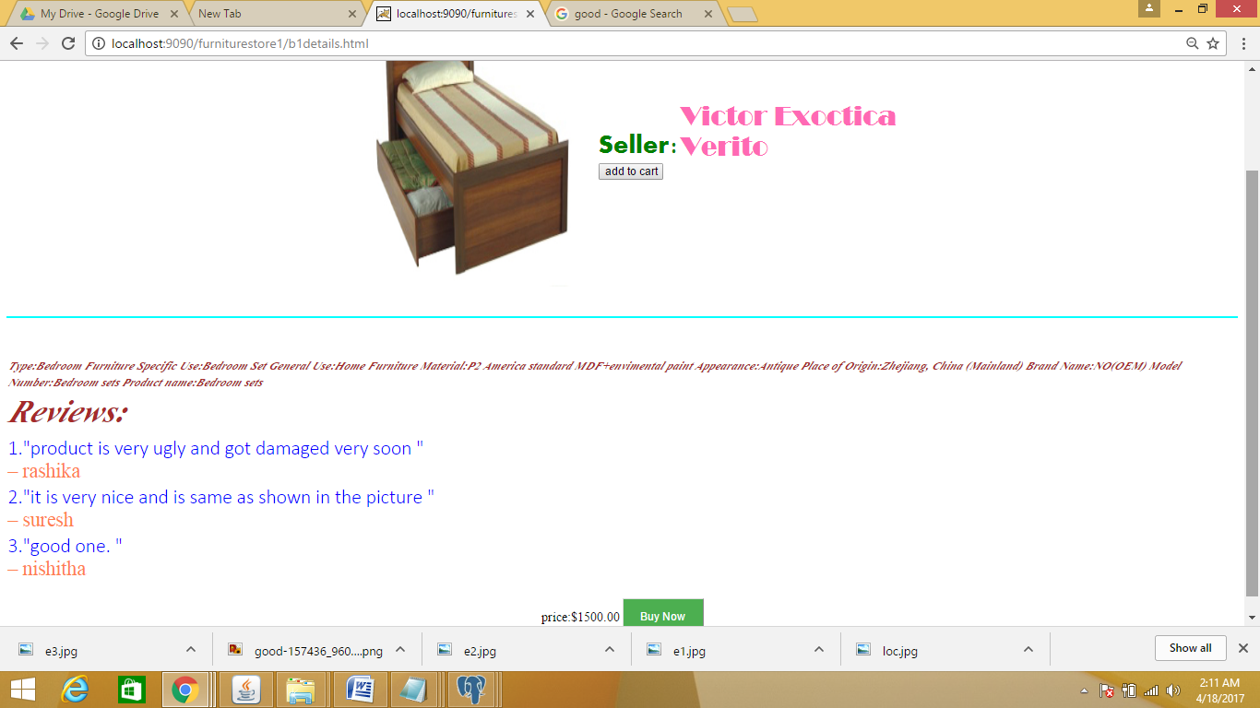

**Dining**

**Dining.html**

<html>

<body>

<h1 align="center"><b>DINING ROOM</b></h1>

<table align="center">

<tr><td><a href="d1details.html"><img src="dining1.jpg" style=" height:320px; width:320px;"></a></td>

<td><a href="d2details.html"><img src="dining2.jpg" style="height:320px; width:320px;" ></a></td></tr>

<tr><td><a href="d3details.html"><img src="dining3.jpg" style="height:320px; width:320px;"></a></td>

<td><a href="d4details.html"><img src="dining4.jpg" style="height:320px; width:320px;"></a></td></tr>

</table>

</body>

</html>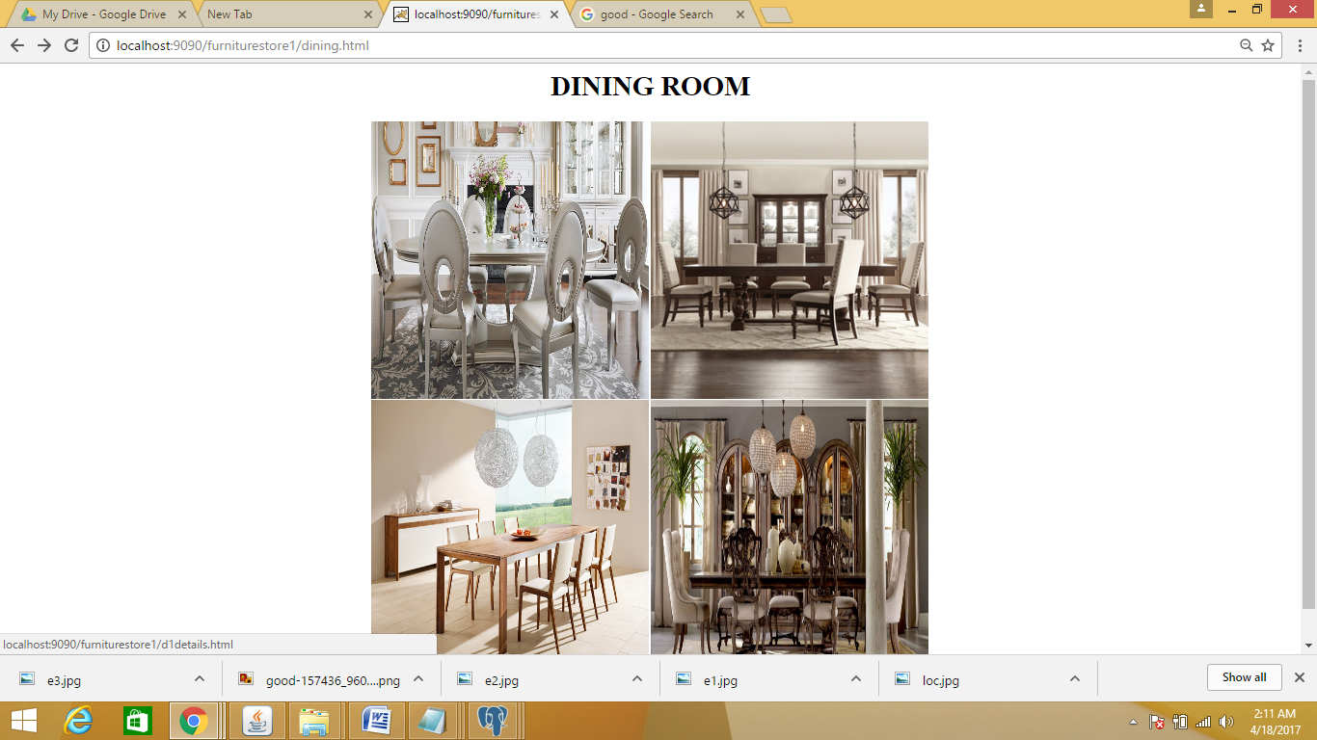

**D1details.html**

<!DOCTYPE html>

<html>

<style>

button {

background-color: #4CAF50;

color: white;

padding: 14px 20px;

border: 2%;

cursor: pointer;

width: 100%;

}

</style>

<body>

<br><br>

<table align="center">

<tr><td><img src="dining1.jpg" style="width:300px;height:400px;"></td>

<td><table>

<tr>

<td></td>

<td></td>

<td><font face="broadway" color="hotpink" size="6">Elegant Essa</font></td>

</tr>

<tr><td><font face="aharoni" color="green" size="6">Seller</font></td>

<td><font face="aharoni" color="green" size="6">:</font></td>

<td><font face="broadway" color="hotpink" size="6">Pepper Fry</font></td>

</tr>

<tr><td><form action="cart.jsp">

<input type="hidden" name="din" value="dining"><input type="submit" name="add to cart" value="add to cart">

</td></tr></form></table>

</td>

</tr>

</table>

<hr color="cyan">

<br><br>

<table>

<tr><td><font face="vijaya" size="4" color="brown"><b><i>Description:Brand: Bohemiana

Dimensions: H 30 X W 67 X D 35

Weight: 38 KG

Colour: white

Warranty: 12 Months' Warranty

Primary Material: Mango Wood

Height: 30.0 inches

Width: 67.0 inches

Depth: 35.0 inches

Seating Capacity: 6 Seater

</i></b></font></td></tr>

<tr><td></td>

<td><font face="calibri light" size="5" color="blue"></font></td>

</tr>

<tr><td><font face="vijaya" size="7" color="brown"><b><i>Reviews:</i></b></font></td></tr>

<tr>

<td><font face="calibri light" size="5" color="blue">1."Excellent product. "</font><br><font size="5" color="coral">– Joe Moore</font></td>

</tr>

<tr>

<td><font face="calibri light" size="5" color="blue">2."Pictures are very deceptive. "</font><br><font size="5" color="coral">– DP Lyle</font></td>

</tr>

<tr>

<td><font face="calibri light" size="5" color="blue">3."Din't like the product " </font><br><font size="5" color="coral">– Robert Dugoni</font></td>

</tr>

</table>

<br>

<table align="center">

<tr><td>price:$2000.00</td><td>

<form action="payment.html" method="post">

<button type="submit">Buy Now</button>

</form>

</td>

</tr>

</table>

</body>

</html>

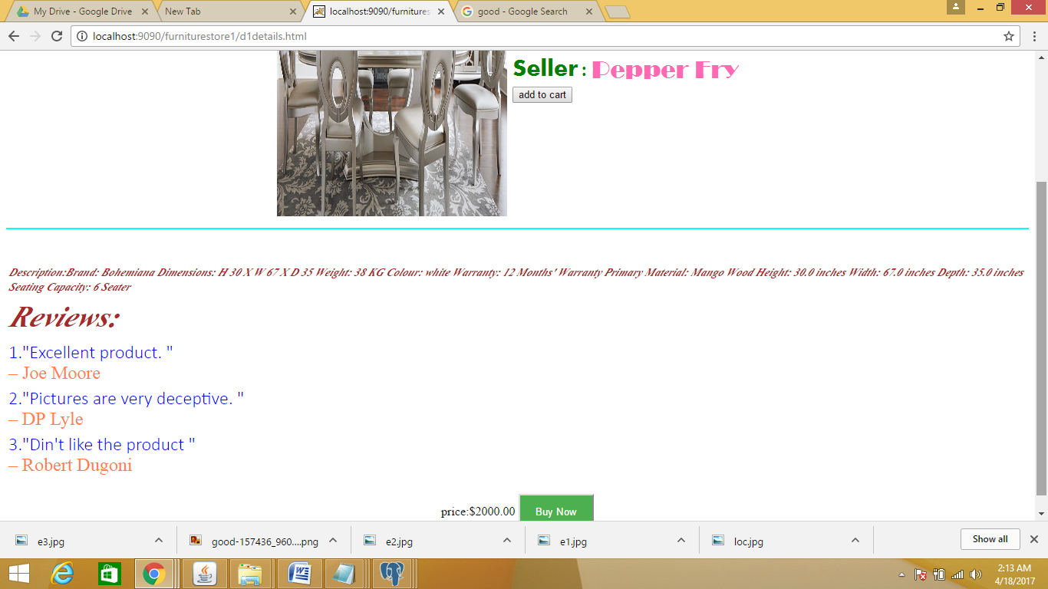

**Others**

**Others.html**

<html>

<body>

<h1 align="center"><b>OTHERS</b></h1>

<table align="center">

<tr><td><a href="other1.html"><img src="other1.jpg" style=" height:320px; width:320px;"></a></td>

<td><a href="other2.html"><img src="other2.jpg" style="height:320px; width:320px;" ></a></td></tr>

<tr><td><a href="other3.html"><img src="other3.jpg" style="height:320px; width:320px;"></a></td>

</table>

</body>

</html>

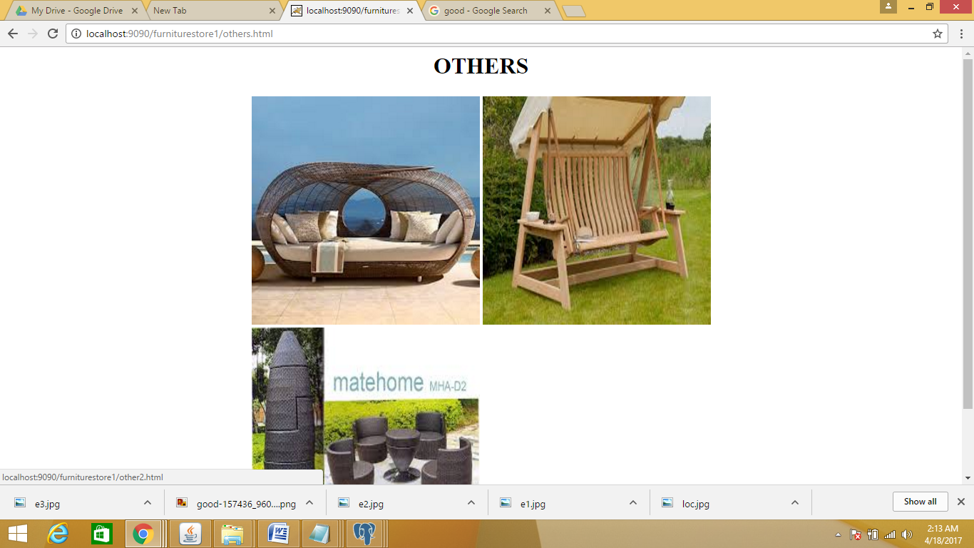

**Other1.html**

<!DOCTYPE html>

<html>

<style>

button {

background-color: #4CAF50;

color: white;

padding: 14px 20px;

border: 2%;

cursor: pointer;

width: 100%;

}

</style>

<body>

<br><br>

<table align="center">

<tr><td><img src="other1.jpg" style="width:300px;height:400px;"></td>

<td><table>

<tr>

<td></td>

<td></td>

<td><font face="broadway" color="hotpink" size="6">Patio Comfort</font></td>

</tr>

<tr><td><font face="aharoni" color="green" size="6">Seller</font></td>

<td><font face="aharoni" color="green" size="6">:</font></td>

<td><font face="broadway" color="hotpink" size="6">Verito</font></td>

</tr>

<tr><td><form action="cart.jsp">

<input type="hidden" name="other" value="other"><input type="submit" name="add to cart" value="add to cart">

</td></tr></form></table>

</td>

</tr>

</table>

<hr color="cyan">

<br><br>

<table>

<tr><td><font face="vijaya" size="4" color="brown"><b><i>Type:Bedroom Furniture

Specific Use:Outdoor Furniture

General Use:Home Furniture

Material:P2 America standard MDF+envimental paint

Appearance:Antique

Place of Origin:Zhejiang, China (Mainland)

Brand Name:NO(OEM)

Model Number:236273

</i></b></font></td></tr>

<tr><td></td>

<td><font face="calibri light" size="5" color="blue"></font></td>

</tr>

<tr><td><font face="vijaya" size="7" color="brown"><b><i>Reviews:</i></b></font></td></tr>

<tr>

<td><font face="calibri light" size="5" color="blue">1."product is not as expected "</font><br><font size="5" color="coral">– kavya</font></td>

</tr>

<tr>

<td><font face="calibri light" size="5" color="blue">2."it is very nice and is same as shown in the picture "</font><br><font size="5" color="coral">– nikhila</font></td>

</tr>

<tr>

<td><font face="calibri light" size="5" color="blue">3."good one. " </font><br><font size="5" color="coral">– nishitha</font></td>

</tr>

</table>

<br>

<table align="center">

<tr><td>price:Rs.15000.00</td><td>

<form action="payment.html" method="post">

<button type="submit">Buy Now</button>

</form>

</td>

</tr>

</table>

</body>

</html>

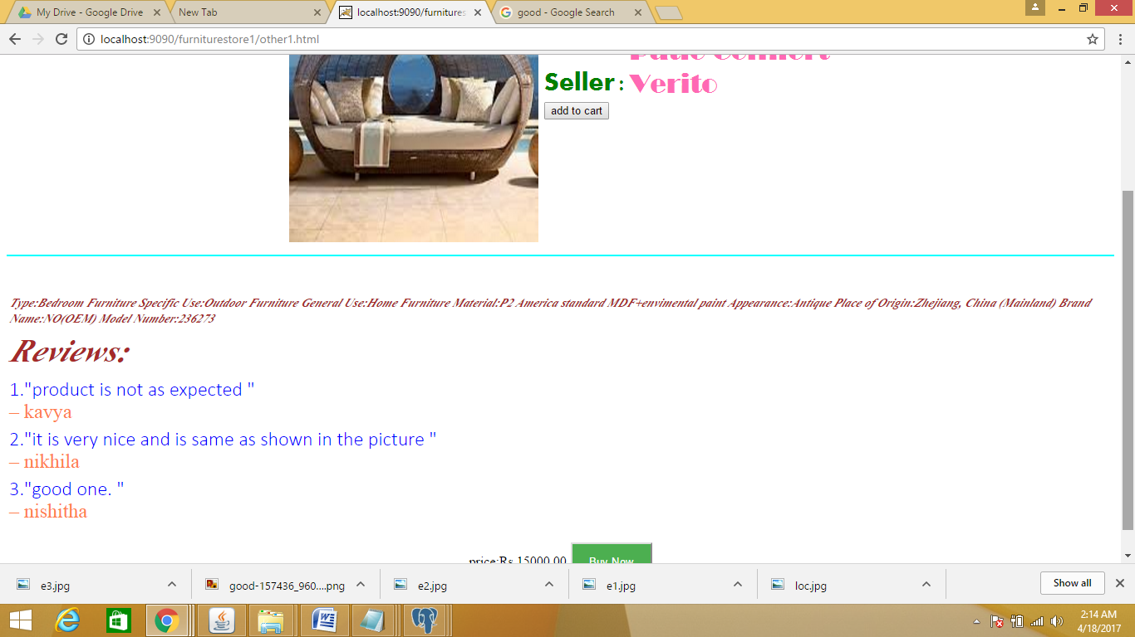

**Kidsroom**

**Kidsroom.html**

<html>

<body>

<h1 align="center"><b>KIDS ROOM</b></h1>

<table align="center">

<tr><td><h2>BEDS</h2><a href="beds.html"><img src="beds.jpe" style=" height:320px; width:320px;"></a></td>

<td><h3>CUPBOARDS</h3><a href="cupboards.html"><img src="cupboards.jpe" style="height:320px; width:320px;" ></a></td></tr>

<td><h3>STUDY TABLES</h3><a href="studytables.html"><img src="studytables.jpe" style="height:320px; width:320px;" ></a></td></tr>

</table>

</body>

</html>

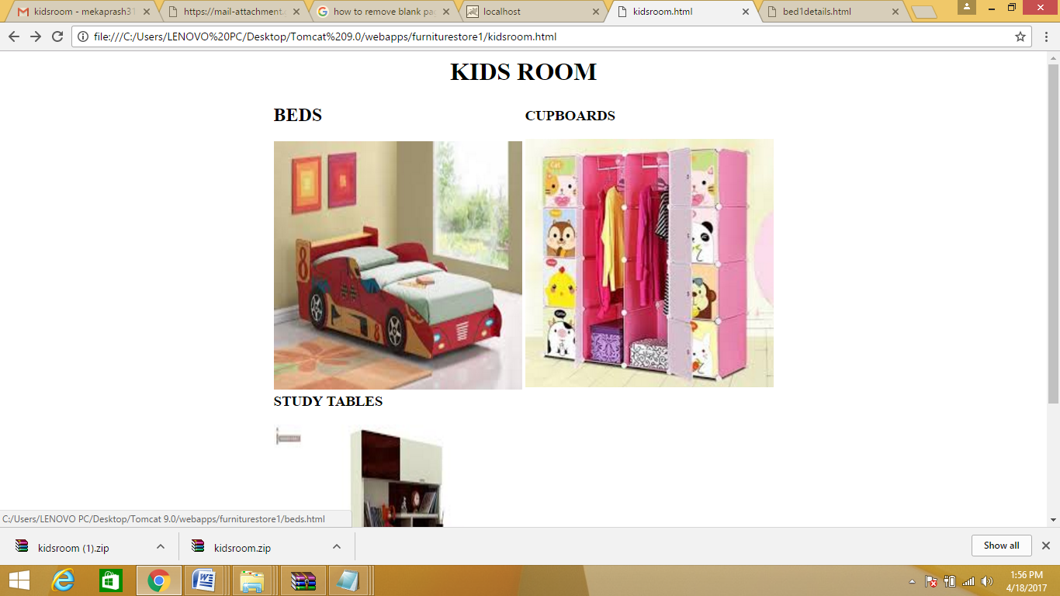

**Beds.html**

<html>

<body>

<h1 align="center"><b>BEDS</b></h1>

<table align="center">

<tr><td><a href="bed1details.html"><img src="bed1.jpg" style=" height:320px; width:320px;"></a></td>

<td><a href="bed2details.html"><img src="bed2.jpe" style="height:320px; width:320px;" ></a></td></tr>

<tr><td><a href="bed3details.html"><img src="bed3.jpe" style="height:320px; width:320px;"></a></td>

<td><a href="bed4details.html"><img src="bed4.jpe" style="height:320px; width:320px;"></a></td></tr>

</table>

</body>

</html>

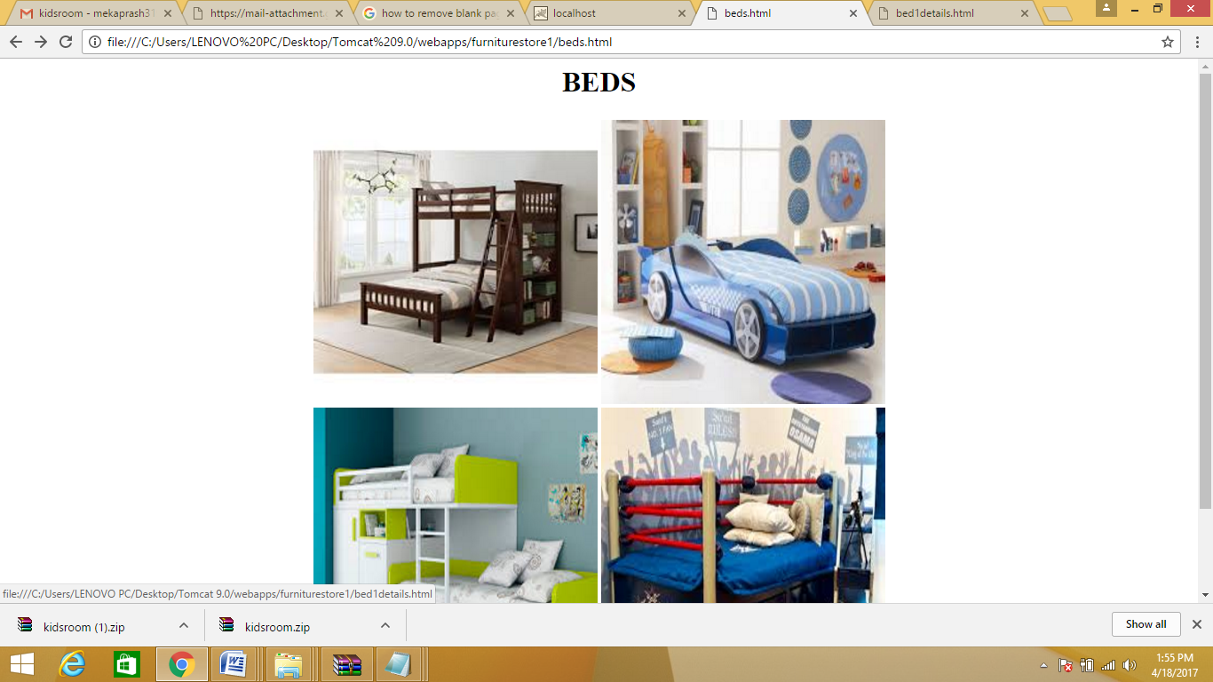

**Bed1.html**

<!DOCTYPE html>

<html>

<style>

button {

background-color: #4CAF50;

color: white;

padding: 14px 20px;

border: 2%;

cursor: pointer;

width: 100%;

}

</style>

<body>

<br><br>

<table align="center">

<tr><td><img src="bed1.jpg" style="width:300px;height:400px;"></td>

<td><table>

<tr>

<td></td>

<td></td>

<td><font face="broadway" color="black" size="6">BUNK BED</font></td>

</tr>

<tr><td><font face="aharoni" color="grey" size="6">Seller</font></td>

<td><font face="aharoni" color="grey" size="6">:</font></td>

<td><font face="aharoni" color="grey" size="6">HOMESTORE</font></td>

</tr><tr><td><form action="cart.jsp">

<input type="hidden" name="kd" value="kids"><input type="submit" name="add to cart" value="add to cart">

</td></tr></form></table>

</td>

</tr>

</table>

<hr color="cyan">

<br><br>

<table>

<tr><td><font face="vijaya" size="4" color="brown"><b><i>Type:livingroom Furniture

Model Number:13421<br>

Specific Use:BED<br>

General Use:Home Furniture <br>

Appearance:Antique<br>

Place of Origin:LADAKH<br>

</i></b></font></td></tr>

<tr><td></td>

<td><font face="calibri light" size="5" color="blue"></font></td>

</tr>

<tr><td><font face="vijaya" size="7" color="brown"><b><i>Reviews:</i></b></font></td></tr>

<tr>

<td><font face="calibri light" size="5" color="black">1."My children love it..!!"</font><br><font size="5" color="coral">– KAVYA</font></td>

</tr>

<tr>

<td><font face="calibri light" size="5" color="black">2."very comfortable but expensive"</font><br><font size="5" color="coral">– NIKHILA</font></td>

</tr>

<tr>

<td><font face="calibri light" size="5" color="black">3."looks very antique " </font><br><font size="5" color="coral">– VARSHA</font></td>

</tr>

</table>

<br>

<table align="center">

<tr><td>price:rs 25,000.00</td><td>

<form action="payment.html" method="post">

<button type="submit">Buy Now</button>

</form>

</td>

</tr>

</table>

</body>

</html>

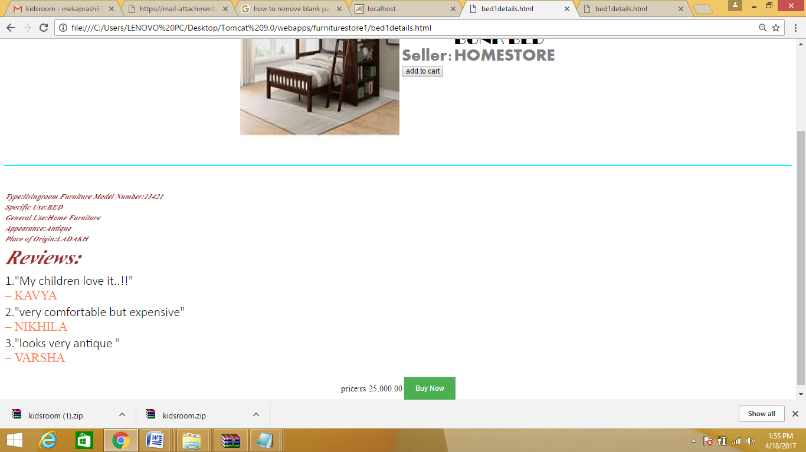

**Cart.jsp**

<%@ page import="java.sql.*" %>

<%@ page import="java.io.*" %>

<html>

<head>

</head>

<body>

<h2>

your cart

<h2>

<%

String sname=(String)session.getAttribute("sna");

out.println(sname);

// String[] items = req.getParameterValues("stable");

String pro=request.getParameter("stable1");

String pro2=request.getParameter("stable2");

out.println("product"+pro);

Class.forName("org.postgresql.Driver");

Connection con=DriverManager.getConnection(

"jdbc:postgresql://localhost:5432/vijaya","postgres","prashanthi");

Statement ps=con.createStatement();

ResultSet rs=ps.executeQuery("select * from cart");

//out.println("Resulye set executed");

while(rs.next())

{

if(pro.equals(rs.getString(2)))

{

//for (int i = 0; i < items.length; i++) {

// out.println("<LI>" + items[i]);

out.println(rs.getString(2)+"<br>"+rs.getString(4));

}

}

%>

</script>

</body>

</html>

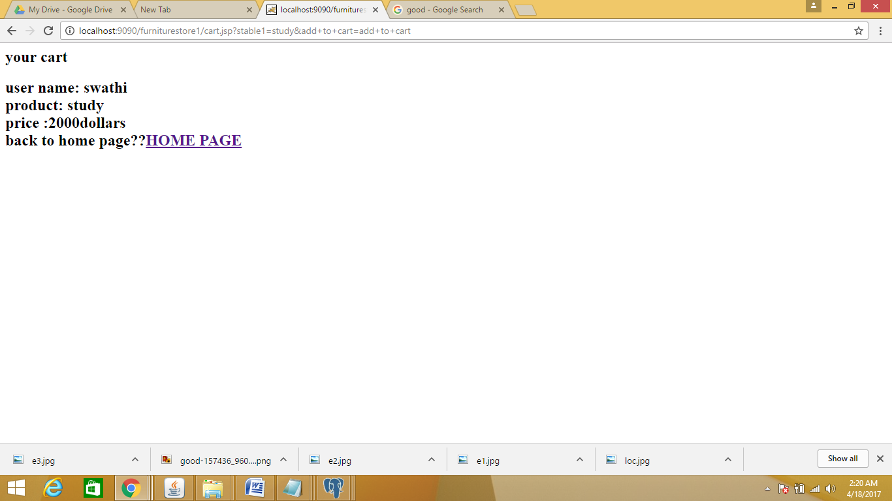

**Payment.html**

<!doctype html>

<html>

<style>

form {

border: 3px solid #f1f1f1;

}

input[type=text], input[type=password] , input[type=email] {

width: 200%;

padding: 12px 20px;

margin: 15px 0;

display: inline-block;

border: 1px solid #ccc;

border-radius: 10px;

box-sizing: border-box;

}

button {

background-color: #4CAF50;

color: white;

padding: 14px 20px;

border: 2%;

cursor: pointer;

width: 75%;

}

.cancelbtn {

width: 150%;

padding: 10px 18px;

color:white;

cursor: pointer;

background-color: #f44336;

}

button:hover{

background-color:lightskyblue;

}

.container {

padding: 16px;

}

span.psw {

float: right;

padding-top: 16px;

}

/* Change styles for span and cancel button on extra small screens */

@media screen and (max-width: 300px) {

span.psw {

display: block;

float: none;

}

.cancelbtn {

width: 100%;

}

}

</style>

<script type="text/javascript">

function payDet()

{

var cnam=new String(document.getElementById("cardname").value);

var cnum=new String(document.getElementById("cardnum").value);

var cvv=new String(document.getElementById("cvv").value);

var exp=new String(document.getElementById("expiry").value);

var numpattern=/[0-9]{16}/;

<--var exppattern=/[0-9]{4}/;-->

var cvvpattern=/[0-9]{3}/;

if(cnam=="")

{

alert("Enter Name on card");

}

else if(cnum=="")

{

alert("Enter cardnumber");

}

else if(cvv=="")

{

alert("Enter cvv");

}

else if(exp=="")

{

alert("Enter expiry date");

}

else if(!(cnum.match(numpattern)))

{

alert("Enter valid cardnumber");

}

else if(!(exp.match(exppattern)))

{

alert("Enter valid expiry date");

}

else if(!(cvv.match(cvvpattern)))

{

alert("Enter valid cvv");

}

else

{

document.write("<html><h3>Successfully Registered!!!</h3><table align=center><tr><td><a href=bookstore.html>Go To Homepage</a></td></tr><tr><td><a href=log.html>Login</a></td></tr></table></html>");

}

}

</script>

<body>

<form action="payment.jsp" method="post">

<h1>Enter details for payment...</h1><br>

<table align="center">

<div class="container">

<tr><td align="left"><label><b><font size=5> Name on the card </font></b></label></td>

<td><input type="text" placeholder="Enter card name" id="cardname" name="name" required></td></tr>

<tr><td align="left"><label><b><font size=5> Card number </font></b></label></td>

<td><input type="text" placeholder="Enter card number" id="cardnum" name="cardnum" required></td></tr>

<tr><td align="left"><label><b><font size=5> Expiry </font></b></label></td>

<td><input type="text" style="width:50%" placeholder="MM/YY" id="expiry" name="expiry" required></td>

<td><label><b><font size=5 > CVV </font></b></label></td>

<td><input type="text" style="width:50%" maxlength=3 placeholder="CVV" id="cvv" name="cvv" required></td></tr>

<tr><td align="center"></td><td><button onclick="payDet()">Pay</button></td>

<!--<tr><td><input type="checkbox" checked="checked"> Remember me

</td></tr>--><td><form action="bookstore.html" method="post">

<button class="cancelbtn">Cancel</button>

<!--<span class="psw">Forgot <a href="#">password?</a></span>-->

</form></td></tr>

</table>

<!--<span class="psw">Forgot <a href="#">password?</a></span>-->

</d

</form>

</body>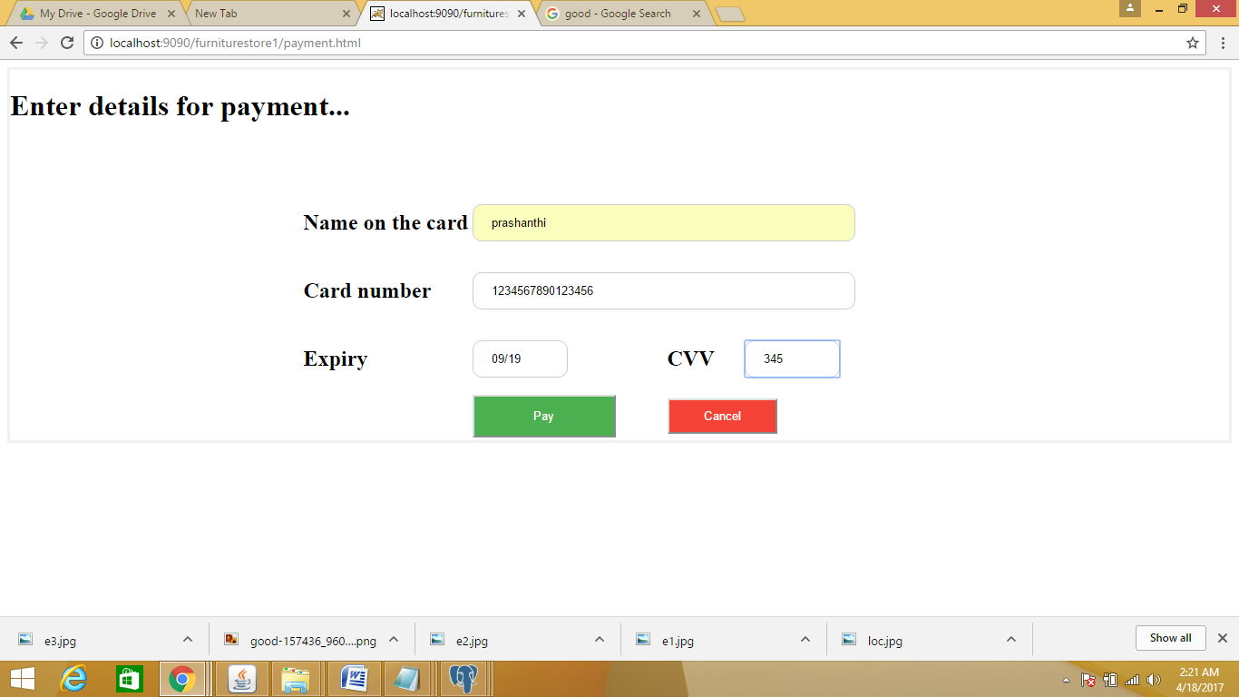

**Payment.jsp**

<%@ page import="java.sql.*" %>

<%@ page import="java.io.*" %>

<html>

<head>

<title> jsp page </title>

</head>

<h1>jsp page</h1>

<%

int flag=0;

String username=request.getParameter("name");

String cardno=request.getParameter("cardnum");

String cvv=request.getParameter("cvv");

try

{

Class.forName("org.postgresql.Driver");

Connection con=DriverManager.getConnection(

"jdbc:postgresql://localhost:5432/vijaya","postgres","prashanthi");

Statement ps=con.createStatement();

ResultSet rs=ps.executeQuery("select * from credit");

out.println("Result set executed");

while(rs.next())

{

if((rs.getString(1).equals(username)) && (rs.getString(2).equals(cardno))&& (rs.getString(3).equals(cvv)))

{

flag=1;

}

}

if(flag==1)

{

out.println("transaction succesful<br>");

out.println("thank you!!!!");

}

else

{ out.println("Invalid User");

}

}

catch(Exception e)

{

out.println(e);

e.printStackTrace();

}

out.close();

%>

<center><h2>

<a href="furniture.html">BACK TO HOME PAGE</a><h2></center>

</html>

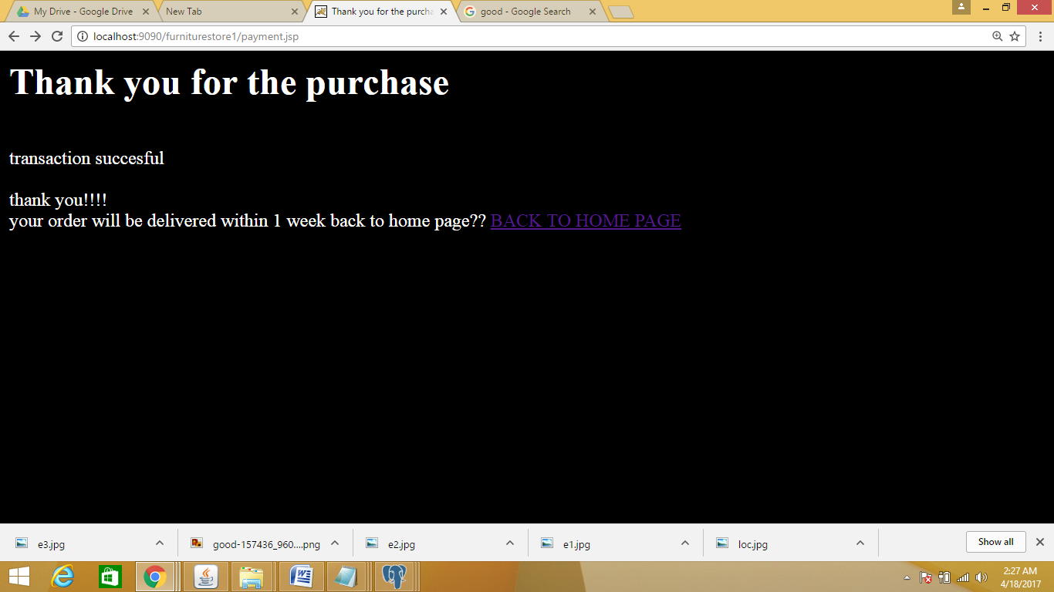

**Logout.jsp**

<%@ page import="java.sql.*" %>

<%@ page import="java.io.*" %>

<html>

<head>

</head>

<body><center>

<h2>

logout succesful ....

Thank you for visiting!!

<h2>

<%

session.invalidate();

out.println("visit again?? "+"<a href='furniture.html'>HOME PAGE</a>");

%>

</script>

</body>

</html>

